Ongatoto Maketū Estuary Water Quality and Ecology Monitoring to 2026 for Consent 67958

Prepared by:
K. D. Hamill (River Lake Ltd)

Prepared for:
Bay of Plenty Regional Council

Released by: ………………………………
Keith Hamill
River Lake Ltd
13 Louvain Street, Whakatane 3120, New Zealand

Mobile: | +64 27 308 7224
Email: keith@riverlake.co.nz
Web: www.riverlake.co.nz
Date: 24 September 2026
Status: Final DRAFT
Reference: wk-1219

Cover Photo: Upper Maketū Estuary looking east towards Papikahiwai Island, February 2026.
All rights reserved. This publication may not be reproduced or copied in any form without the permission of the client. Such permission is to be given only in accordance with the terms of the client's contract with River Lake Ltd.
Contents
1 Introduction 2
1.1 Background to re-diversion of the Kaituna River to Maketū Estuary 2
1.2 Consent monitoring 3
1.3 Scope of this report 3
2 Monitoring of Maketū Estuary 4
2.1 Monitoring for consent compliance 4
2.2 Ecological monitoring in addition to consent requirements 5
2.3 Monitoring of Maketū undertaken in 2025/2026 6
2.4 Trend analysis 15
2.5 Non-metric Multidimensional Scaling 15
3 Results 17
3.1 Cover of macroalgae 17
3.2 Sediment 21
3.3 Macrofauna 32
3.4 Pipi surveys in the lower estuary 47
3.5 Dissolved oxygen and salinity loggers 51
3.6 Water quality 54
3.7 Shellfish microbial condition 65
4 Summary and Conclusions 67
References 74
Appendix 1: Relevant Monitoring Conditions of Consent 67958 76
Appendix 2: Maketū Estuary Sampling Protocols (BOPRC) 80
Appendix 3: Total macroalgae by site 84
Appendix 4: Dissolved oxygen and electrical conductivity logger results 87
Appendix 5: Macrofauna and Shellfish graphs 91
Appendix 6: Water quality results 94

Introduction

Background to re-diversion of the Kaituna River to Maketū Estuary
The Ongatoro/Maketū Estuary is a shallow, inter-tidal estuary. Originally, the Kaituna River flowed directly into the estuary, but a flood control scheme in 1957 diverted the Kaituna River to the sea. This altered the estuary's hydrodynamics and salinity regime and precipitated a loss of wetlands associated with Papahikahawai Island.
In 1964 a causeway was constructed north of Papahikahawai Island and tidal areas north of Fords Cut were reclaimed for farmland. In 1971 a second causeway was constructed west of Papahikahawai Island to the reclaimed farmland. This isolated about 14ha in the north-western part of the estuary from tidal flows. Together these activities caused adverse ecological impacts including excessive accumulation of macroalgae, anoxic sediments in the upper estuary and reduced diversity of the benthic macrofauna.
Culverts and flap gates were installed at Fords Cut in 1995 to re-divert some water back to the estuary and these become fully operational in 1998. However, the volume of water rediverted to the estuary remained relatively small (about 3.4 m³/s per tidal cycle).
The Kaituna River Re-diversion and Maketū Estuary Enhancement Project was developed with the aim of restoring at least 20% of the Kaituna River’s flow to the estuary and improving ecological and cultural health. In 2015 Bay of Plenty Regional Council (BOPRC) obtained consent (67958-AP) to enable rediverting water from the Kaituna River back into the Ongatoro/Maketū Estuary and to undertake associated projects for restoration of the estuary. These restoration activities included:
- Removal of the causeway on the northern side of Papahikahawai Island on 6th June 2017 to open Papahikahawai Creek back up to the estuary.
- Removal of the reclamation bund around the southern margin of Papahikahawai Island in July 2017 to open this area back up to the estuary and restore it as intertidal wetland.
- Removal of the causeway linking the former Brain farmland (now Te Pā Ika wetland) to Papahikahawai Island in September 2018; removal of the reclamation bunds around the southern half of farmland in October 2018; and removal of the bunds on the northern half for the farmland in June 2019.
- Stage 1 commissioning on 12th February 2020, which involved opening 9 out of 12 gates.
- Full commissioning on 12th February 2021, which involved opening all 12 of the gates.
The three projects associated with Papahikahawai Island returned a total of about 45 ha back to the intertidal zone of Maketū Estuary (Papahikahawai Creek 15.5 ha, Papahikahawai Island 7 ha, and Te Pā Ika 22.5 ha), increasing the total estuary area by 19% from 230 ha to 275 ha. This is a significant increase in the estuarine area and tidal prism.
Full commissioning of the gates was modelled to increase the volume of Kaituna River flow back into the estuary to about 600,000 m³ per tidal cycle under average tide and average river flow conditions (DHI 2014). Gauging of tidal flows following commissioning has been used to validate the modelled flows (Putt 2021, DHI 2021).

Consent monitoring
The consent for restoration work required environmental monitoring of the estuary to assess the condition of the estuary and changes result from the restoration works. A monitoring programme for water quality, shellfish, estuarine ecology, sediment and algae was prepared by Park (2017). The results of environmental monitoring have been reported annually since Stage 1 commissioning, with the results reported annually in Park (2020, 2021, 2022, 2023 and 2024) and Hamill 2026.

Scope of this report
This report provides results of the water quality and estuarine ecological compliance monitoring up to June 2026, as required by Conditions 32, 33 and 35 of Consent 67958. Other environmental monitoring required by Consent 67958 relating to water flows (condition 30), erosion and bed levels (condition 31), and wetland vegetation (condition 34) are reported separately.
The summer of 2025/26 was the final year of ecological monitoring required under Consent 67958. Consequently, this report is more comprehensive than previous compliance reports and includes additional analysis to better understand the effects of the Project as recommended in previous review comments by Waugh et al. (2022).

Monitoring of Maketū Estuary

Monitoring for consent compliance
This report describes environmental monitoring required by consent conditions relating to:
- Water quality and shellfish microbial quality (condition 32);
- Ecology (fauna) (condition 33), and
- Sediment and Algae (condition 35).
The full wording of these consent conditions is in Appendix 1. The timing of monitoring relates to Stage 1 commissioning which occurred in February 2020, and full commissioning which occurred in February 2021. A summary of the compliance monitoring and when it has occurred is below:
- Conditions 32.1, 32.2 and 32.3 requires using data loggers to monitor dissolved oxygen, water temperature and salinity. This is to occur at two sites within two years of commissioning and at five year following commissioning. BOPRC undertook this monitoring during February-March 2017, March 2018, April-May 2019, February-March 2020, February-March 2021, March-April 2023 and March 2026. Monitoring under this condition was completed in 2026 and is no longer required under the consent.
- Condition 32.4 requires water quality monitoring at three sites - Fords Cut (site 1), mid-estuary (site 5), and the boat ramp (BR) in the lower estuary. Commencing from Stage 1 commissioning, sampling is to occur annually, on three occasions during summer (December to March), at low tide and high tide. Samples are analysed for salinity, nutrients and faecal indicator bacteria (FIB). This monitoring is ongoing.
- Conditions 32.5 to 32.7 requires monitoring of shellfish flesh and microbial water quality. The monitoring is to occur at three sites in the lower estuary, including a minimum of five shellfish samples (i.e. pipi and cockle). Sampling is to occur at low tide, three times in winter and three times in summer, commencing from Stage 1 commissioning. This monitoring is ongoing.
- Condition 32.8 requires a pipi survey of the lower estuary to occur annually for five years following Stage 1 commissioning. This monitoring was undertaken in February 2018, February 2021, February 2022, February 2023, December 2023 and March 2026. Monitoring under this condition was completed in 2026 and is no longer required under the consent.
- Condition 32.9 requires shellfish size class monitoring at three sites in the mid-estuary for five years following Stage 1 commissioning. This monitoring occurred in January 2014, April 2017, January 2018, January 2019, January 2020, December 2020, December 2021, December 2022, December 2023 and January 2026. The shellfish size classes were determined when processing cores for infauna monitoring. Monitoring under this condition was completed in 2026 and is no longer required under the consent.
- Condition 33.1 requires broad scale mapping of the distribution of macroalgal species in Maketū estuary. This is to occur for five years following Stage 1 commissioning. This mapping was undertaken using aerial images for the summers ending 1939, 1948, 1961, 1977, 1994, 2007, 2014, 2018, 2019, 2020, 2021, 2022, 2023 and 2026. The aerial photos from 2023/24 and 2024/25 were not reported due to the aerial photographs not covering a sufficient area of estuary to enable the mapping. Monitoring under this condition was completed in 2026 and is no longer required under the consent.
- Conditions 33.2 and 33.3 requires a survey of benthic macrofauna (i.e. infauna and epifauna) and measurements of habitat variables (i.e. algae cover, mud cover, depth and anoxic depth) at 10 sites in the estuary. This is to occur within two years of commissioning and at five year following commissioning. This monitoring was undertaken in January 2014, January 2018, January 2019, January 2020, November 2020, December 2022, January 2024 and January 2026. Monitoring under this condition was completed in 2026 and is no longer required under the consent.
- Conditions 35.1, 35.2 and 35.3 require a survey of sediment and algae in the estuary along at least seven transects. This monitoring has occurred in 2018, 2019, 2020, 2021, 2022, 2023, 2024, 2025 and 2026. Monitoring under this condition was completed in 2025 and is no longer required under the consent.

Ecological monitoring in addition to consent requirements
Over the years, additional ecological monitoring has been undertaken in Maketū Estuary to provide a more robust data set to enable interpretation of any changes in the estuary due to the rediversion project. Some of this monitoring overlaps with the Natural Environment Regional Monitoring Network (NERMN). This additional monitoring includes:
- Fish surveys were undertaken in March 2017, October 2017, March 2018 and April 2020.
- Dissolved oxygen monitoring had additional baseline surveys in 2017, 2018, and 2019.
- Water quality sampling of shellfish sites at low tide has included analysis of nutrients in both summer and winter.
- The pipi survey had an additional baseline survey in 2018, and additional transects and replicates.
- Broad scale mapping of algal cover was assessed for baseline periods.
- Surveys of benthic macrofauna and habitat had additional replicates, was undertaken at three additional sites (13 sites in total), and was done in additional years as part of the NERMN monitoring programme.
- The shellfish size class monitoring has occurred at additional sites (19 sites in total).
- Algal and sediment transect monitoring was done at an additional site (8 sites in total) and undertaken in additional years (including 2024/25 and 2025/26). Additional variables were measured for sediment as part of the NERMN monitoring programme, including nutrients, metals, total organic carbon and particle size distribution.
- Sediment plate monitoring, measuring sediment accumulation rates, has been done as part of the NERMN monitoring programme at eight sites since 2017 and at 11 sites from 2019 to 2025/26.
Reporting on the long term NERMN monitoring programme was completed in 2026 and provides a longer-term assessment than presented here in this compliance report (Ho et al. 2026).

Monitoring of Maketū undertaken in 2025/2026
All monitoring was undertaken using the protocols described in BOPRC ‘Maketū Compliance Monitoring Protocol’ and BOPRC ‘Sampling Protocols for Benthic Ecology Sites’ (Appendix 2).

Broad scale mapping of macroalgal cover
Broad scale mapping of algal cover was undertaken by BOPRC using aerial images flown between 31 Oct 2025 and 8 Dec 2025. The algae was classified as Gracilaria spp., Ulva spp., and blue green algae. The cover of seagrass was mapped separately.
The coverage of algae was mapped in the following classes, 0-5%, 5-15%, 15-25%, 25-75%, and 75-100%. These cover classes corresponded to health grades of ‘High’, ‘Good’, ‘Moderate’, ‘Poor’, and ‘Bad’ respectively. The mid-point of each cover class was used for the purpose of mapping and for calculation of Percent Cover Available Intertidal Habitat (AIH).
Cover or macroalgae was expressed as:
- Percent Cover of AIH (%) = (Total % Cover / AIH) x 100 - where Total % Cover = Sum of {(patch size) / 100} x average % cover for patch. i.e. the cover or macroalgae in each size class is weighted by the mid-point of the size class.
- Area Affected (AA) (ha) = Sum of all patch sizes with macroalgal cover >5%.
- AA/AIH (%), this is the percent AA to the AIH in the estuary (Robertson et al 2016, Steven and Robertson 2015).

Sediment Plate Monitoring Sites
Sediment plates were monitored at eleven sites - P1 to P11 (Figure 2.1). The sites were sampled on 12 December 2025 (P1, P2, P3), 12 December 2025 (P4, P6), 7 January 2026 (P7, P8), 8 January 2026 (P5), and 2 February 2026 (P9, P10 and P11).
At each sediment plate site, a 50m x 20m plot was established which included 10 subplots of 10m x 10m. The following measurements were made of:
- Oblique photo of the site.
- Sediment depth. 10 replicate measurements of sediment depth were made over buried sediment plates. The average of these measurements was used to calculate Sediment Accumulation Rate (SAR).
- Redox Potential Discontinuity (aRPD) depth at three locations, measured as “aRPD” – apparent redox potential discontinuity.
- Photo quadrats to measure algae cover and epifauna. One 0.25m² quadrat was randomly placed and photographed in each of the 10 subplots. The photos were later used to measure algae cover and to count and identify epifauna.
- Algal biomass. If greater than half of the photo quadrats had 100% cover of algae, than three replicate algae biomass samples were collected. Each biomass replicate consisted of all macroalgae within 0.25m² quadrats. Samples were washed, drained by spinning in a mesh bag, and either weighed in the field or returned to the laboratory for weighing.
- Sediment sample. One sediment sample was collected per site, this consisted of 20 replicates composited into a single container, with two replicates collected per subplot. Each replicate sample was 30mm diameter and 20mm deep.
- In the laboratory, the sediment samples mixed and split into two samples. One sample was sent to University of Waikato for particle size class analysis, i.e. percent fraction mud, sand, and gravel by laser diffraction. The other sample was sent to Hill Labs for analysis of: total organic carbon (TOC), total nitrogen (TN), total phosphorus (TP), total arsenic (As), total cadmium (Cd), total chromium (Cr), total copper (Cu), total lead (Pb), total mercury (Hg), total nickel (Ni) and total zinc (Zn).

Guidelines for sediment quality
Ecological quality status (EQS) condition thresholds from Stevens et al. (2024) were used to assess the state of a site according to mud, TOC, TN, TP, heavy metal concentrations or aRPD (Table 2.1). These represent updated, ecologically relevant thresholds to assess estuarine conditions.
EQS thresholds for Sediment Accumulation Rate (SAR) were: Good 0-1mm/yr, Fair 1-3mm/yr, Poor 3-10mm/yr, and Very Poor >10mm/yr (Stevens et al. 2024).
Table 2.1: Recommended ecological quality status condition thresholds for sediment mud content, TN, TOC, aRPD, and the trace metals (from Sevens et al. 2024 in Ho et al. 2026). The Interim Sediment Quality Guideline-Low and High (ISGQ-Low; ISGQ-High) from (ANZECC 2000).
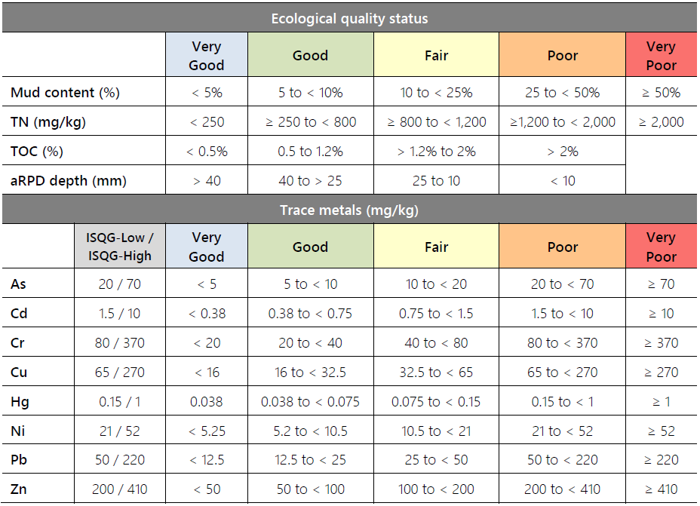

Benthic macrofauna, shellfish size class and habitat plots
Benthic macrofauna were monitored at 10 sites – P1 to P8, Causeway 2 and S43c (Figure 2.1). The sites were sampled on 11 December 2025 (P1, P2, P3), 12 December 2025 (P4, P6), 7 January 2026 (P7, P8, Causeway 2), and 8 January 2026 (P5, S43C). Eight of these sites overlap with the sediment accumulation rate sites, with exception of Causeway 2 and S43c.
At each macrofauna site, a 50m x 20m plot was established which included 10 subplots of 10m x 10m. A sediment core was collected from each of the 10 subplots. Each core was 130mm diameter and 150m deep. Cores were shallower if peat was encountered.
Sediment cores for macrofauna were sieved through a 1mm sieve, preserved in ethanol and send to Earth Sciences NZ (previously NIWA) for processing. Processing consisted of identification and counting of all macrofauna in the sample. Shellfish (bivalves) were measured and counted with 5mm size classes.
In addition, the following measurements were made:
- Oblique photo of the site.
- Photo quadrats to measure algae cover and epifauna as described above.
- Algal biomass measurements as described above.
In previous years, sediment samples were collected at all macrofauna sites – including Causeway 2 and S43c which do not have a sediment plate.

Algal transects
Algae were measured along transects at eight sites (AT1, AT2/P2, AT3, AT4, AT5/P5, AT6, AT7/P7, and AT8/P8). Four of these sites overlapped with sediment plate sites (Figure 2.1).
At each algal transect, algae cover was measured at the start, middle and end of the transect, with 10 replicate measurements at each point. Replicates consisted of a 0.25m² quadrat randomly placed within 10m of the point. A photo was taken of each quadrat and measurements made of percent algal cover and species. Where sites overlapped with sediment plates, the measurements were made in each of the 10 subplots as described above.
Algal biomass was measured at each of the three points along the transect by collecting and weighing all macroalgae in three of the 0.25m² quadrats.

Guidelines for macroalgae
NZETI (2016) adopted the Opportunistic Macroalgal Blooming Tool (OMBT – WFD 2014) with uses several metrics to assess the ecological quality of an estuary. This includes the following metrics:
- % cover on available intertidal habitat (AIH) – with ecological quality ratings of ‘High’, ‘Good’, ‘Moderate’, ‘Poor’ and ‘Bad’ corresponding to thresholds of <5, 15, 25, 75 and >75.
- Affected area (AA) – with ecological quality ratings of ‘High’, ‘Good’, ‘Moderate’, ‘Poor’ and ‘Bad’ corresponding to thresholds of <10, 50, 100, 250 and >250.
- AA/AIH (%) - – with ecological quality ratings of ‘High’, ‘Good’, ‘Moderate’, ‘Poor’ and ‘Bad’ corresponding to thresholds of <5, 15, 50, 75 and >75

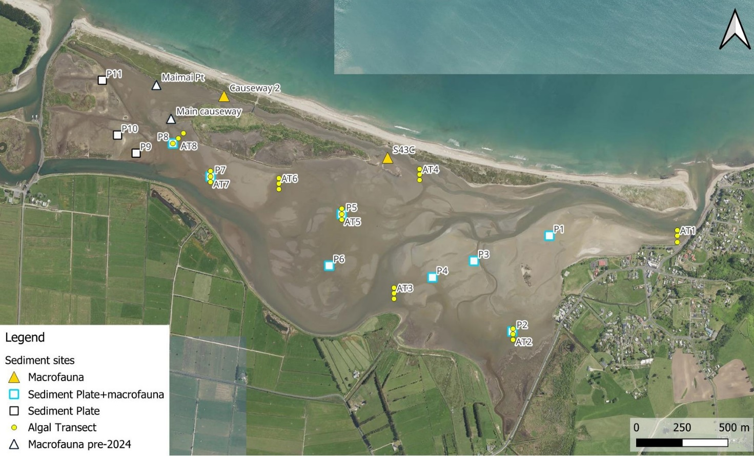
Figure 2.1: Monitoring sites in Maketū estuary for sediment plates, benthic macrofauna, and algae transects. The macrofauna sites at Maimai Pt and Main causeway were not sampled in 2026 but had been previously sampled up to December 2025.

Pipi survey
A pipi survey was undertaken along three transects in the lower Maketū estuary – T1, T2 and T3. The pipi survey was undertaken on 3 February 2026 and 5 March 2026 (Figure 2.2).
Each transect extended across the full channel width which was 120m to 130m. Every 10m along the transect replicate cores were collected within a 2m radius. Along Transect 1, five replicate cores were collected at each point, while along Transects 2 and 3, three replicate cores were collected at each point. All pipi within each core were counted. For Transect 1 and Transect 3, pipi size was measured at every second point within 5mm sized classes. Each core was 130mm diameter and about 150m deep.
Previous pipi surveys in Maketū estuary occurred in 2018 (transects 1 to 4), 2021 (transects 1 to 12), 2022 (transects 1, 6, 7, 8), 2023 (transects 1, 2, 3, 5, 6), and 2024 (transect 1). In previous surveys every second transect along the channel had pipi size measured at every second point along that transect (i.e. transects 1, 3, 5 etc), and 10 replicate cores were collected at each point. Fewer replicates were used in 2026 due to the relative low standard error in past samples when pipi number were low (i.e. mean relative standard error of 9% when >5 pipi per core).
The channels in the lower estuary changed considerably between 2017 and 2022. Restoration of the tidal flows into the Te Pā Ika & Papahikahawai Creek areas from June 2017 to June 2019 increased the tidal volume, which caused scouring and widening of the main channel to accommodate the extra tidal volume. Increase of river flow with full commissioning in 2021 has also causing changes in the morphology of the estuary entrance including changes in the flood tide delta. This dynamic nature of the estuary means that there can be high variability in precisely where the peak density of pipi occur from year to year.
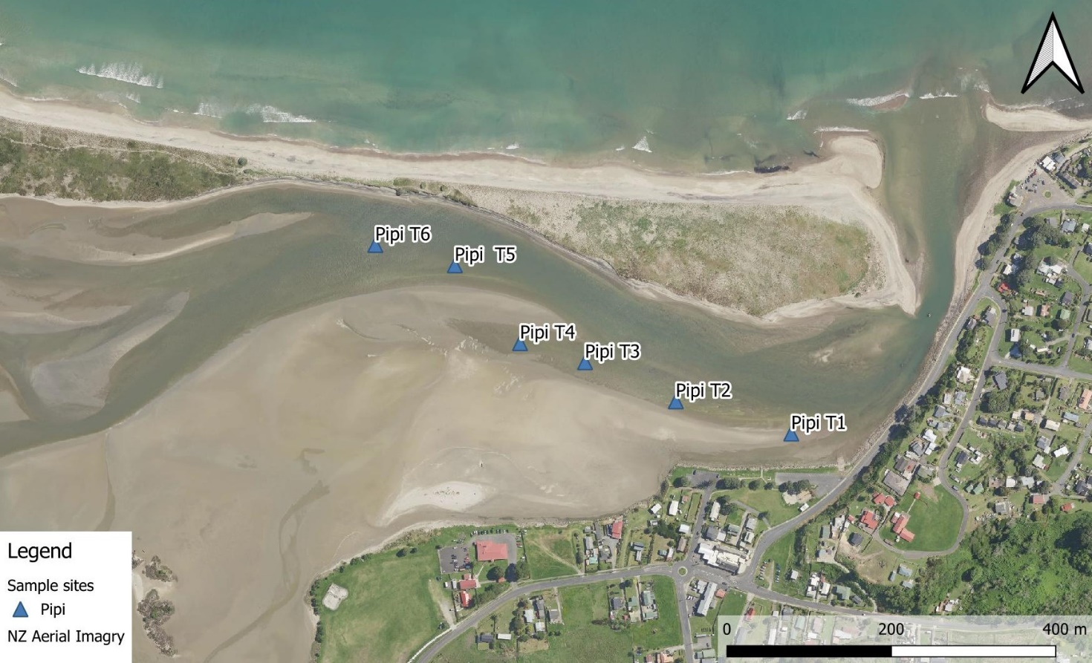
Figure 2.2: Pipi survey transects in lower Maketū estuary. Transects 1, 2 and 3 were surveyed in March 2026.

Data Loggers for temperature, dissolved oxygen and salinity
Water quality data loggers were deployed at two sites – WQ Site 5 and 150m downstream of Causeway 2 at the footbridge (Figure 2.3). The logger could not be placed at the Causeway 2 site as in previous years because soft mud made access to deep water section of the channel impractical. The loggers were installed for four weeks from 3 February 2026 to 3 March 2026. Loggers were checked on 9 February. No macroalgae or seaweed was observed fowling the loggers during deployment.
Measurements were collected at 10-minute interval for water temperature, dissolved oxygen, percent dissolved oxygen (using Hobo U26 optical dissolved oxygen loggers), and electrical conductivity (EC) (using Hobo U24 loggers). At Site 5, additional loggers were installed to measure water level and atmospheric pressure. The EC logger at the Causeway 2 site failed during deployment making the data unavailable.
The dissolved oxygen loggers were calibrated in water saturated air before and after deployment. In addition, the loggers were cross calibrated in a bucket of water at the end of deployment.

Water quality
Water quality was measured at four sites in the estuary – Site 1 (Fords Cut), Site 5 (Mid-estuary), Site 9 and at Maketū Boat Ramp (Figure 2.4). Samples were collected on three occasions during winter i.e. 21 July 2025, 8 August 2025, and 19 August 2025), and on three occasions during summer (i.e. 1 December 2025, 27 January 2026 and 9 February 2026). The winter samples were collected during low tide, and the summer samples were collected at both low tide and high tide. Sample dates were coordinated to be the same as for shellfish flesh sampling.
Samples were analysed for total nitrogen (TN), nitrate nitrite nitrogen (NNN), total ammoniacal nitrogen (NH4-N), total phosphorus (TP), dissolved reactive phosphorous (DRP), salinity, electrical conductivity (EC), faecal coliform bacteria (FC), E.coli bacteria (ECOLI), enterococci bacteria (ENT), turbidity and total suspended solids (TSS). Field measurements were made of water temperature, specific electrical conductivity (EC), dissolved oxygen (DO) and percent dissolved oxygen (%DO).

Processing of water quality data
Water quality monitoring consistent with the consent condition began in December 2020, although there were many years of sampling at lower frequency prior to 2020, some as part of the estuary water quality NERMN monitoring network.
Water quality data was analysed after filtering the dataset to include only summer samples. Winter sampling was excluded to avoid bias as it only occurred at some sites and seldom occurred pre-diversion. The data was analysed for samples collected since January 2006 which is when analysis of TN began. This provided a dataset with 18 sample occasions during summer before February 2020 (Stage 1 commissioning) and 20 or more sample occasions from stage 1 commissioning to February 2026. The lower estuary sites (site 9 and boat ramp) have had additional sampling, collected at low tide, on occasions when the shellfish sampling did not coincide with the water quality sampling (increasing sampling occasions to 25). For analysis purposes samples from Site 9 North of Marae were grouped with Site 9.
The boat ramp site only has low tide and high tide data since 2016, i.e. 7 sample occasion prior to Feb 2020. However, there is a longer data record collected as part of the NERMN monitoring programme was also analysed.
Outliers occurred for TP on 2 Feb 2016 high tide at site 5 (TP 2.95 mg/L, TN 14 mg/L), and on 25 Jan 2018 mid-tide at site 5 (TP 4.0 mg/L) and Fords Cut (TP 2.9 mg/L)– these were excluded from the analysis.

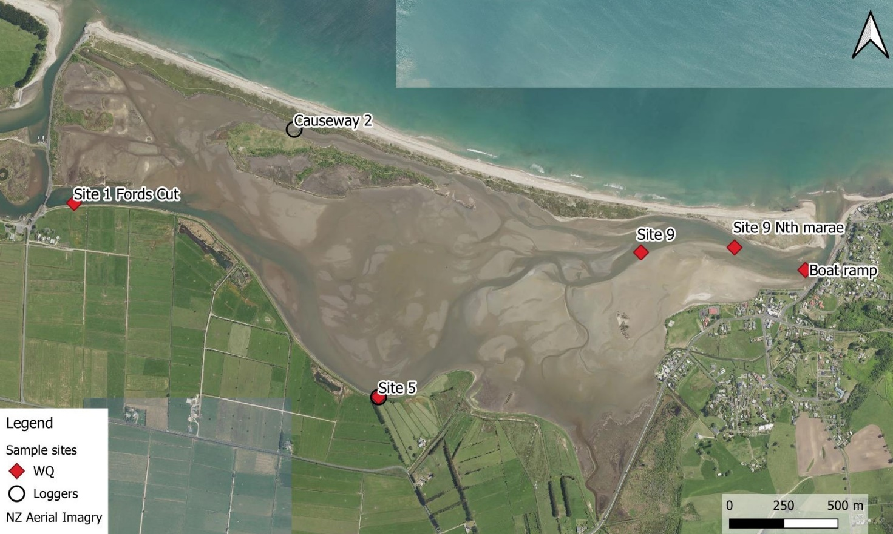
Figure 2.4: Water quality and data logger monitoring sites in Maketū Estuary. Note that the Causeway 2 site monitored for macrofauna is located 150m upstream of where the loggers were placed in 2026.

Microbial water quality and shellfish flesh
Shellfish flesh samples were collected at five sites in the lower Maketū estuary - pipi were collected from sites at Boat Ramp, Site 10 and Site 9 North or Marae, tuangi (i.e. cockle) samples were collected from Site 9 north of marae and Site 9. Water quality samples were collected from the Boat Ramp, Site 9 and Site 9 North of marae (Figure 2.4). The sample dates were integrated with that of water quality sampling collected at low tide.
Shellfish flesh samples were tested for E. coli bacteria, and water samples were tested for E.coli bacteria (ECOLI), faecal coliform bacteria (FC) and enterococci bacteria (ENT).
Shellfish beds are mobile, so the precise location where shellfish were collected may differ between years. During 2025/26 pipi were consistently more abundant lower in the estuary near the entrance, and tuangi (cockle) were more abundant from Site 9 towards the mid-estuary. The cockle beds are often more directly exposed to inflows from the Waitipuia Stream entering the southern part of the estuary.
Consent conditions require the shellfish and water quality samples from the three sampling sites are to be tested for faecal coliform and enterococci bacteria. For shellfish testing, laboratory accredited methods changed for bacterial analysis of shellfish flesh after the 2021 winter sampling, and the enterococci and faecal coliform methods are no longer available. MPI shellfish consumption guidelines (MPI 2024) also now use E.coli bacteria. Fortunately, testing for E. coli bacteria in Maketū Estuary shellfish has also been undertaken since 1992 which correlates strongly with the other two indicators (E. coli / faecal coliform r² = 0.77 for pipi sampling). Pipi and tuangi were also sampled on a number of occasions in winter prior to the compliance requirement in order to build up a comparative baseline from which any changes associated with the increased river flows might be discerned.
As with previous years, cockles in the estuary were small and sparse, which made it challenging to obtain sufficient numbers for sample analysis.

Processing of shellfish data
Shellfish flesh and water quality sampling consistent with the consent condition began in December 2017, and there were many years of sampling at lower frequency prior to 2017.
Water quality data collected as part of the shellfish monitor was analysed as part of the water quality monitoring dataset. Water quality data from ‘Site 9’ and ‘Site 9 North of Marae’ are grouped together in the historical database and we have not attempted to differentiate these sites as part of the analysis in this report.
For analysis purposes, all cockle samples were grouped as if replicates of the same site, and all pipi samples were grouped as if replicates of the same site. Prior analysis found no significant difference in E.coli in pipi flesh collected at the different sites.
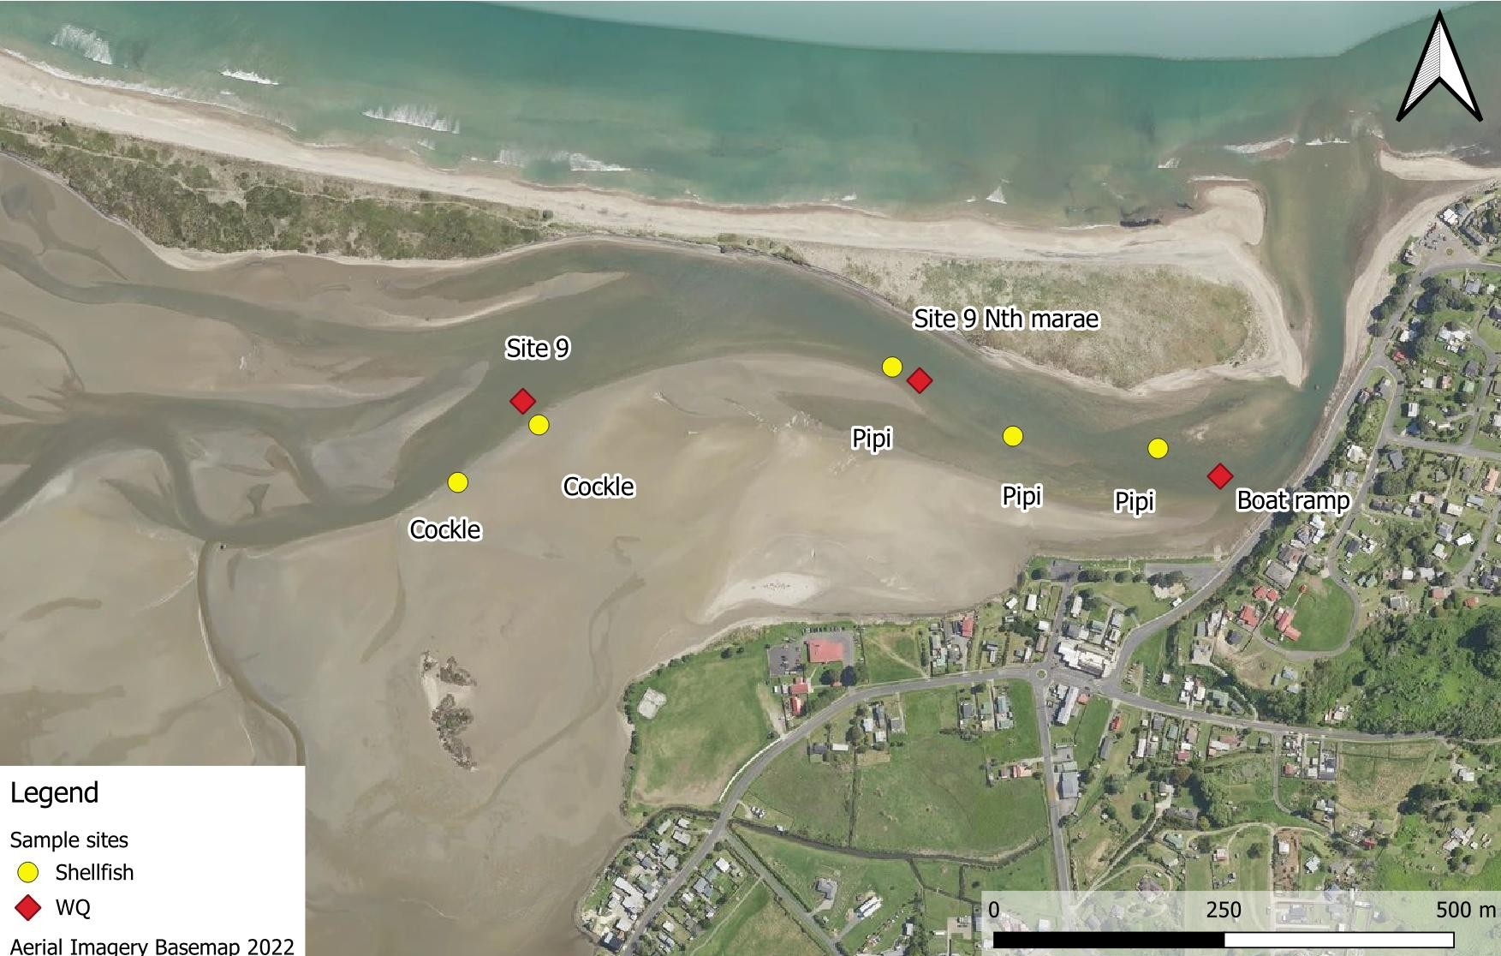
Figure 2.4: Water quality and shellfish microbial monitoring sites in the lower Maketū Estuary. Cockles were generally small and sparse. On some occasions the second cockle replicate was collected downstream of Site 9 rather than upstream of Site 9 as shown on this map.

Trend analysis
The trends were statistically determined using a Mann Kendall trend test performed using R-Studio software and the TimeTrends v8.0 software package (Jowett 2018). This is a non-parametric analysis. Tests were performed using the median of annual time steps.
The Kendall test P-value was used to assess the confidence in the direction of a trend. The lower the P-value the more likely it is that the trend is real (not due to chance). Rather than just accept a P-value to define statistical significance (e.g. P-value <0.05), the likelihood that the trend has a given direction was expressed in a more nuanced way using probabilities.
Summary tables used in this report show the trend confidence as “very likely”, “likely” and “uncertain/unlikely” as described in Table 2.2 below. The tables use arrows to indicate the trend confidence and direction as follows: “very likely increasing” , “likely increasing” , “uncertain” , “likely decreasing” , and “very likely decreasing” .
Table 2.2: Confidence categories used to express the probability of a trend in water quality (from Time Trends and consistent with Stocker et al., 2014, Snelder and Fraser 2018)
Likelihood summary | Likelihood (TimeTrends) | Kendall P-value | Confidence limits (%) | Slope Direction Likelihood
Very Likely | Virtually certain | ≤0.01 | 99 | ≥0.995
Very Likely | Very likely | ≤0.05 | 95 | ≥0.975
Likely | Likely | ≤0.1 | 90 | ≥0.95
Likely | Possible | 0.33 | 0.67 | ≥0.835
Uncertain / Unlikely | About as likely as not | ≤0.67 | 33 | ≥0.665
Uncertain / Unlikely | Unlikely | ≤0.9 | 10 | ≥0.55
Uncertain / Unlikely | Extremely unlikely | ≤0.95 | 5 | ≥0.525
Uncertain / Unlikely | Exceptionally unlikely | 0.99 | 1 | ≥0.505

Non-metric Multidimensional Scaling
Non-metric Multidimensional Scaling (NMDS) was used to visualize patterns of similarity or dissimilarity in macrofauna species composition among sites. All analysis were performed in the R statistical package using the vegan (NMDS, Dissimilarity Indices), indicspecies (Species Importance) and ggplot (to generate plots) packages. The metaMDS analysis was used to complete the NMDS with the following process:
First, the species abundance data was standardized to reduce the influence of extreme values on analyses using Hellinger-transformation. Next, a Bray-Curtis dissimilarity index was generated, which shows how different each observation (i.e., site and date combination) is from one another. The index is presented as a matrix of percentage values corresponding to the dissimilarity between sites, with 0% indicating identical species composition, and 100% indicating no similarities (i.e., no common species). The matrix data was plotted in 2D ordination space with the aim of minimizing the discrepancy between the observed dissimilarities and the distances in the 2D ordination space (i.e., minimizes “stress”). Species labels can be added to show how species contribute to the patterns observed.
The result was an ordination plot where sites are positioned based on their ecological similarities. Sites that are more similar are closer together, while those that are more different are farther apart.
A pairwise PERMANOVA test was conducted to compare the statistical significance between sites with a Betadisper dispersion test to assess variability in within-site variability.

Results

Cover of macroalgae

Broadscale mapping
Broadscale mapping of macroalgae using aerial images shows an increase in macroalgae cover in Maketū Estuary after the diversion of the Kaituna River in 1957 and reclamation of the northwestern part of the estuary between 1964 and 1971. Aerial photos from the summers of 2006/07 and 2013/14 show the highest cover of macroalgae (about 35% of available habitat).
A reduction in macroalgal cover was observed between June 2017 when the first causeway in Papahikahawai Creek was removed and 2021 following full commissioning. Since full commissioning in 2021 the total macroalgae cover in the estuary has been less than 6% of the available habitat, and in 2025/26 it was less than 4% cover (Figure 3.1).
Prior to the re-diversion project large areas of the upper and mid-estuary had dense cover of the macroalgae Gracilaria spp., and Ulva spp., and Papahikahawai lagoon in the northwestern estuary had extensive cover of the cyanobacteria Lingbya sp. and Ulva flexuosa. The macroalgae in Papahikahawai lagoon was largely gone by the summer of 2019/20 following removal of the causeways, and the macroalgal cover in the upper and mid-estuary was dramatically reduced following full commissioning (Figure 3.1, Figure 3.2). In 2014 the metric AA/AIH >75% - corresponding to “Bad”, and in 2025/26 it was 2.4% - corresponding to “Very Good”.
During the summer of 2025/26 macroalgae was scarce. Gracilaria sp. was mostly restricted to newly formed estuary areas on Papahikahawai Island and in Te Pā Ika wetland. Dense macroalgal cover (i.e. >60% cover) was mostly limited to the southern arm of the estuary near Waitipuia Stream and narrow strip along Fords Cut (Figure 3.2).
Seagrass (Zostera sp.) was once dominant in the mid and upper Maketū Estuary, but by 2014 only tiny remnants (c. 40m²) remained on sand flats near Kakaho Island, west of the domain. There was hope that low salinity water grom the Kaituna River re-diversion would assist the expansion of seagrass around Maketū Estuary (Park 2014), however this has not yet eventuated, and seagrass cover remains very sparse (Figure 3.2).
Very few mangroves were present in the estuary, being limited to individuals in the southern estuary.

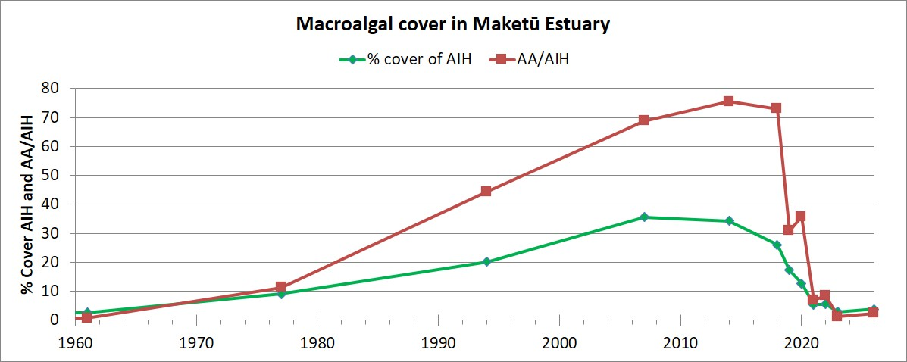
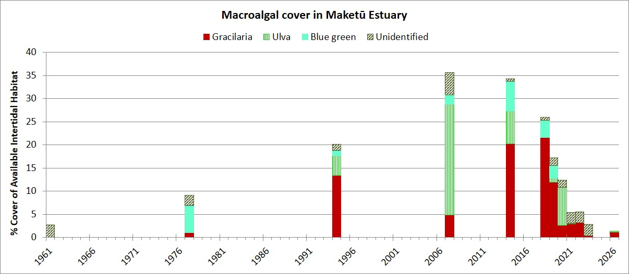
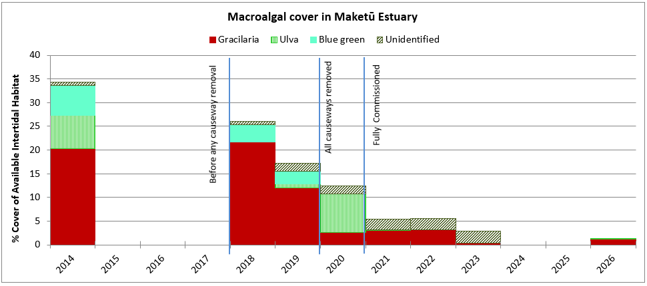
Figure 3.1: Cover of macroalgae in Maketū Estuary since 1961 (top graphs) and the same data since 2014 (lower graph). Percent cover of AIH is weighted according to cover density, AA/AIH shows total % cover regardless of density. Years are hydrological years (i.e. 2025/26 is shown as 2026). The aerial photos used for broadscale mapping in 2021 were taken after full commissioning in February 2021.
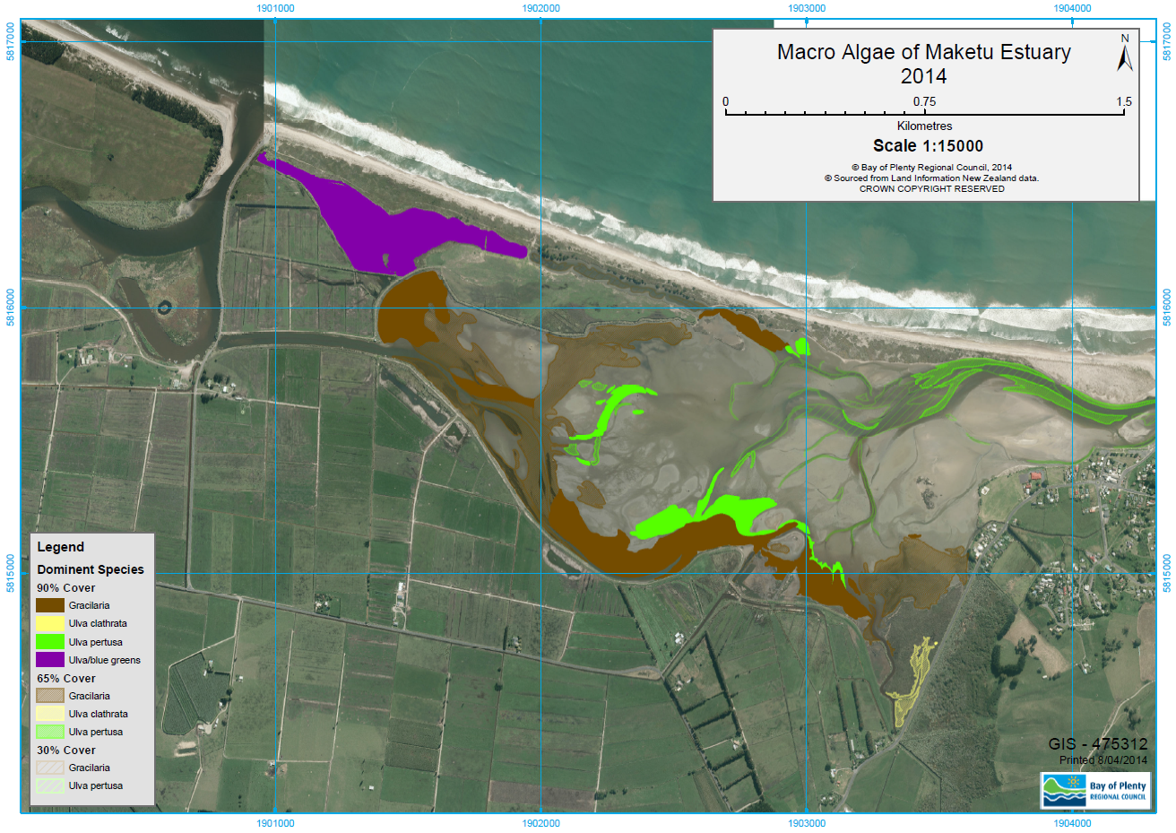
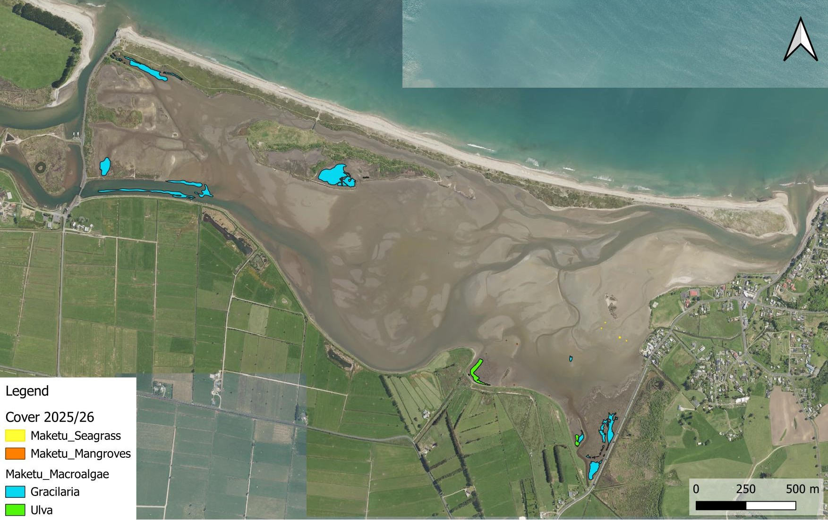
Figure 3.1: Cover of macroalgae in Maketū Estuary in 2014 (top image), and in late 2025 (lower image).

Macroalgae in monitoring plots and algal transects
In 2025/26 macroalgal cover was measured at 13 quadrates associated with either macrofauna or sediment sampling, and eight algal transects. Four of these transects have a point overlapping with a quadrat site, resulting in a total of 17 spatially separated sites.
The algae monitoring at quadrats and along algal transects confirm the results of broadscale mapping, i.e. high macroalgae cover in the estuary prior to 2017/18, a reduction macroalgae in Papahikahawai lagoon following works to remove bunds in this area during 2017/18 to 2018/19, and a reduction macroalgae throughout the main estuary following commissioning of the gates in February 2020 and 2021. Macroalgae cover recorded at quadrats and transects between 2022/23 and 2025/26 have been less than 1% and in 2025/26 the average cover was <0.1% (Figure 3.2). The only sites with high (>30%) macroalgal cover following full commissioning were P11, and Maimai Point – and this was only in in February 2022 (see Appendix 3).
Not surprisingly, a statistical analysis comparing before and after Stage 1 commissioning found “strong evidence” of less macroalgae after commissioning. The individual sites in the main estuary with a statistically significant reduction in macroalgae from before to after Stage 1 commissioning were: AT1, P2, AT2, P3, AT3, P4, AT4, P5, AT6, P7, P8 and AT8.
Although there was little macroalgae cover in the estuary we did observe green microalgae on the mudflats at many sites (e.g. P6, P9, P10). Samples of sediment chlorophyll-a were not collected.
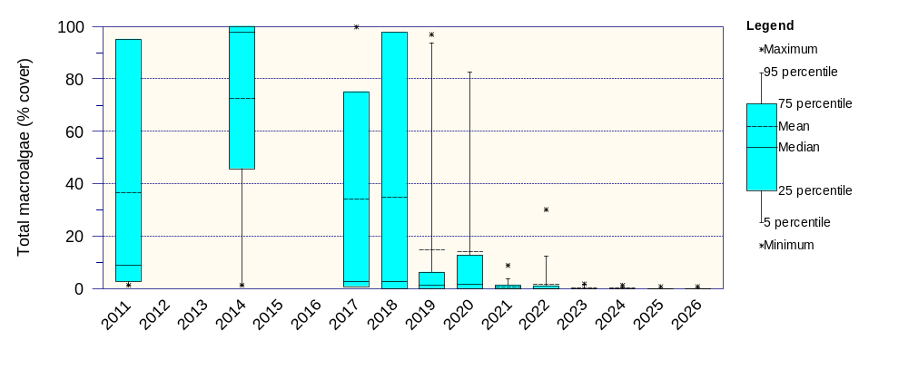
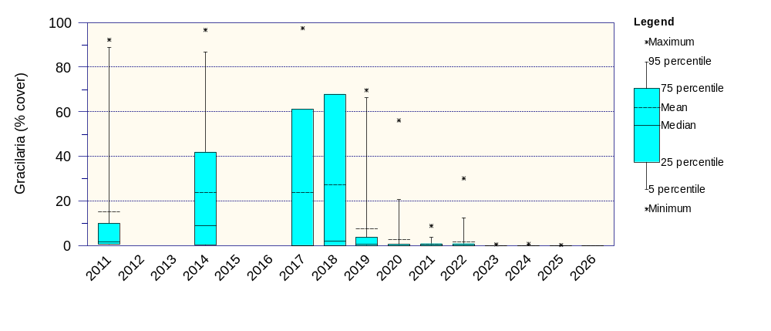
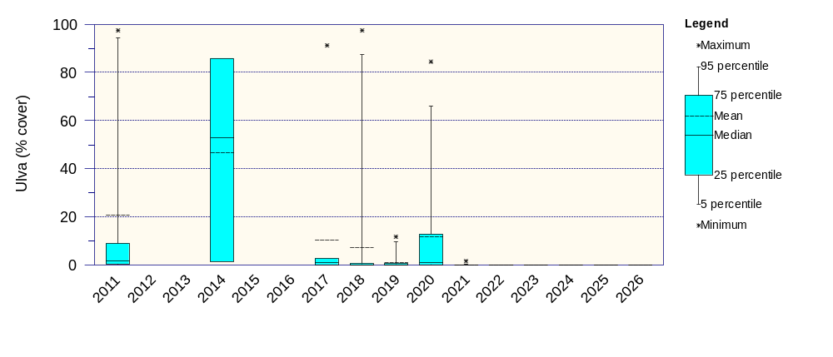
Figure 3.2: Cover of macroalgae in Maketū Estuary measured at quadrates and algal transects at all sites excluding Papahikahawai Lagoon (i.e. Mimi Pt, Causeway2, S37, S38, S43d). Hydrological year 2019 and 2020 were before Stage 1 commissioning but after opening of the causeways. 2022 was after full commissioning of the gates.

Sediment

Sediment Accumulation Rates (SAR)
Sediment Accumulation Rates (SAR) has been measured over sediment plates at 11 locations. Sediment plates were installed in the main estuary (sites P1 to P8) during January 2017, and on Te Pā Ika wetland (sites P9 to P11) during October 2019. Data analysis was undertaken on the average of 10 measurements of sediment depth over the plates. For sites P1 to P4 data was analysed from July 2017 to allow time of the plates to stabilise. Statistical analysis of trends was undertaken using a Mann-Kendall Trend test, and step changes in trends in Table 3.1 were assessed using CUSUM (Cumulative Sum) plots.
There has been a statistically significant trend of sediment accumulation at three sites since plates were installed - P1, P3 and P11. Erosion occurred at sites P2, P4, P6 and P8 (Table 3.1). The sediment accumulation at P11 jumped substantially between 2023 and 2024.
Site P8 in the upper estuary had a dramatic 70mm reduction in sediment after the causeways to Papahikahawai lagoon were removed in mid-2019. Sites P2 (southern estuary) and P7 had reductions around the same time but increased again during 2023 and 2024. Sediment loss at site P6 appeared to stabilise in 2021 following full commissioning.
During the summer of 2022/23 there was a change in the strength and/or direction of sediment accumulation/loss at several site (i.e. P2, P4, P5, P7, P9, P10 and P11). This may have been in response to unusually high river flows that occurred over this period, with associated sediment deposition (Table 3.1, Figure 3.3). In 2026 there was significant erosion observed at multiple sites, including P2, P4, P5, P6, P7, P9, and P10.
Table 3.1: Sediment accumulation rates and statistical trends using Mann-Kendall Trend test. P8 had considerable erosion between July 2019 and January 2020 but has been stable since this time.
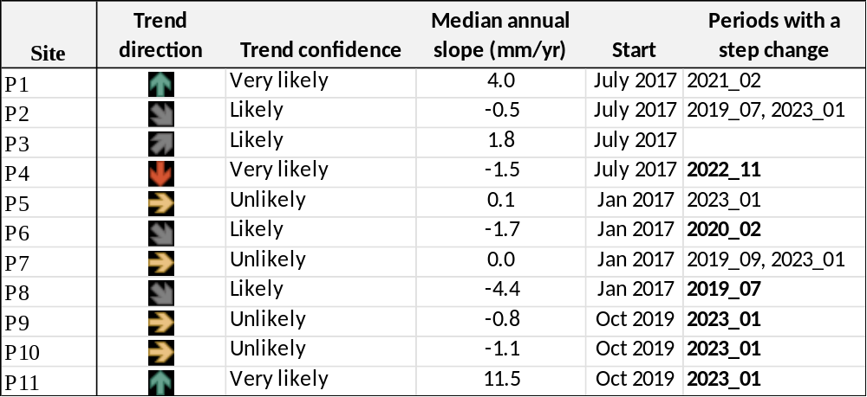

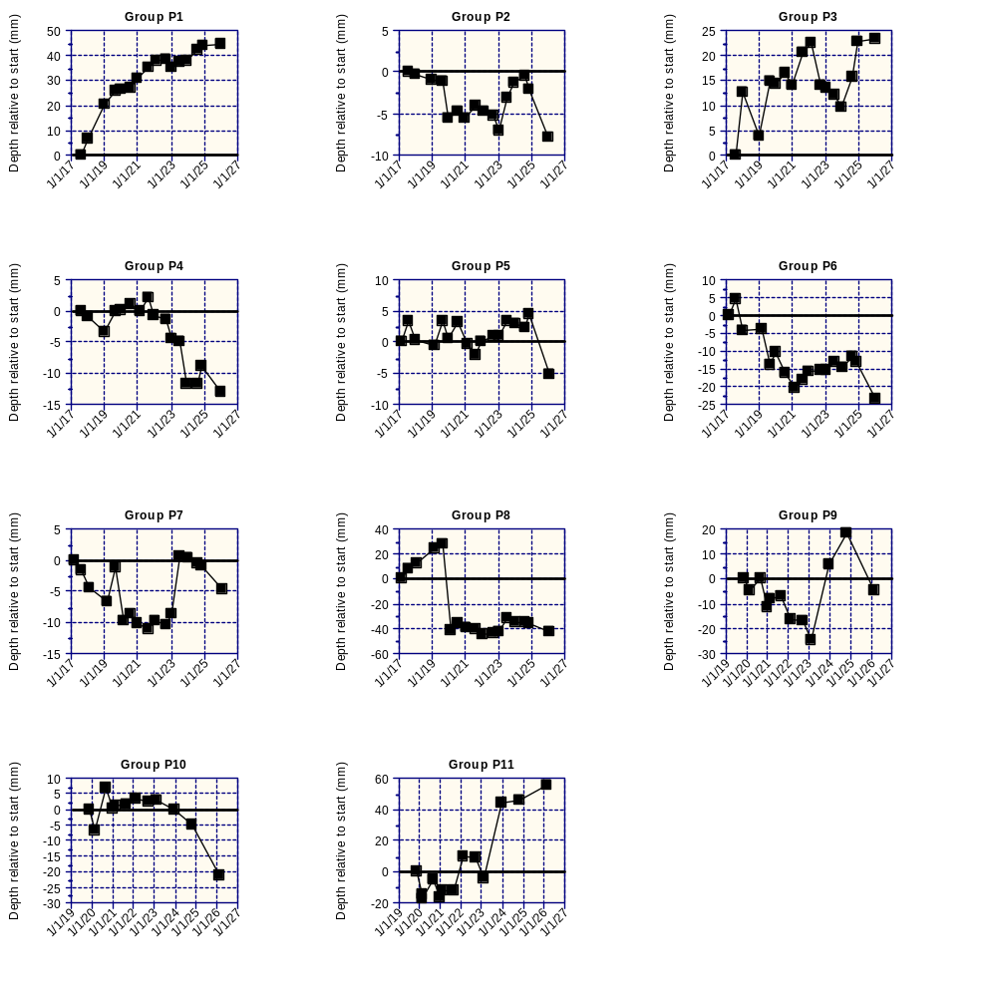
Figure 3.3: Depth of sediment over sediment plates relative to starting depth.

RPD
Apparent Redox Potential Discontinuity (aRPD) was measured at each sediment plate site. Deeper RPD depths indicate that the upper layer of sediment is more oxygenated. Measurements were made as apparent RPD which is a visual observation, and in some sediments requires a level of subjective interpretation which may cause some of the variation between years.
Ecological Quality Status (EQS) bands for RPD depth are: Very Good >40mm, Good 40-25mm, Fair 25-10mm, Poor <10mm (Stevens et al. 2024). Most of the sites in Maketu estuary have RPD depth in the Fair range (Figure 3.4).
Sites that show generally higher RPD (i.e. more oxygenated sediment) since full commissioning of the gates are P2, P4, P5, P6, P7 and P8. For the upper estuary sites P7 and P8, aRPD improved (was deeper) after stage 1 commissioning i.e. by November 2020. However, for the mid-estuary sites improvements in aRPD were not apparent until late 2022 - which was over a year after stage 2 commissioning (Figure 3.4). For site 8 in the upper estuary, while removal of the bunds resulted in loss of muds, the improvements in aRPD did not occur until after Stage 1 commissioning.

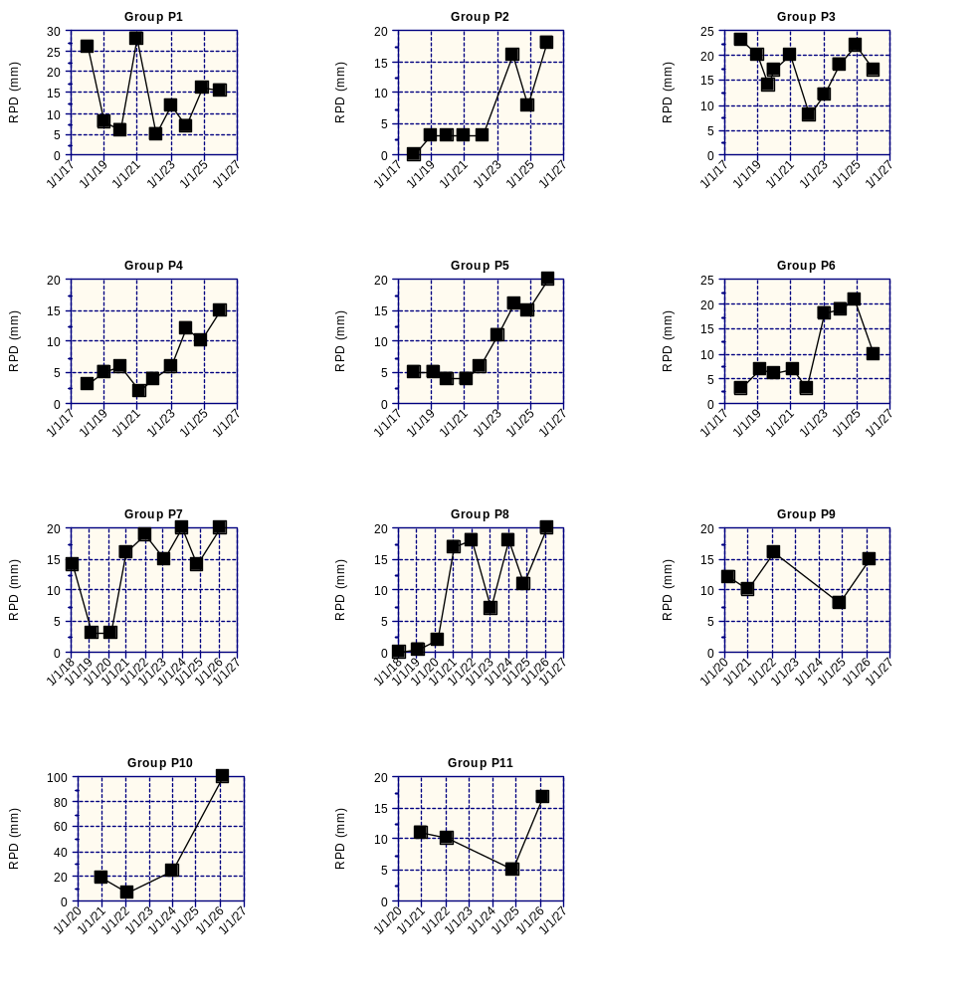
Figure 3.4: Apparent Redox Potential Discontinuity of sediment at each site in Maketū Estuary.

Sediment quality

Percent Mud content
Ecological Quality Status (EQS) bands set for % mud content are: Very Good >5%, Good 5-10%, Fair 10-25%, Poor 25-50%, and Very Poor >50% (Stevens et al. 2024)
Sites in the lower to mid-estuary have relatively little mud, ranking as Good or Fair. However sites in the upper estuary, Papahikahawai channel and southern arm have more mud than the mid-estuary and are mostly classed as ‘Poor, i.e. P2, P5 to P11, S43c, Causeway 2, and Maimai Point (Table 3.2).
Ten sites in Maketū Estuary have had a ‘very likely’ or ‘likely’ increase in mud content since 2012 and a corresponding decrease in percent sand, these were mostly in the mid to lower estuary i.e. Sites P1 to P7, S43C and main causeway. There was a significant decrease in mud at P8, Causeway 2 and Maimai Point, and no significant trend at P9 and P10 (Table 3.3, Figure 3.5).
The sites with the largest increase in mud content were Main Causeway (3.9% mud p.a.), P11 (2.8% mud p.a.), P7 (2.1% mud p.a.), P6 (1.5% mud p.a.) and P2 (1.5% mud p.a.). The sites with the largest decrease in mud content were Causeway 2 (-2.2% mud p.a.) and P8 (-2.0% mud p.a.).

Total Organic Carbon
Ecological Quality Status (EQS) bands set for total organic carbon are: Very Good >0.5%, Good 0.5-1.2%, Fair 1.2-2%, and Poor >2%, (Stevens et al. 2024)
TOC in the surface sediment is low (EQS scoring of ‘good’ or ‘very good’) at most sites in Maketū Estuary. Sites that have had TOC rated as ‘poor’ P10 and P11 – both in the upper estuary. Maimai Point and Main causeway had high TOC (rating ‘poor’) prior to 2020, but TOC have been dramatically lower (‘good’) since the January 2020 sampling (Table 3.2, Figure 3.5).
Ten sites in Maketū Estuary had a decrease in TOC in the sediment. This decrease was particularly evident at sites influenced by removal of the bunds connecting Papahikahawai Island i.e. sites P8, P9, P10, P11, main causeway, Causeway 2 and Maimai Point (Table 3.3, Figure 3.5).
Site P7 had an increase in TOC, mud content, TN, TP and many of the metals. This increase occurred after 2021 and may reflect a redistribution of mud previously located in the upper estuary near P8. Site P3 had a similar increase in TOC, mud content, TN, TP and many of the metals occurring after 2021, but measurements from 2014 were also high.
At most sites changes in TOC and TN were strongly correlated.

Total Nitrogen and Total Phosphorus
At most sites the TN concentration in the sediment indicated “Good” quality. High TN concentrations (Poor quality) were only found at sites P10 and P11, which were farmed prior to the restoration works. Sediment TP had a similar spatial pattern to that of TN, being generally low except for sits P10 and P11. However, the two sites in Papahikahawai channel, S43C and Causeway 2 had the unusual feature of having higher concentrations of sediment TP relative to TN (Table 3.2).
Changes in TN over time closely match changes in TOC. Most sites (10) had a decrease in sediment TN, and only three sites (P1, P3 and P7) had an increase in sediment TN. Only sites, P3, P6, P7 and Causeway 2 had an increase in TP over time (Table 3.3, Figure 3.5).

Sediment metals
At all sites the concentration of metals in the sediment were within ANZG (2018) default guideline values (DGVs) and it within the EQS banks of either Good or Very Good (Table 3.2). However, after adjusting for the fraction of fine sediment (i.e. mud), mercury at site P4 was slightly above the DGV. No trend in mercury was detected at this site.
Table 3.2: Median sediment quality during last 5-years (1 November 2021 to February 2026) in Maketū Estuary. % mud, TOC and TN are shaded according to EQS bands in Stevens et al. (2024). Sediment accumulation rate (SAR) is the average of annual changes.
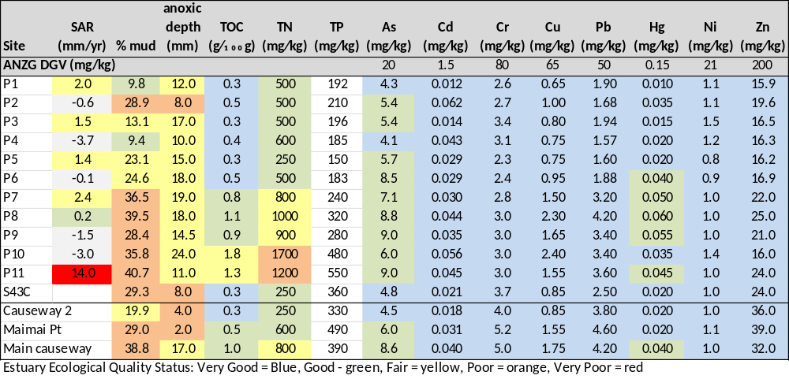
Table 3.3: Trend likelihood for sediment quality variables over period 2012 -2026. Arrows indicate the trend confidence and direction as follows: “very likely increasing” , “likely increasing” , “uncertain” , “likely decreasing” , and “very likely decreasing”
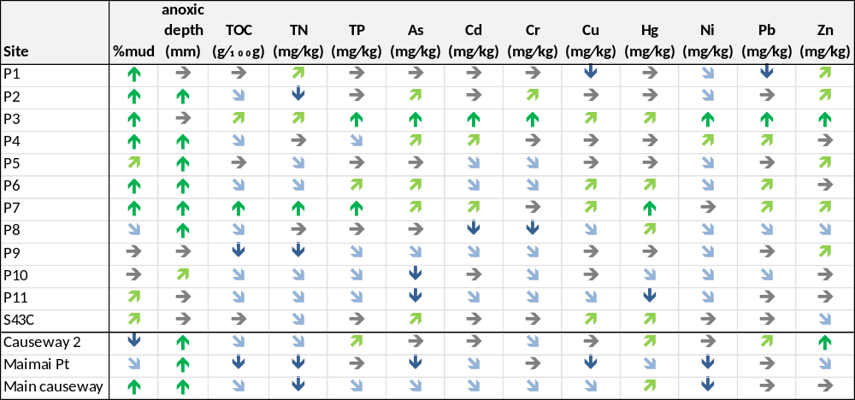
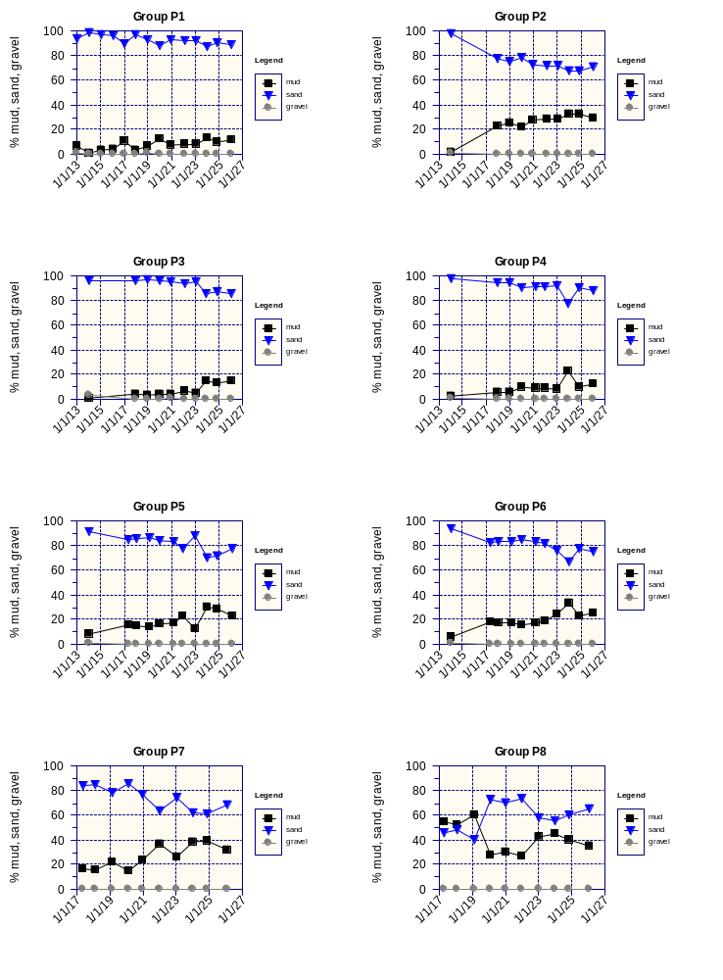
Figure 3.5a: Change in substrate size (% mud, sand and gravel) in Maketū Estuary – main estuary sites.
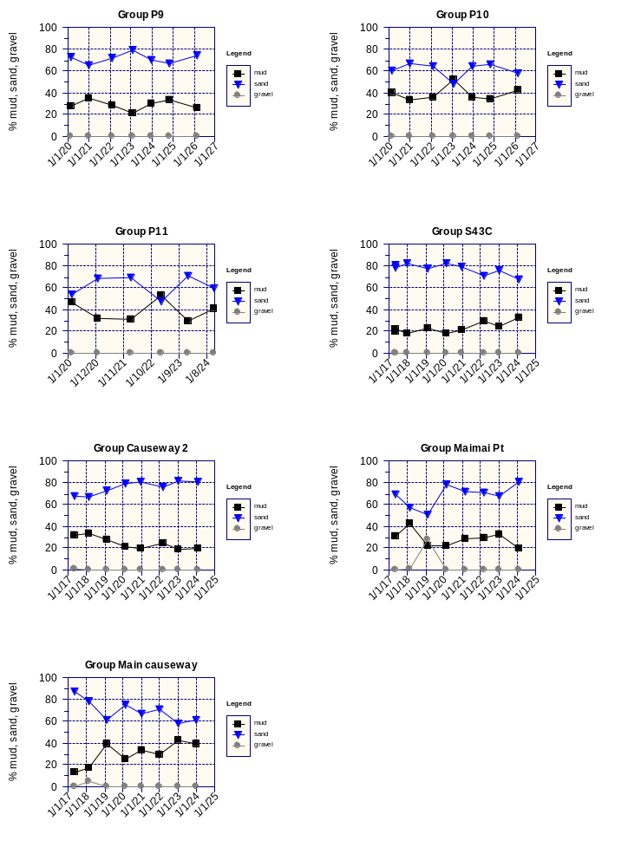
Figure 3.5b: Change in substrate size (% mud, sand and gravel) in Maketū Estuary - Te Pā Ika wetland and Papahikahawai channel sites.
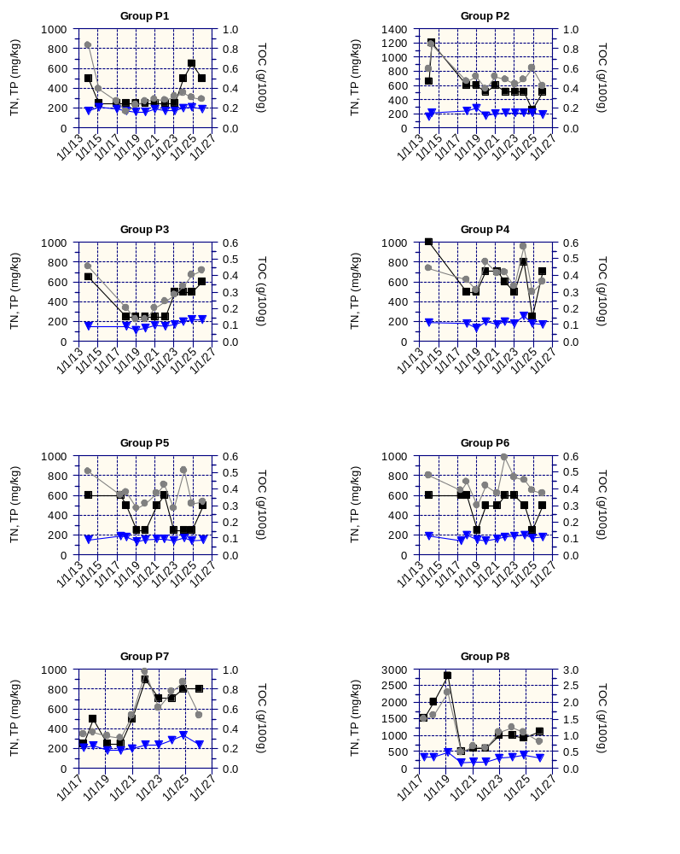
Figure 3.5a: Total organic carbon, nitrogen and phosphorus in Maketū estuary – main estuary sites. TOC, TN and TP represented by grey dots, black squares and blue triangles respectively.

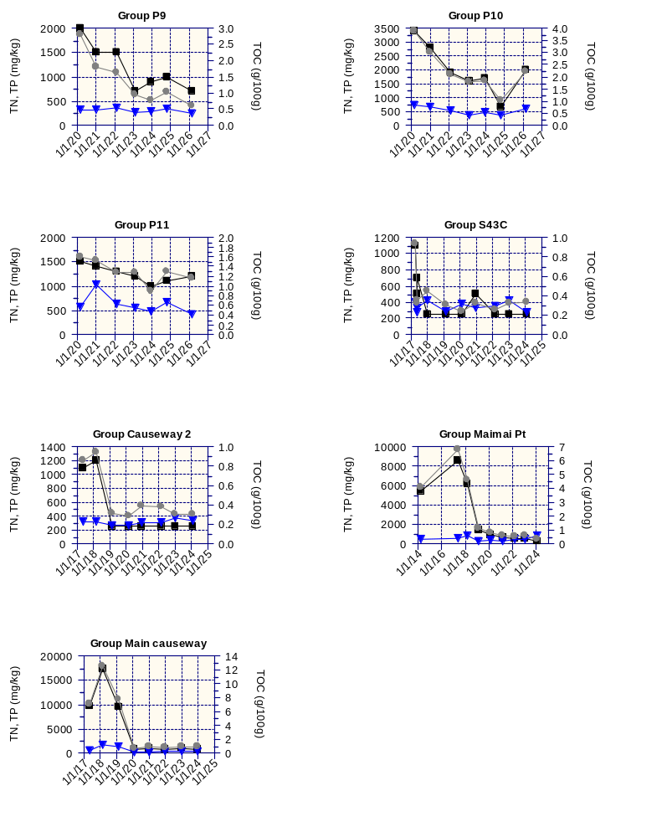
Figure 3.5a: Total organic carbon, nitrogen and phosphorus in Maketū Estuary - Te Pā Ika wetland and Papahikahawai channel sites. TOC, TN and TP represented by grey dots, black squares and blue triangles respectively.

Macrofauna

Macrofauna Diversity
The diversity of macrofauna in each site in Maketū Estuary was assessed using the Shannon-Wiener Diversity Index (H’). The lower-estuary and mid-estuary (sites P1-P6) had higher species diversity than sites in the upper estuary (P7, P8) and the previous Papahikahawai lagoon (sites at Main causeway, Maimai Point, and Causeway 2) (Figure 3.6).
Prior to any of the interventions, removing the causeways associated with Papahikahawai Island (June 2017 to Sept 2018), and the re-diversions in February 2020 and February 2021, the macrofauna diversity in the upper estuary sites was extremely low (near zero). Diversity improved in the 2018 at site P7, Causeway 2 and Maimai Point following removal of the northern causeway and removal of the reclamation bund around the southern margin of Papahikahawai Island. In 2019 diversity improved further at Maimai Point and P7 following removal of the causeway linking Papahikahawai Island to the farmland. Diversity improved at P8 and Main Causeway site in 2020 which may be a delayed response to opening of the causeway and/or associated with Stage 1 flows.
The step change improvement at sites P8, Causeway 2, Maimai point and Main causeway were all statistically significant (using Kruskal-Wallis test). A Mann-Kendall trend test also found statistically significant improving trends in diversity at sites P2, P7 and P8. The improvement in diversity at P2 is interesting because it in the Southern Estuary and only indirectly affected by increased flow from the re-diversion.

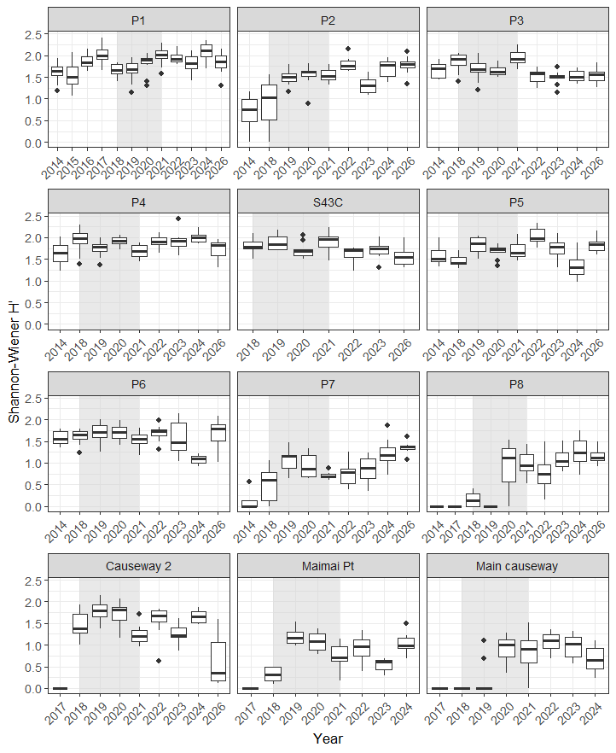
Figure 3.6: Macrofauna diversity at sites in the Maketū Estuary express as the Shannon-Wiener index. The shaded section indicates the years interventions occurred.

Macrofauna community composition
Non-metric Multidimensional Scaling (NMDS) was used to visualize patterns of similarity in macrofauna species composition. The ordination plots show sites (or years) positioned according to their ecological similarities. Sites (or years) that are more similar are closer together, while those that are more different are farther apart. The plots of sites are presented with a colour gradient based on their approximate location in the estuary. Separate plots were made for sites comparing how the macrofauna community composition changes over time with a colour gradient indicating chronological change over time (blue tones prior to 2020 and red tones after).
In 2022 at S43C, a replicate 1 was an extreme outlier with zero cockle, wedge shell, and the polychatetes Aonides oxycephala (paoox) and Scoloplos cylindifer (psccy). This outlier was excluded from the plots but remained part of the analysis. In 2017 at Causeway 2, there was high variability within the plot due to extremely low number of species (range 0 to 3), outliers were excluded from the plots.

Difference in macrofauna composition between sites
In 2025/26 the macrofaunal community composition in Maketū Estuary could be broadly grouped into lower to mid-estuary sites (P1-P5 and S43C) and upper estuary sites (P7, P8 and Causeway 2). The macrofaunal community composition of P6 had high within-site species variability with species composition spanning upper and mid-estuary. (Figure 3.7). Key findings of the analysis were:
- The mid to lower estuary sites (P1 – P5, S43C) shared many species in common such as tuangi cockle Austrovenus stutchburyi (baust), wedge shell Macomona liliana (bteli), and the polychetes Scoloplos cylindifer (psccy) and Aonides oxycephala (paoox).
- P6 had a wide range of species composition that included species form both the upper estuary sites and lower to mid-estuary sites.
- The upper estuary sites (P7, P8 and Causeway 2) are strongly clustered together with distinctly different macrofauna community composition compared to the other sites – characterised by the snails Halopyrgus pupoides (ghapu) and Potamopyrgus estuarinus (gpoes), bivalve Arthritica bifurca (barbi), polychaete Scolecolepides benhami (pscbe), and the amphipod Paracorophium lucasi (cpalu).
- Neighbouring sites had more similar species composition, with strong overlap between P1 and P2, P1 and P3, P2 and P3, P3 and P4, P3 and P5, and P3 and S43C (Figure 3.7)
- Site P2 and P4 were separated by presence of the polychaetes Heteromastus filiformis (phefi) and Aquilaspio aucklandica (paqau) and the bivalve Arthritica bifurca (barbi).
- Site P3 was strongly characterised by the cockle Austrovenus stutchburyi (baust), the barnacle Elminius modestus (celmo), and crab Halicarcinus whitei (chawh) - consistent with its known high cockle abundance.
- P7 had polychaete worms Ceratonereis sp (pcesp), Boccardiella magniovata (pboma), and Microspio maori (pmima) as its top indicators — distinct polychaete taxa not found in abundance elsewhere and not recorded prior to 2026. P8 was separated from P7 by the amphipods Paracorophium excavatum (capex), and Melita awa (cmeaw)). Causeway 2 was defined by snails Potamopyrgus estuarinus (gpoes) and the mud snail tītiko / Amphibola crenata (gamcr).

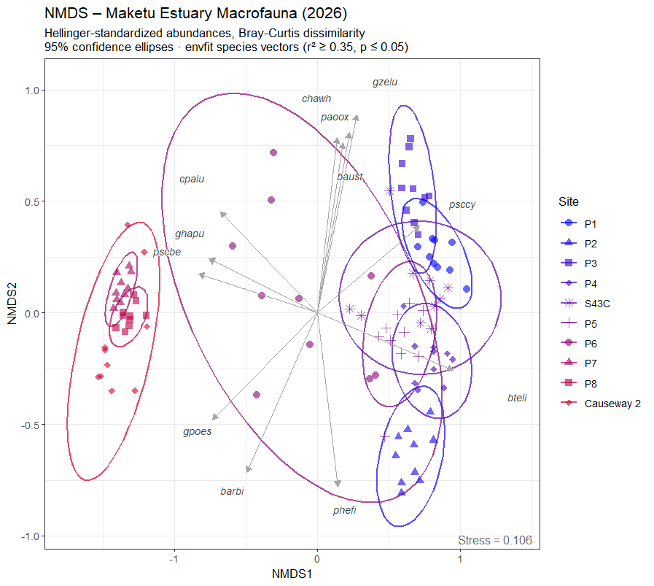
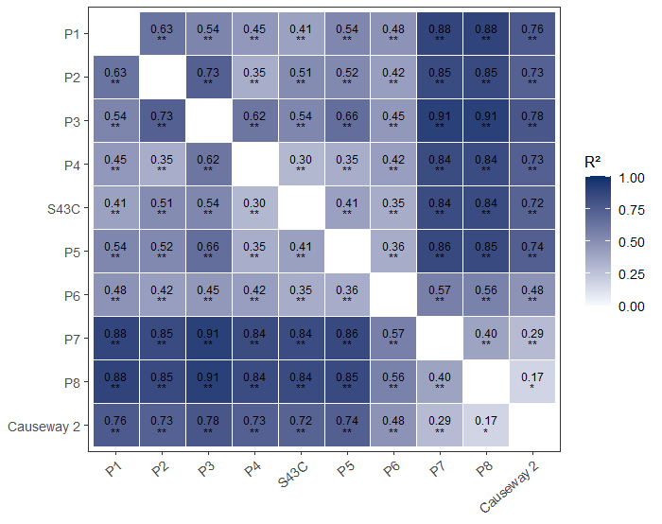
Figure 3.7: NMDS plots of macrofauna composition at sites in Maketū Estuary during 2026 sampling (top plot) and heatmap of the pairwise PERMANOVA test (lower plot).

Changes in macrofauna over time
Macrofauna species composition differed between most years at most sites (Figure 3.8); however, the magnitude of change differed between sites. A Permutational Multivariate Analysis of Variance (using adons2 test in R) was used to test whether the community composition differed across years. This found the variation explained by difference between years was small (R² <10%) for sites P1, P4, and S43C, moderate (R² 10%-20%) for sites P5, Causeway 2 and Main Causeway, and strong (R² 20%-30%) for P7, P6, P3, P2 and Maimai Pt; and strongest (42%) for P8. These shifts (and overall R² values) are clearly seen in Figure 3.8. A heatmap of the pairwise (post-hoc) PERMANOVA per site which shows which individual years differ is in Appendix 5.
Site P8 had zero species in 2014, 2017 and 2019, Main Causeway had zero species in 2017 and 2018, and Maimai Point has no species in 2017. The PERMANOVA test does not account for years with zero species present, so will under-estimate the strength of change in macrofauna composition that has occurred at site P8, Main Causeway and Maimai Point.
At site P8 the change macrofauna community structure reflected a shift from having no species in 2014-2017, arrival of the polychaetes Perinereis nuntia var vallata (ppenu) and Scolecolepides benhami (pscbe) in 2018-2019, arrival of Paracorophium lucasi (cpalu) in 2020, arrival of snails Potamopyrgus estuarinus (gpoes) and Halopyrgus pupoides (ghapu) in 2023, and most recently in 2026 the arrival of polychaete Ceratonereis sp. (pcesp), isopod Exosphaeroma planulum (spp A) (cexpl), bivalve Arthritica bifurca (barbi) and pipi Paphies australis (bpaau).
It is interesting to note that the macrofauna composition at S43C was extremely stable between years – dominated by cockle Austrovenus stutchburyi (baust), wedgeshell Tellina liliana (bteli), and the polychaetes Scoloplos cylindiferm (pssccy) and Aonides oxycephala (paoox).
Although mud the content of sediment has increased at many of the sites in Maketū Estuary, there is no indication of adverse effects on the macrofaunal community. Macrofaunal diversity has remained stable or increase in the mid to lower estuary. Sand-preferring bivalves wedgeshell (M. Liliana) and tuangi (A. stutchburyi) had stable or increasing trends at several sites. Ho et al. (2026) also found that the mud tolerant species, the polychaetes Heteromastus filiformis, Scoloplos benhami and Nicon aestuariensis, as well as the gastropod Z. lutulentus (hornshell) showed a significant or near-significant decline at P1, P5 and P6, suggesting that current sediment conditions are acceptable at these sites.
The laboratory used to identify macrofauna in the sediment samples was changed in 2026, and it is possible this change could account for some differences in species composition in 2026 compared to previous years (e.g. at P7, P8 and Causeway 2).

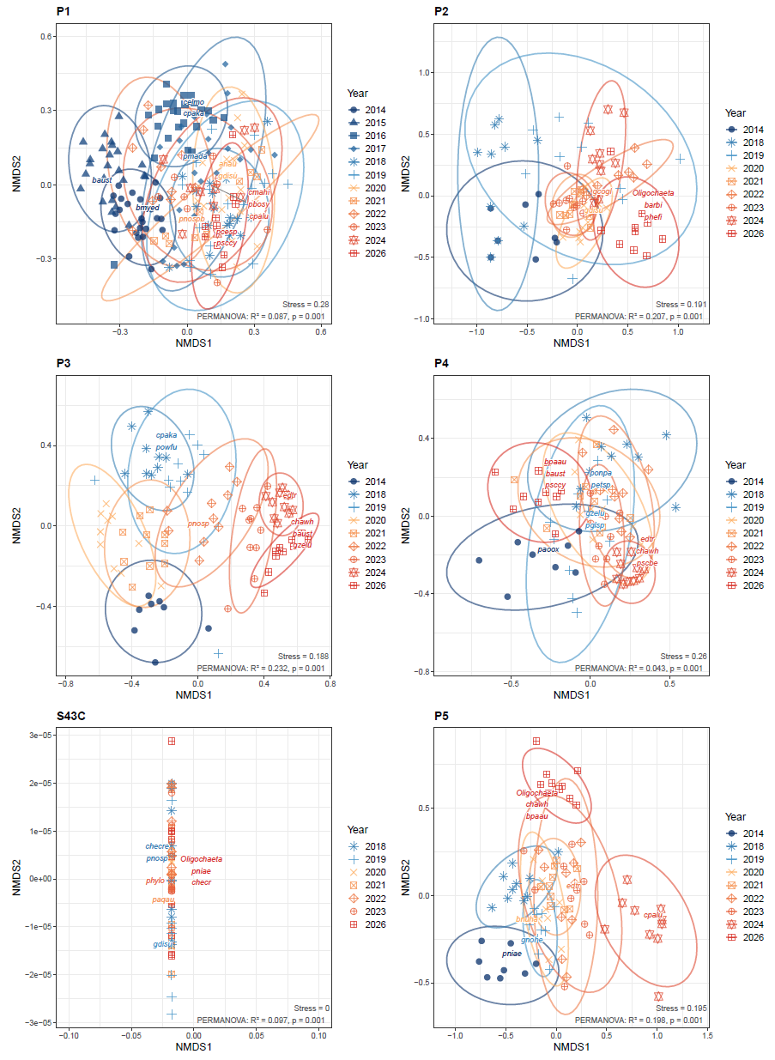
Figure 3.8a: NMDS plots showing change in macrofauna composition between years for each site in Maketū Estuary.
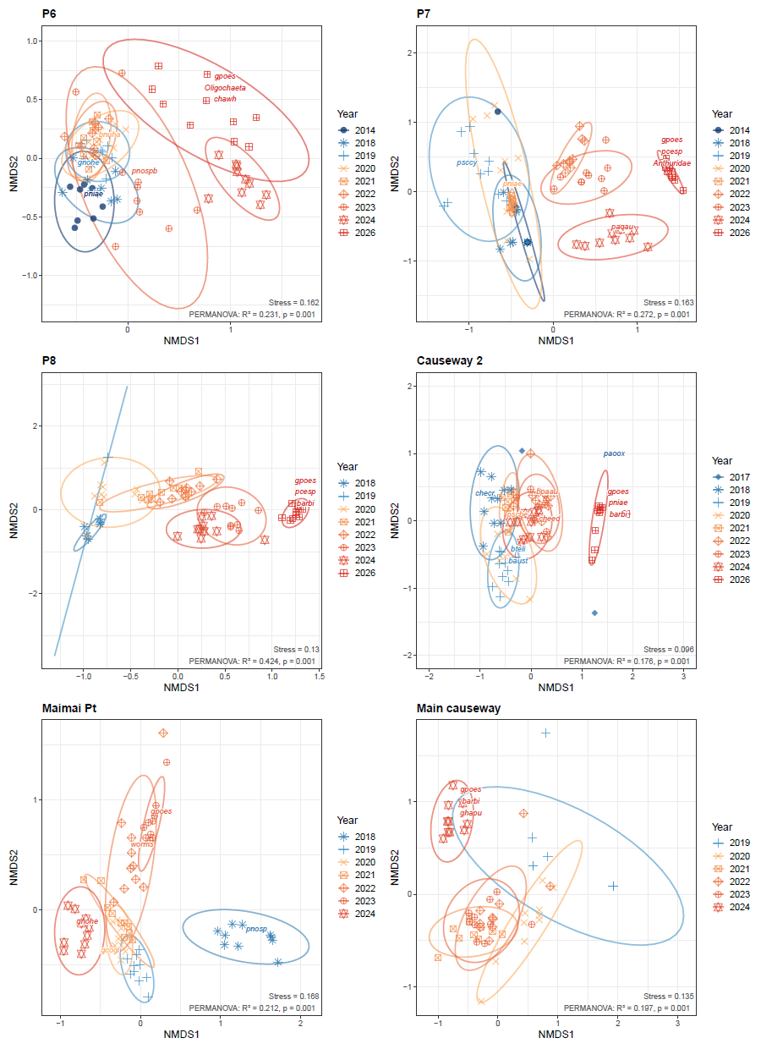
Figure 3.8b: NMDS plots showing change in macrofauna composition between years for each site in Maketū estuary. Site P8 had zero species in 2014, 2017 and 2019, and Main Causeway had zero species in 2017 and 2018.

Shellfish abundance and size class
This sub-section discusses the results of shellfish indicator species – tuangi, hanikura and pipi sampled as part of the macrofaunal monitoring plots in the Maketū estuary. Each of these bivalves prefer sandy substrate rather than mud – which explains them being typically in low abundance or absent from the upper estuary. The results of pipi surveys in the lower estuary are discussed in the following section.

Cockle / Tuangi
P3 had dramatically more tuangi/cockles (median 7875 per m²) than all other sites. S43C is significantly higher than P2 (median 1168/m² and 226/m² respectively). Sites P7, P8 and Causeway 2 all had near zero cockles. The remaining sites (P1, P4, S43C, P5, P6) are broadly similar to one another (median range 641/m² to 1017/m²) (Figure 3.9).
A Mann-Kendall trend test found a strong significant increase in tuangi abundance at P3 (step increase after 2021) and S43C; and a ‘possible’ increase at sites P2, P4 and P5. P2 had a step increase in tuangi after 2019. Site P1 has had large changes in cockle abundance between years, which may reflect changes in morphology (Figure 3.10).
Size class analysis found most cockle at site P3 (the site with the highest density) were small (i.e. 5-10mm range), but still significant number (c. 1500/m²) in the 10-15mm range. At all sites there were very few cockle larger than 20mm (Figure 3.12).

Wedge shell / Hanikura
Hanikura / wedge shell (Macomona liliana) were found in relatively high density in the lower estuary (i.e. P1, P2, P3 and P4). They were present in moderate density at S43C and P5, but have been consistently scarce or absent in the upper estuary (P6, P7, P8 and Causeway 2). P4 had the highest density (median 1017/m²) and was significantly higher than sites S43C and P5 (both p ≈ 0.001) (Figure 3.9).
A Mann-Kendall trend test found a significant increases in wedge shell abundance at sites P2, P3, P4 and P5; and a ‘possible’ increasing trend at P1. There has been a decrease in abundance at site S43C (Figure 3.11).
At sites P1 to P4, wedge shell had a relatively even distribution of sizes in each size class. At P5 larger wedge shell (>20mm) were more common than smaller wedge shell, but the overall density was still less than at sites P1 to P4 in the lower estuary.

Pipi
Pipi (Paphies australis) were most abundant at site P5 (median 452/m²) but had been absent from this site in all previous surveys. Some pipi were present at sites P3, P4 and P8, and near zero pipi at the other sites. The absence of pipi from site P1, despite being in the lower estuary, likely reflects the distance of the plot from the main channel (Figure 3.9).
For all plots, including P5, the density of pipi was low compared to the pipi density recorded along the pipi transects in the lower estuary (medians of c.2500/m² to 4500/m² for T3 to T1) (see section 3.5). The sites for macrofauna plots do not target pipi habitat as they are all exposed at low tide, while pipi tend to be most abundant within channels and in the lower estuary. The results of pipi surveys are discussed in the following section of this report.
A Mann-Kendall trend test found a significant increase in pipi abundance at P3, and a ‘possible’ increase P4, P5 and P8 driven by more abundant pipi in the 2026 survey.
Where pipi were present at a site, they were predominantly small, i.e. mostly less than 5mm, followed by 5-10mm size range. The small size of pipi likely reflects the plots being located out of the channels and being exposed during low tides.
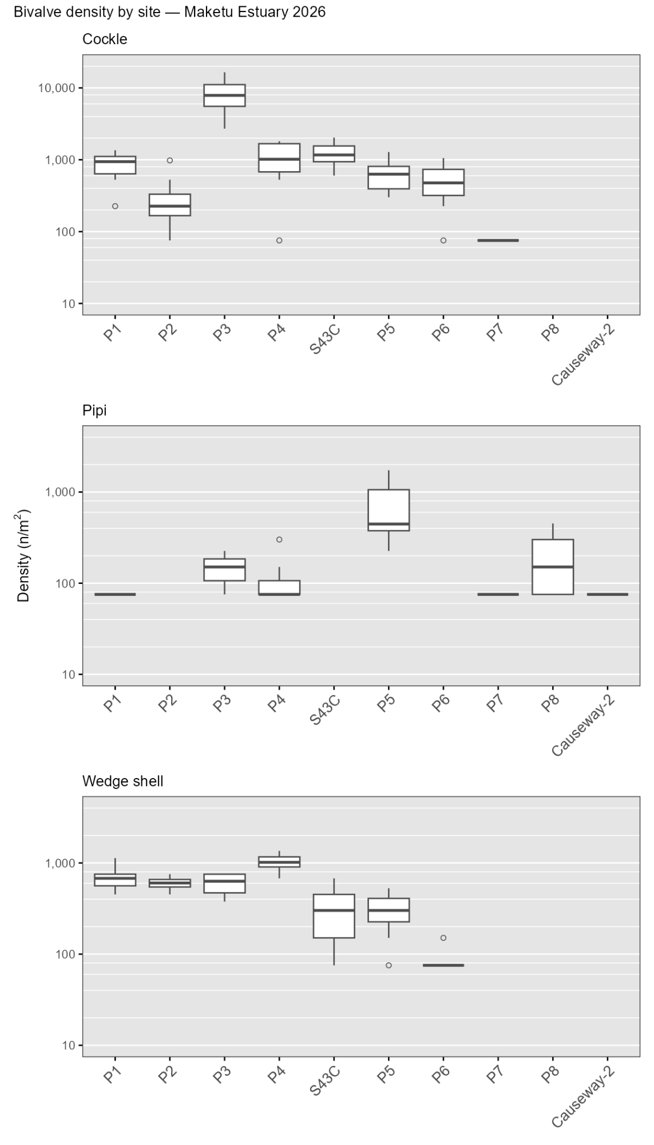
Figure 3.9: Shellfish abundance in 2026 from 10 cores at each site. Note density of 75/m² corresponds to a single shellfish in a core.
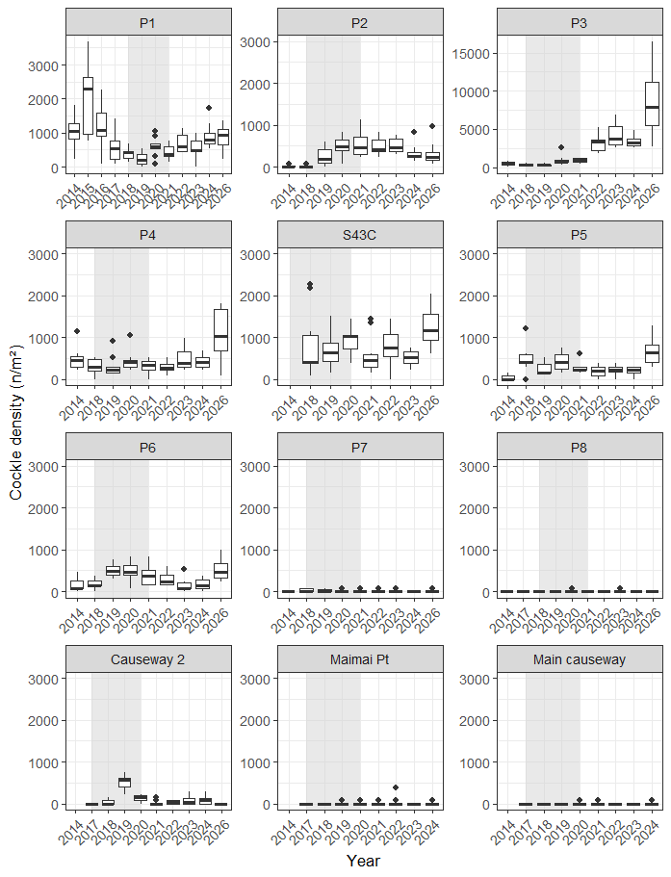
Figure 3.10: Cockle density at sites in the Maketū Estuary. The shaded section indicates the years interventions occurred. Note the much cockle higher abundance and large y-scale for site P3.

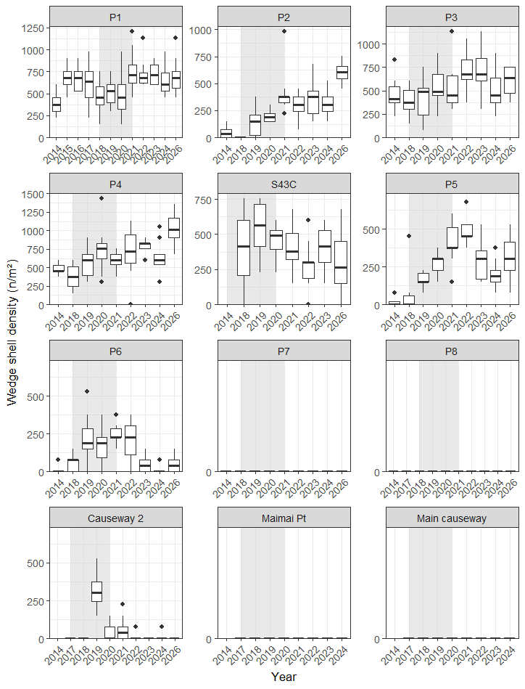
Figure 3.11: Wedge shell density at sites in the Maketū Estuary. The shaded section indicates the years interventions occurred. Note the much cockle higher abundance and large y-scale for site P3.
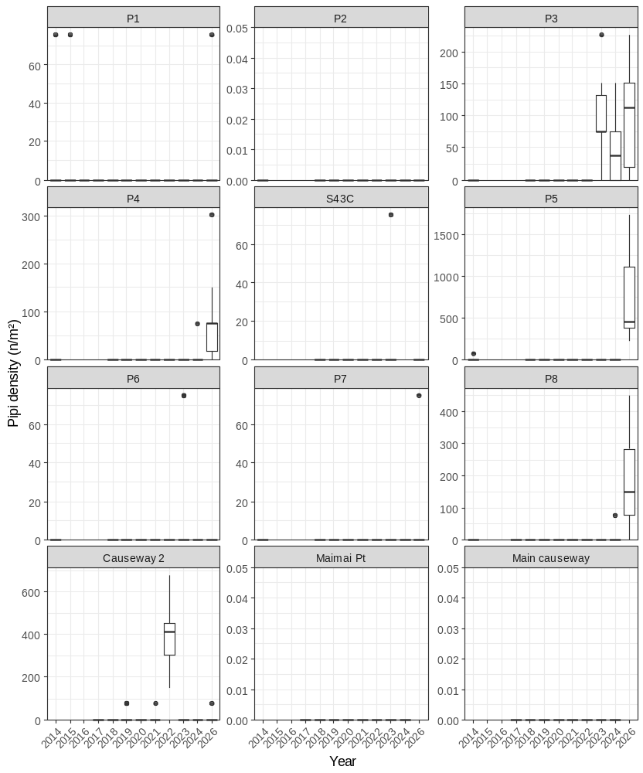
Figure 3.11a: Pipi density at sites in the Maketū Estuary. The shaded section indicates the years interventions occurred. Note the much cockle higher abundance and large y-scale for site P3.

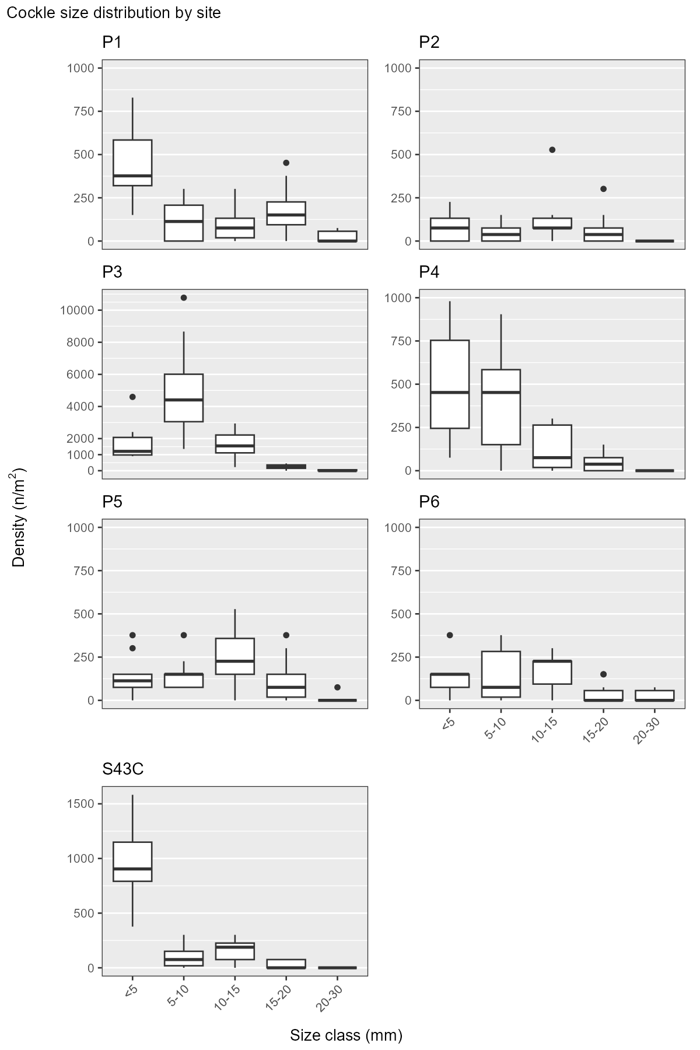
Figure 3.12: Cockle size class distribution in 2026 from 10 cores at each site. Boxes show inter-quartile range and median; whisker 1.5x inter-quartile range. Highest cockle density at site P3. Sites P7, P8 and Causeway 2 excluded due to having no or very scarce cockle present.

Pipi surveys in the lower estuary
Density of pipi was higher in main channel of the estuary with more water flow. In 2026 the main channel in the lower estuary was towards the northern side, corresponding to about plot 40m along transect 1, 50m along transect 2, and 60m along transect 3. Along transect 3 there was very low pipi density between plots at 20m and 60m. This corresponded to an area of soft sand which appears to be recently deposited (Figure 3.13). Movement of the main channel between years causes changes in the density of pipi across the transects (Appendix 5).
Pipi density has increased at transect 1 since the re-diversion. Statistical analysis using an equivalence test found “strong evidence of a practically important difference” when comparing before and after July 2022. Transect 2 also appeared to have higher pipi density compared to previous years, but the difference was not statistically significant (Figure 3.14). The data is consistent with improvements in pipi numbers since the re-diversion.
In 2026, pipi were counted within 5mm size classes at every second plot along T1 and T3. Size class data for previous years was only available as the sum of counts aggregated for each plot along the transect rather than the individual counts per replicate, it also appeared to be based on a subset of replicates. In order to compare between years, the size class data was converted to a percentage fraction of the total count for the plot, and this was multiplied by the density of pipi in each plot.
Transect 1 appeared to have more large pipi (>40mm) in 2024 and 2026 compared to previous years. However, a statistical analysis couldn’t confirm this result because the small number of replicates reduced the power of the test . Transect 3 had a shift towards smaller sized pipi in 2026 compared to previous years. This may reflect changes in the channel at this location or recruitment processes (Figure 3.15, Figure 3.16).
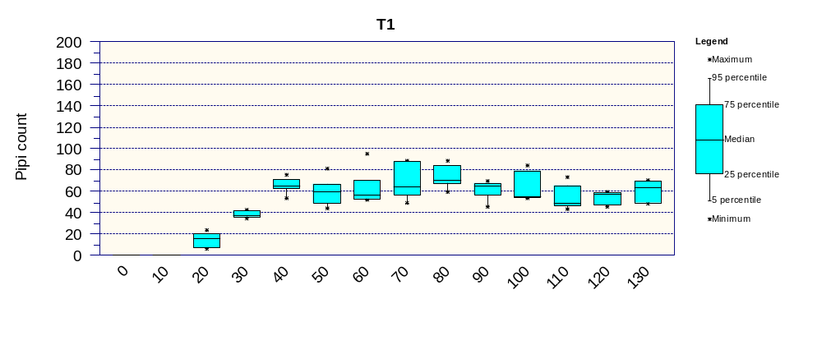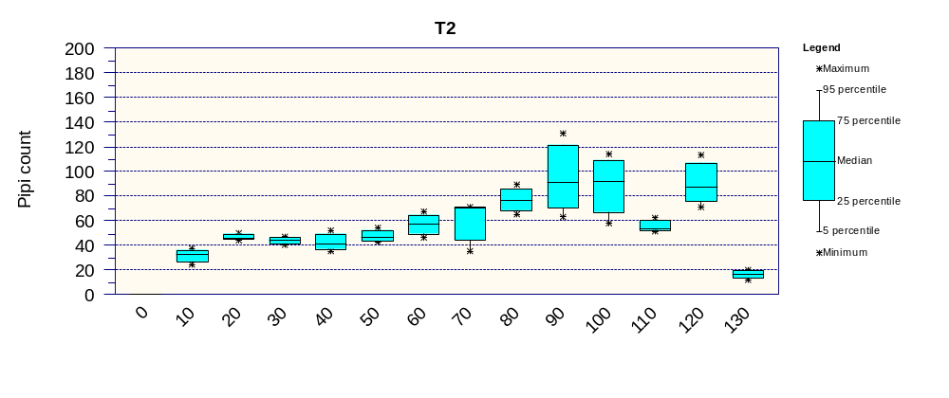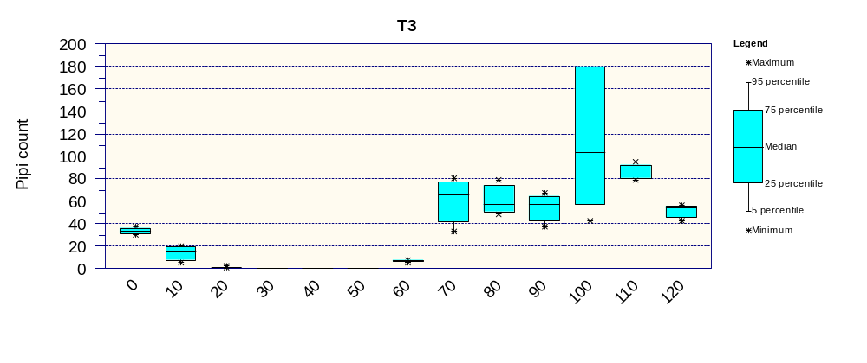
Figure 3.13: Number of pipi at transects T1, T2 and T3 in March 2026. Boxes show the median and inter-quartile range, minimum, and maximum for five replicate samples taken at 10m intervals along transect.

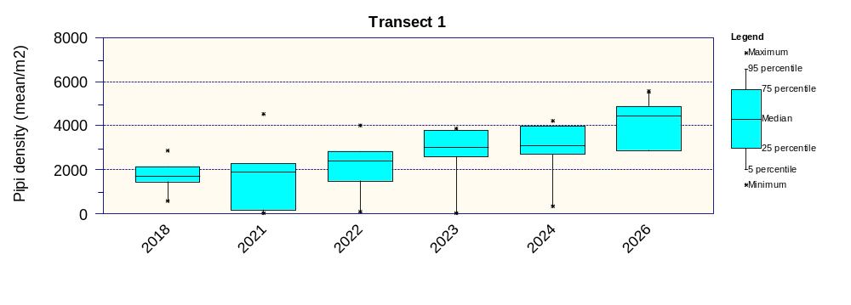
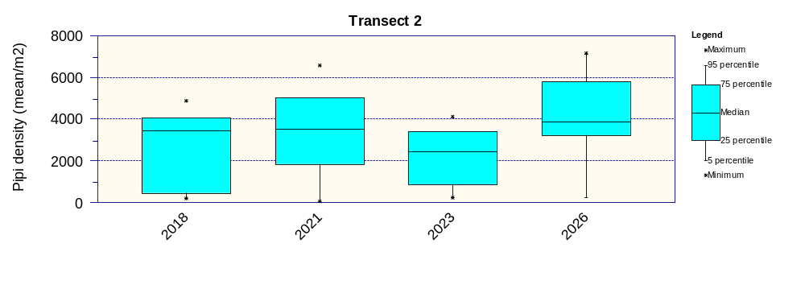
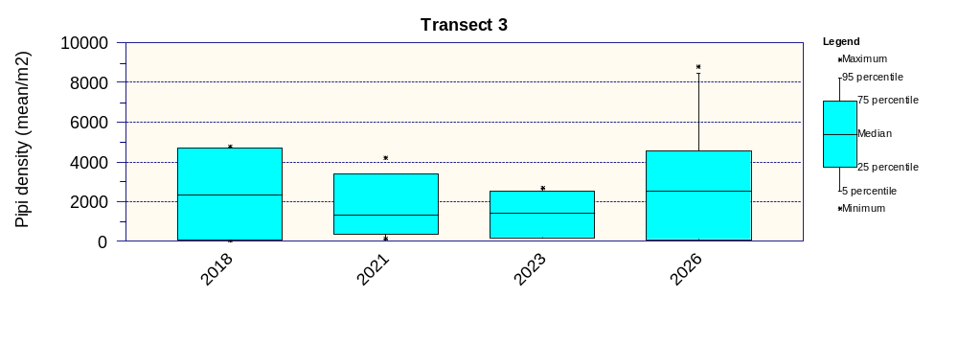
Figure 3.14: Pipi density at transects T1, T2 and T3 during years where surveys have been undertaken since 2018. Boxes show the median and inter-quartile range, minimum, and maximum of mean density in each plot along the transect.

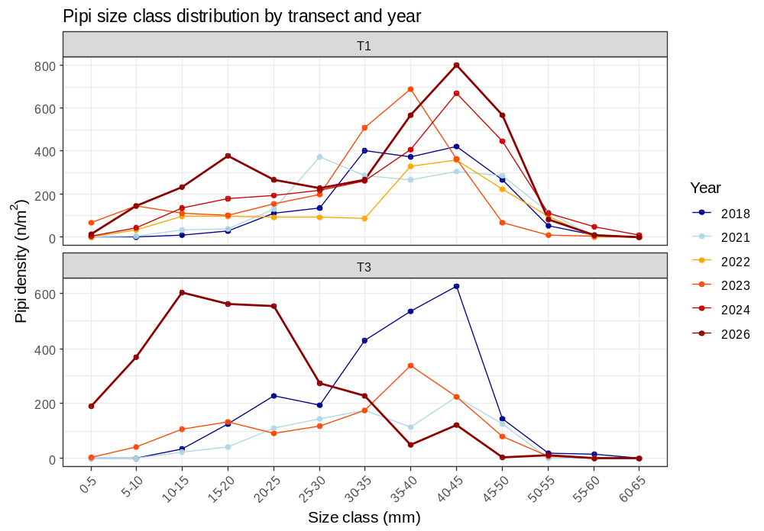
Figure 3.15: Pipi size class distribution at T1 and T3. Note an increase in large pipi >40mm at T1 and a shift towards smaller pipi at T3 which may indicate a recruitment in this location.
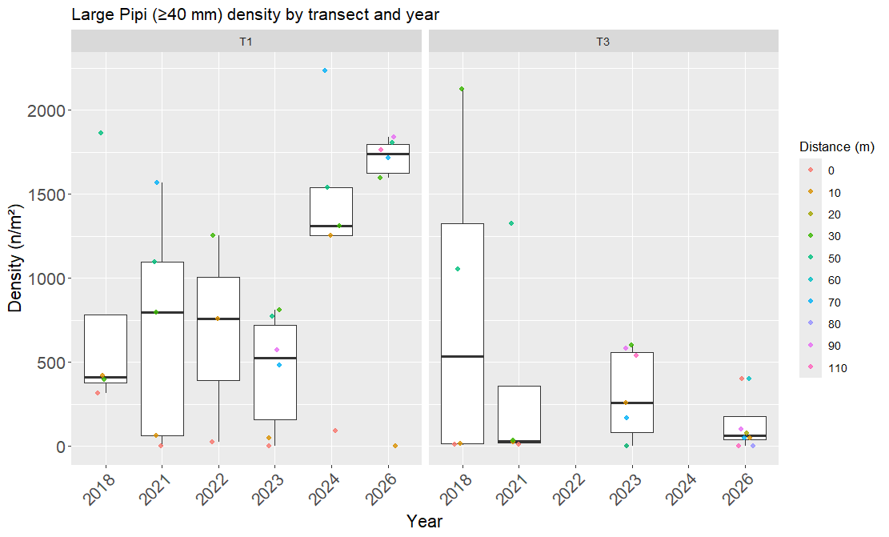
Figure 3.16: Density of large pipi over 40mm at each transect and year. Individual data points are coloured according to their distance along the transect. Large pipi are at lower densities in plots at the start of the transects – further from the channel.

Dissolved oxygen and salinity loggers
The dissolved oxygen (DO) regime in upper Maketū estuary can appear complex due to multiple intersecting processes. Common to most natural waterbodies, the estuary has diurnal fluctuations in DO with the DO concentration increasing during the day due to plant and algae photosynthesis and decreasing a night due to respiration. Overlaid over the diurnal variation is a tidal pattern from oxygenated saline water entering from the entrance at high tide, and a second tidal pattern of oxygenated fresh or brackish water entering from Fords cut. Higher flows in the Kaituna River result in lower salinity / electrical conductivity and smaller diurnal DO fluctuations – this was evident with elevated flows between 13-15 February 2026 (Figure 3.17).
The DO regime in the estuary at Causeway 2 has larger diurnal fluctuations and on average lower DO compared to the main estuary at Site WQ 5. During the 28 days monitoring in February 2026 Site WQ 5 has a mean DO of 94% (7.5mg/L) with a range of 62% to 152% (4.9 – 11.7 mg/L), while Causeway 2 had a mean DO of 88% (7.0 mg/L) with a range of 23% to 203% (1.7 – 14.6 mg/L). The lower DO at the Causeway site is likely due to more oxygen demand exerted by the muddy sediments at this site (Figure 3.18).
The mean DO concentration would place both sites in Band B (Good quality), while the 1-day minimum values would place site WQ 5 in Band C (fair) and the Causeway 2 site in Band D (poor).
A summary of DO and EC logger results since 2017 is provided in Figure 3.19 and in Appendix 4. The graphs show Site WQ5 had:
- Considerably lower salinity following Stage 1 re-diversion.
- Smaller diurnal variation in DO and slightly higher (better) mean DO in the years following re-diversion compared to before the re-diversion.
- Lower salinity during February 2026 – this may reflect changes to the gates operating regime because river flows were generally lower in February 2026 compared to March 2023 which had similar salinity to previous years post-diversion.
- A period of transition in the weeks following Stage 1 re-diversion on 12 February 2020. At site WQ5 daily minimum salinity immediately reduced but DO took weeks to adjust – possibly reflecting time need to flush algae and muds (Appendix 4).
- Smaller diurnal DO fluctuations and lower EC (salinity) during periods with higher flows in the Kaituna River (e.g. during March 2013, 13 February 2026).
Site WQ2 (Causeway 2) had:
- Considerably lower salinity following Stage 1 re-diversion, but wider variation in salinity with more tidal influence from the flow through Ford’s cut.
- Smaller diurnal variation in DO in the years following re-diversion. Note the 2018_11 monitoring is not easily comparable to other sites monitoring in late summer.
- Consistently lower DO compared to the mid-estuary site WQ5.

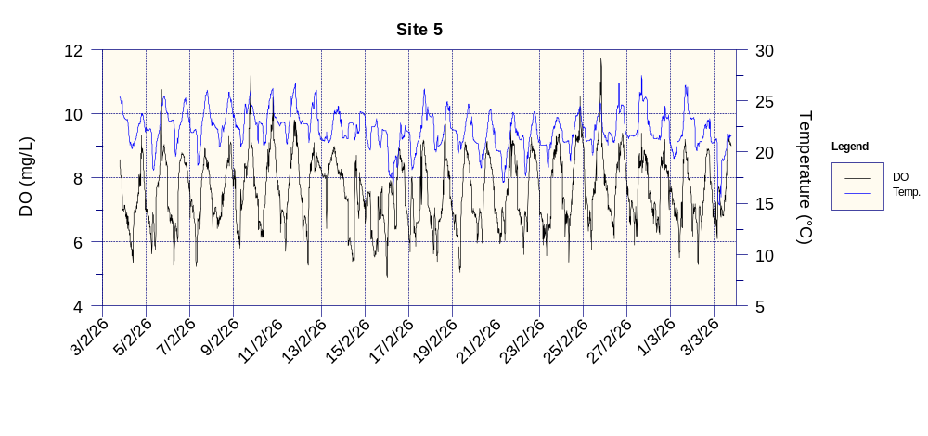
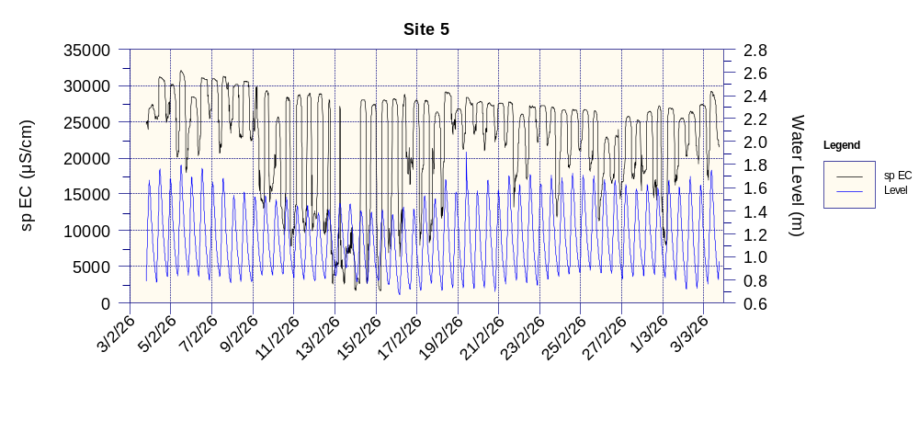
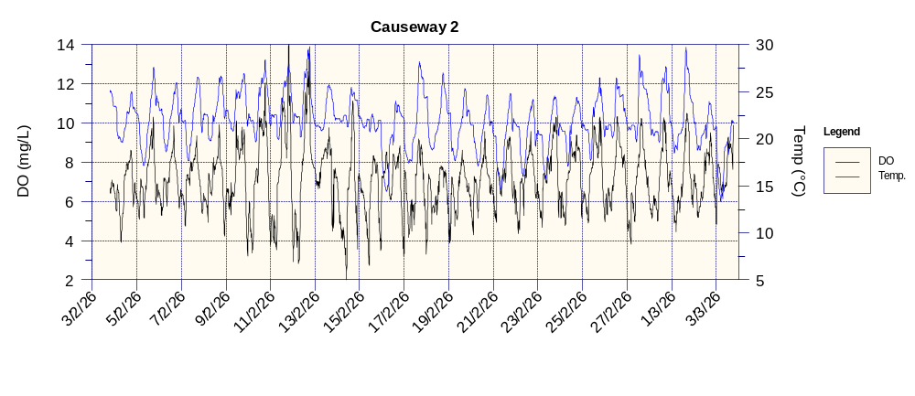
Figure 3.17: Dissolved oxygen, water temperature, electrical conductivity and water level in Maketū Estuary sites WQ 5 and Causeway 2 during February 2026.

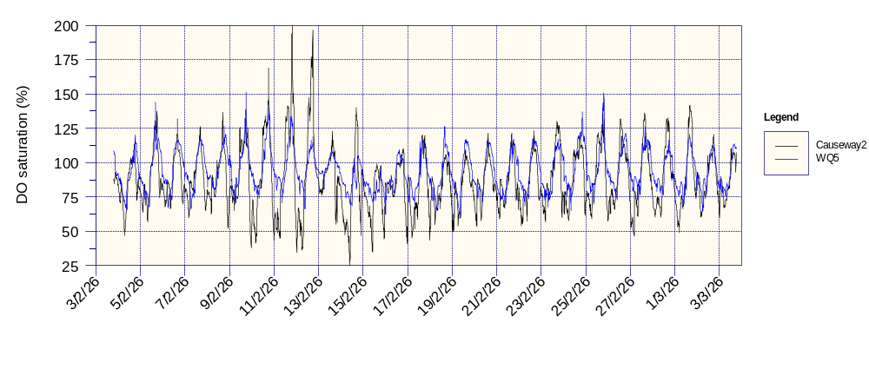
Figure 3.18: Dissolved oxygen in Maketū Estuary sites WQ 5 and Causeway 2 during February 2026. Note generally lower DO and more extreme DO fluctuations at the Causeway site.

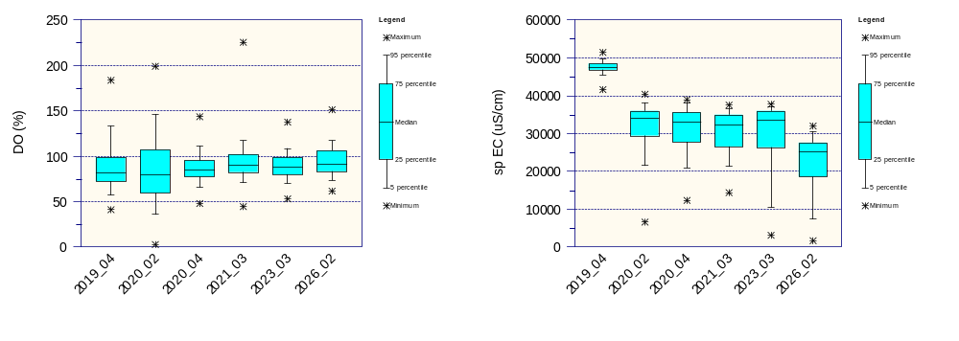
WQ5 Mid-Estuary
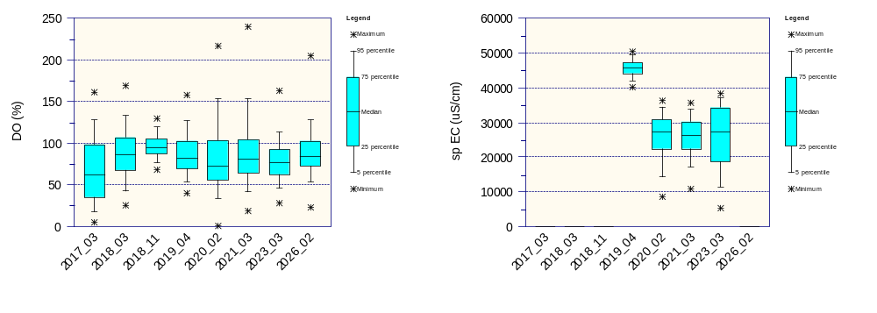
WQ2 Causeway 2
Figure 3.19: Summary dissolved oxygen and electrical conductivity logger in Maketū Estuary at sites WQ 5 (top graph) and Causeway 2 (lower graph). The 2017_03 logging period occurred before causeways were removed and Stage 1 opening of the gates occurred on 12 February 2020 – halfway through the 2020_02 logging period.

Water quality

Effect of tide on water quality
Water quality sampling occurs at low tide, mid-flood tide and high tide. Water quality changes during the tidal cycle with salinity/EC higher at high tide, but the concentration of other variables typically lower at high tide. The effect of tides on water quality is stronger at sites located lower in the estuary. Box plots comparing water quality at low, mid and high tide are in Appendix 6.
A Kruskal-Wallis test with a Dunn post-hoc test found significant differences (p < 0.05) between tides for the following site/variable combinations:
- Fords Cuts for TN, NNN, NH4-N, TP and EC.
- Site 5 for NH4-N and TP.
- Site 9 – differences between tides were significant for all variables.
- Boat Ramp – differences between tides were significant for all variables except ENT.

Change over time
Time series graphs of water quality data for each site (i.e. Fords Cut, Site 5, Site 9 and Boat Ramp) at all tides are provided in Appendix 6. A seasonal Kendall trend test over the period 2010-2026 found:
- A very likely or likely increasing trend for NNN at Site 5, Site 9 and Boat Ramp,
- A likely increase in TN and turbidity at Site 9,
- A likely decrease in NH4-N at Site 5 and Boat Ramp,
- A likely increase in E.coli and decrease in EC at Site 9.
Restricting the analysis to only samples collected at low tide found:
- A very likely or likely increasing trend for NNN at Site 9 and Boat Ramp,
- A likely increasing trend in E.coli at Fords Cut,
- A likely decreasing trend in EC at Site 9 and Boat Ramp, and
- A likely decreasing trend in DRP at Site 5.
Heavy rain just prior to sampling in February 2022 caused elevated concentrations of nutrients and bacteria. Similarly, unusually wet conditions and high river levels during the summer of 2022/23 may have contributed to high nutrient concentrations in the estuary. Nutrient and bacteria concentrations have reduced in subsequent years.
Crawshaw and Dare (2026) reported long-term water quality state and trends in BOP estuaries, including at Maketū Boat Ramp. They found that for the period 2020-2025 Maketū Estuary had relatively low salinity (and EC) and relatively high concentrations of nitrogen (TN, NNN, NH4-N) and phosphorus (TP and DRP) compared to most other BOP estuaries except Waihi Estuary (EC, N and P) and Waiotahi Estuary (EC, N).

Differences between sites
The water quality of Maketū Estuary differs between the upper estuary (Fords cut), mid-estuary (Site 5) and lower estuary (Site 9 and the boat ramp). The water quality at each of these sites is characterised for the period before the Stage 1 re-diversion in Figure 3.20, and for the period after the re-diversion in Figure 3.21. Key spatial patterns apparent in the estuary include:
- Salinity (expressed as EC) is lower and more variable in the upper estuary (Fords Cut and Site 5) compared to lower estuary (Site 9 and BR).
- Microbial indicators of FC, E.coli and ENT were similar at all sites following the re-diversion. Prior to the re-diversion microbial indicators were lower at Site 5 and Site 9 compared to Fords Cut.
- TN and NNN are considerably higher in the upper estuary compared to the lower estuary.
- NH4-N had no significant difference between sites before the re-diversion, but after the re-diversion there was significantly less NH4-N at Fords Cut compared to Site 5 and Site 9.
- TP or DRP had no significant difference in between sites either before or after the re-diversion.

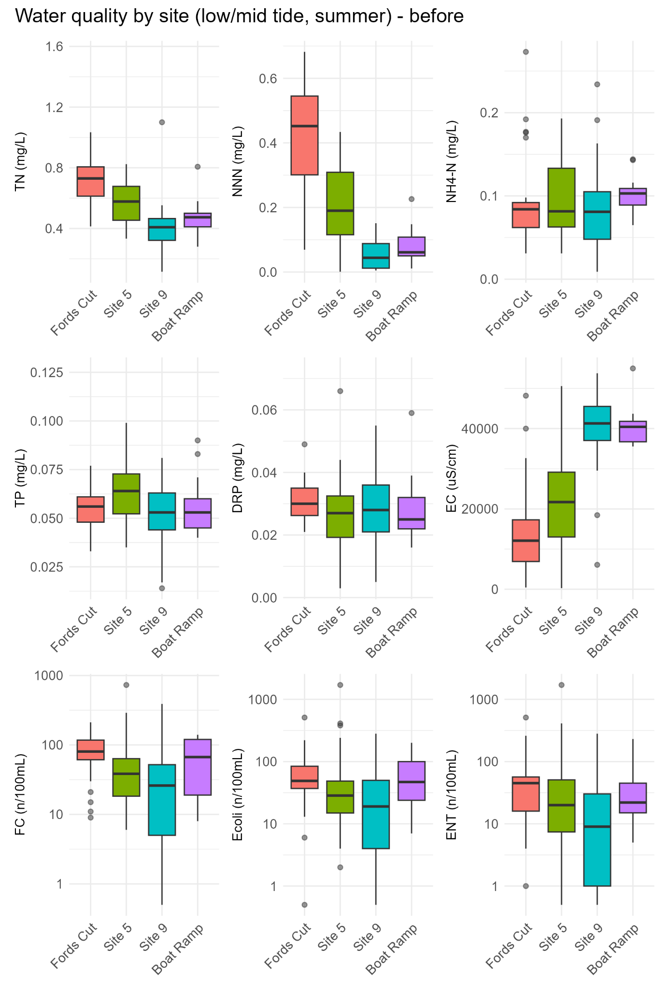
Figure 3.20: Maketū Estuary water quality at each site before the re-diversion. Low and mid-tide data collected during summer from January 2006 to February 2020. y-axis is truncated for TN and TP.
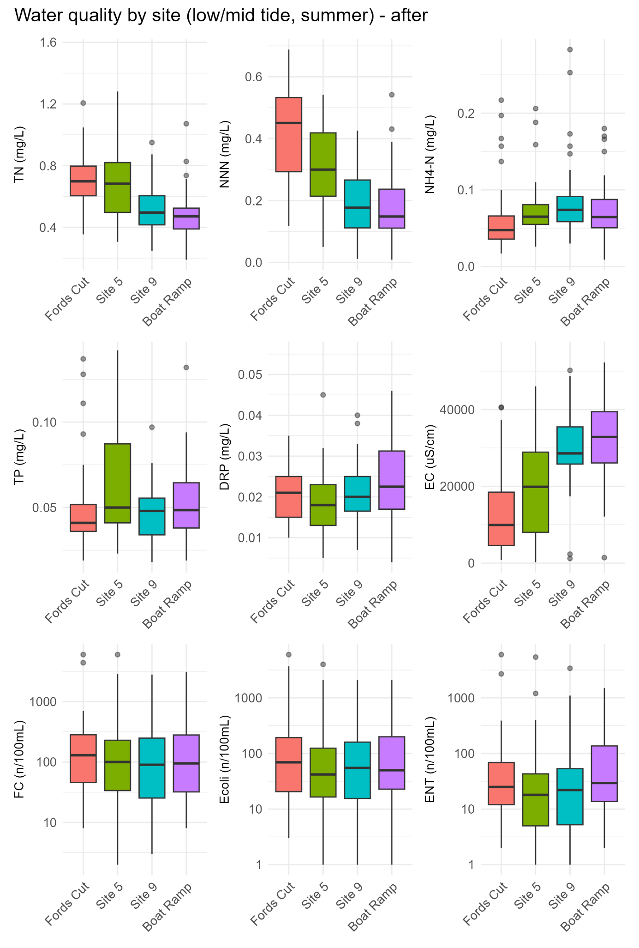
Figure 3.21: Maketū Estuary water quality at each site after the re-diversion. Low and mid-tide data collected during summer from March 2020 to February 2026. y-axis is truncated for TN and TP.

Change in water quality since commissioning
Water quality has changed for many variables and sites since the re-diversion in February 2020. The statistical significance of change between periods was assessed using a Wilcoxon rank-sum test. The results of this test are summarised in Figure 3.22, showing the direction of change, magnitude of change and its statistical significance. Box plot comparisons are in Figures 3.23 to Figure 3.26. The analysis found:
- Salinity/EC declined at all sites reflecting a larger volume of water from the Kaituna River. The reduction in EC was strongest in the mid-estuary. Significantly lower EC was apparent at the Boat Ramp site when High tide data was excluded.
- NNN, and to a lesser extent TN, increased in the mid estuary and lower estuary (Site 5, Site 9 and Boat Ramp). This reflects more influence of river water.
- NH4-N, TP, DRP declined at Fords Cut. A decline in DRP also occurred at Site 5 (extending to site 9 when high tide data was excluded). A decline in NH4-N also occurred at the Boat Ramp (extending to Site 5 when high tide data was excluded). These changes may reflect less internal phosphorus load due to less cover of macroalgae and associated anoxic sediments.
- Significant increases in microbial indicators (FC, E.coli and ENT) at Site 9 and site 5 (FC), and possible increases at the Boat Ramp.
The change in water quality at Maketū Boat Ramp was also analysed using the monthly monitoring dataset from 2010 – 2026 all collected at mid-tide. This found that following the re-diversion the Maketū Boat Ramp site had statistically significant decrease in salinity / EC, and statistically significant increases in all other variables except ENT. Interestingly, the trend for NH4-N was in the opposite direction from the analysis of the consent monitoring data (Figure 2.27).
Crawshaw and Dare (2026) undertook trend analysis by for the Maketū Boat Ramp (2015-2025) using season Kendall analysis and found similar results, i.e. very likely increasing (worsening) trends for TN, NNN, NH4-N, DRP, E.coli, FC, Enterococci, chlorophyll-a and turbidity, and very likely decreasing trend for EC.
Some caution is needed in attributing these changes in water quality as being solely due to the re-diversion due to the relatively small dataset and extreme weather during 2022/23. This may contribute to FIBs having a larger range of values in the post re-diversion dataset.

Comparison with expected change
The changes in estuarine water quality are broadly consistent with predictions made by DHI (2014) prior to the re-diversion, i.e. that the increasing influence of freshwater from the Kaituna River would lower salinity and increasing nitrate concentrations in the mid-estuary (i.e. Site 5). Nitrate concentrations at Site 5, under mean river flow, were predicted to be in the range of 0.3 mg/L to 0.35 mg/L following the re-diversion, which is very similar to the measured values after the re-diversion.
Interestingly, DRP concentrations were expected to increase following re-diversion, but have instead decreased in the upper estuary sites. At Site 5 the measured concentrations are very similar to what was predicted after re-diversion (i.e. 0.20 mg/L to 0.25 mg/L), but the actual concentrations prior to the re-diversion were higher than what was modelled. This is probably because the model did not account for internal nutrient loads. The re-diversion has reduced algae cover, which has reduced the extent of anoxic sediments, which in turn would reduce the release of DRP and NH4-N from the sediments.
Microbial guidelines for approved shellfish growing areas (MPI 2024) require median FC of water samples to be less than 14 MPN/100mL, and the 90th percentile to be less than 43 / 100 mL. Prior to the re-diversion in February 2020, the median concentration of FC at Site 9 and the Boat ramp was 34 MPN/100mL and 44 MPN/100mL respectively, not meeting microbial guidelines.
Since Stage 1 re-diversion, the median concentration of FC at Site 9 and the Boat ramp was 100 MPN/100mL and 58 MPN/100mL respectively; and the 90th percentile concentration was 460 MPN/100mL and 383 MPN/100mL respectively. This reflects a large increase in water column faecal coliforms. But this number is only indicative as the samples size since the re-diversion is small (i.e. 31).
Modelling by DHI (2014) predicted that the re-diversion would increase the concentration of faecal indicator bacteria in the lower estuary. Exceedances of the swimming guideline (i.e. ENT of 280/100ml) was predicted to increase from 2% of the time to 3.3% of the time; and exceedances of the guideline for shellfish gathering waters (median faecal coliform counts < 14/100ml) was predicted to increase from 32% of the time to 44% of the time. While there appears to be an increase in FC, E.coli and ENT in the lower estuary, it is too early to make a valid comparison with these predictions. Microbial data is highly variable and datasets sizes of >30 to 60 independent samples are commonly advised to provide confident assessments of water quality state (MPI 2024, NPS-FM 2020).
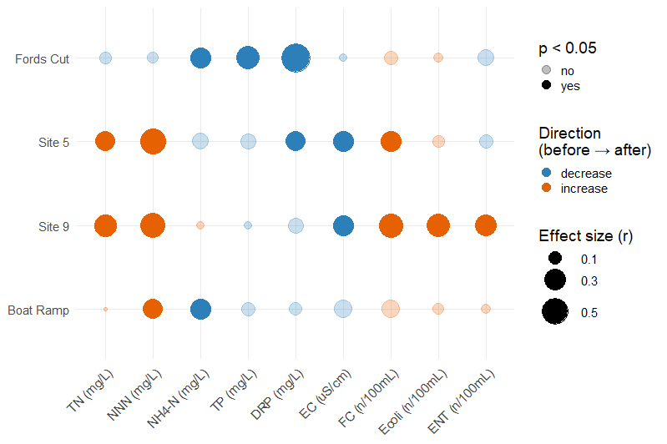
Figure 3.22: Shift in water quality before and after the re-diversion (Feb 2020). Summer samples for all tides. c effect size (r), colour = direction of median change, faded = not significant. Effect size forest dot plot. Results of the Wilcoxon rank-sum test.
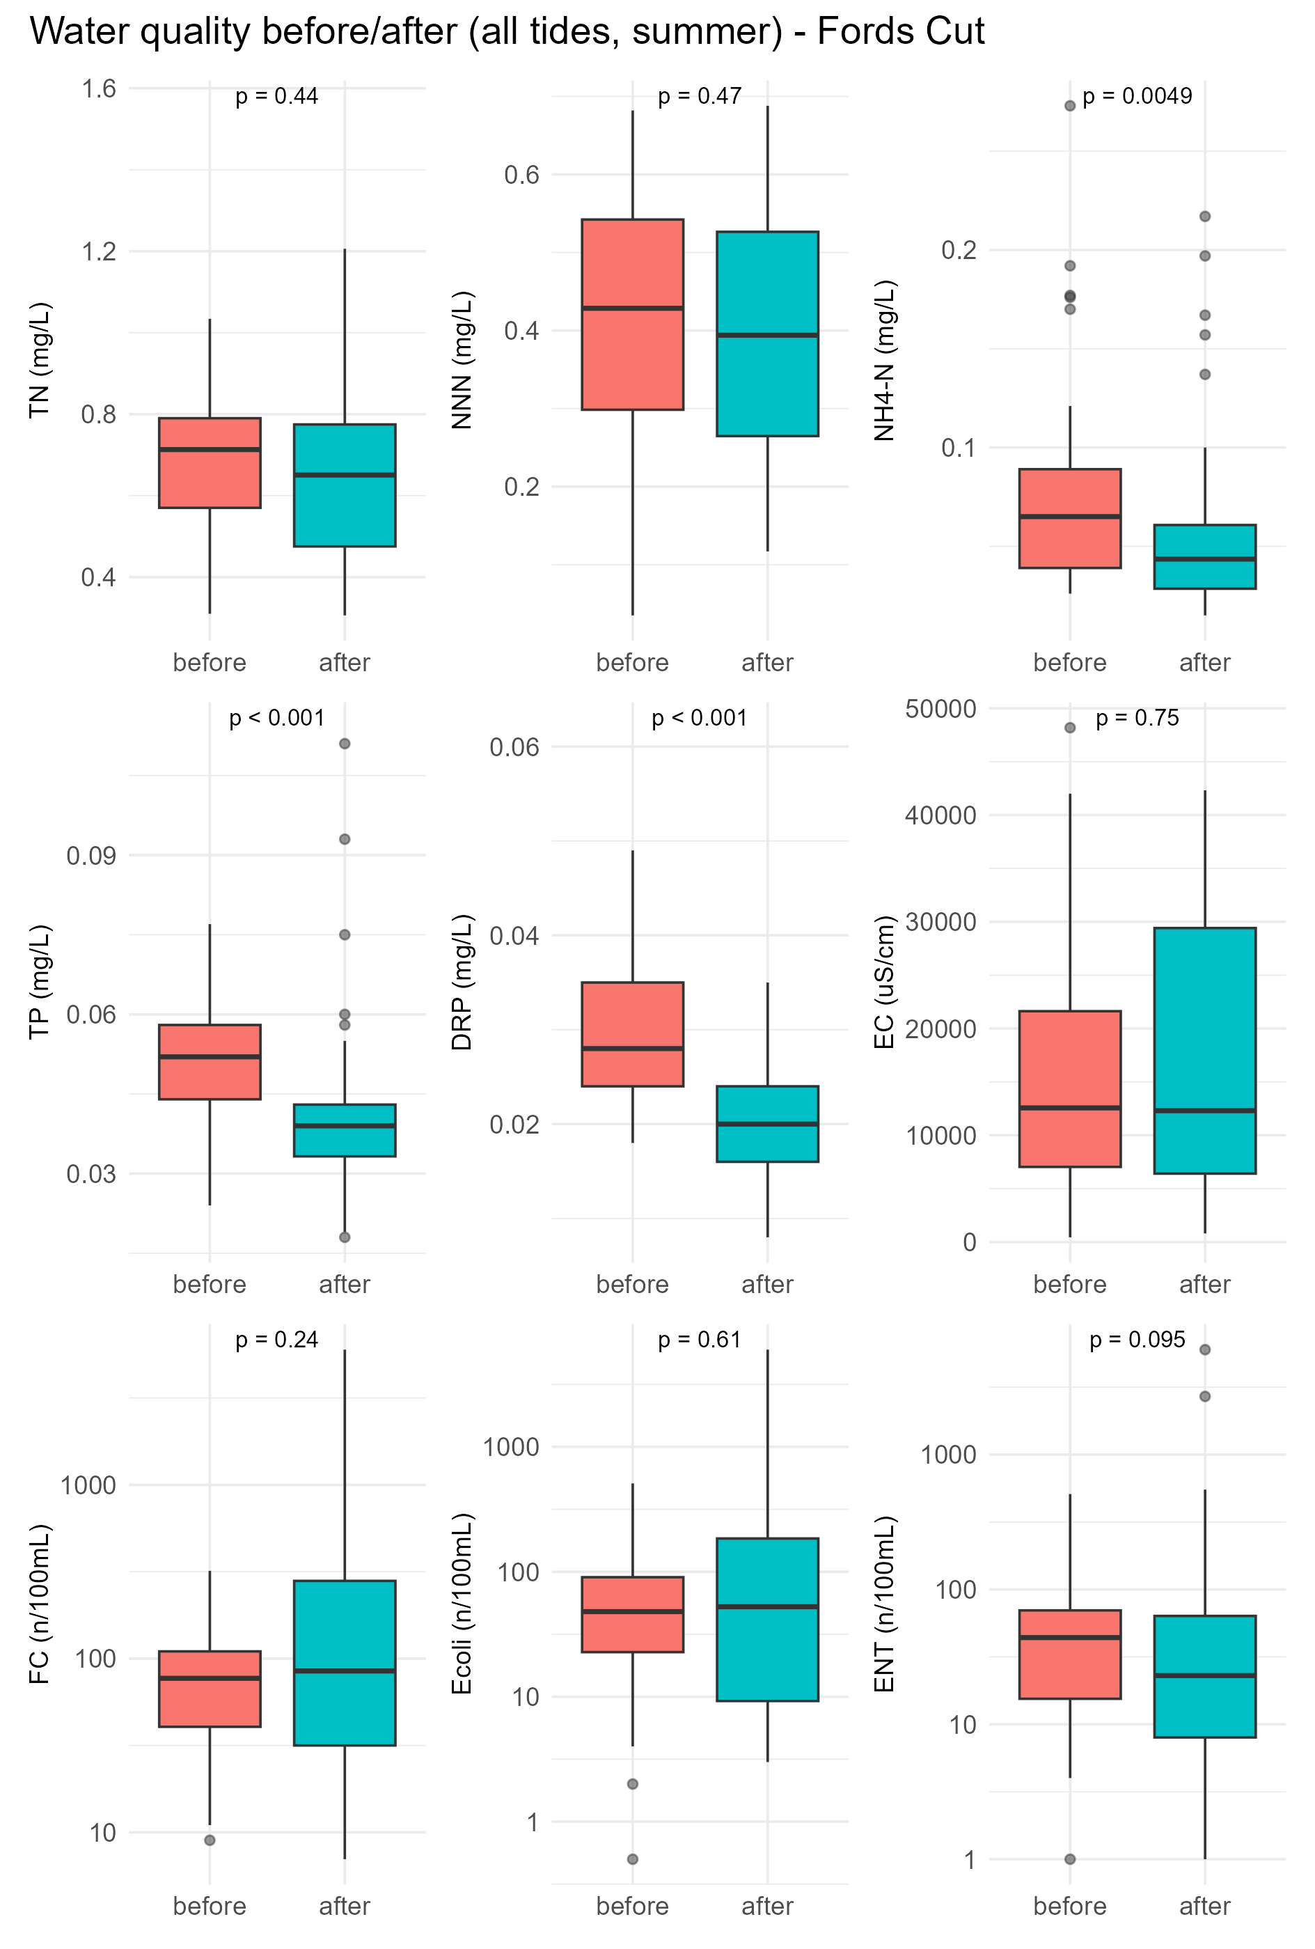
Figure 3.23: Comparison of summer water quality before and after the re-diversion (Feb 2020) at Fords Cut. All tides, summer. P-values indicate the result of the Wilcoxon rank-sum test.
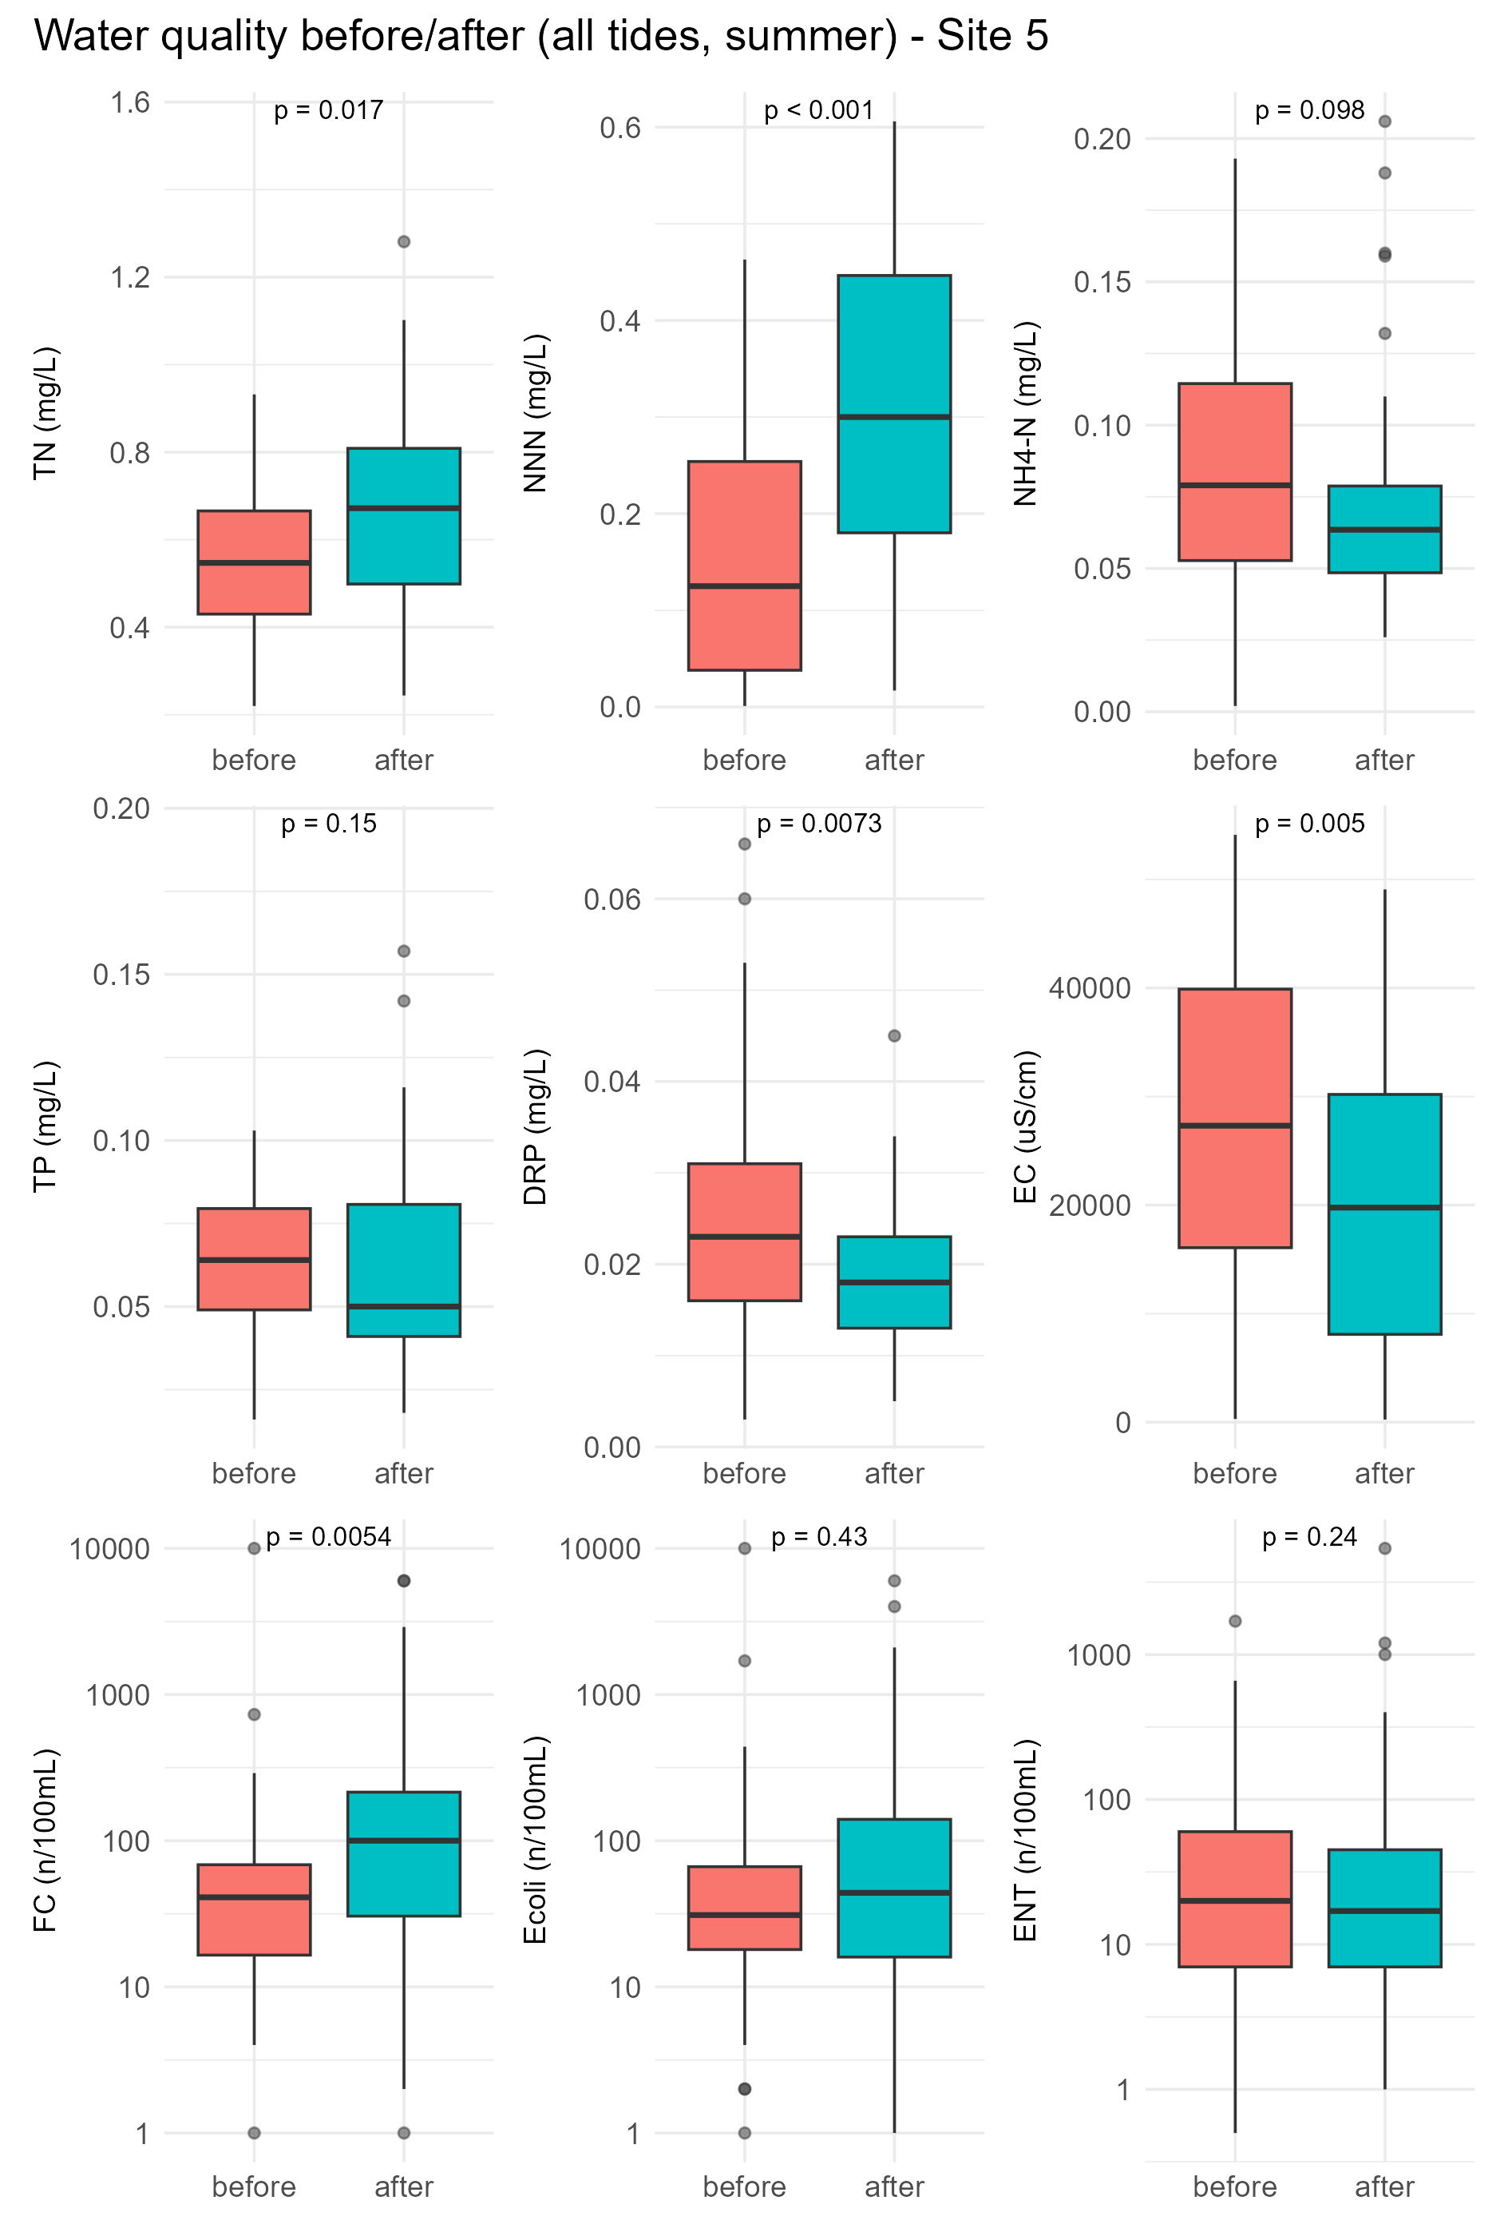
Figure 3.24: Comparison of summer water quality before and after the re-diversion (Feb 2020) at Site 5. All tides, summer. P-values indicate the result of the Wilcoxon rank-sum test.
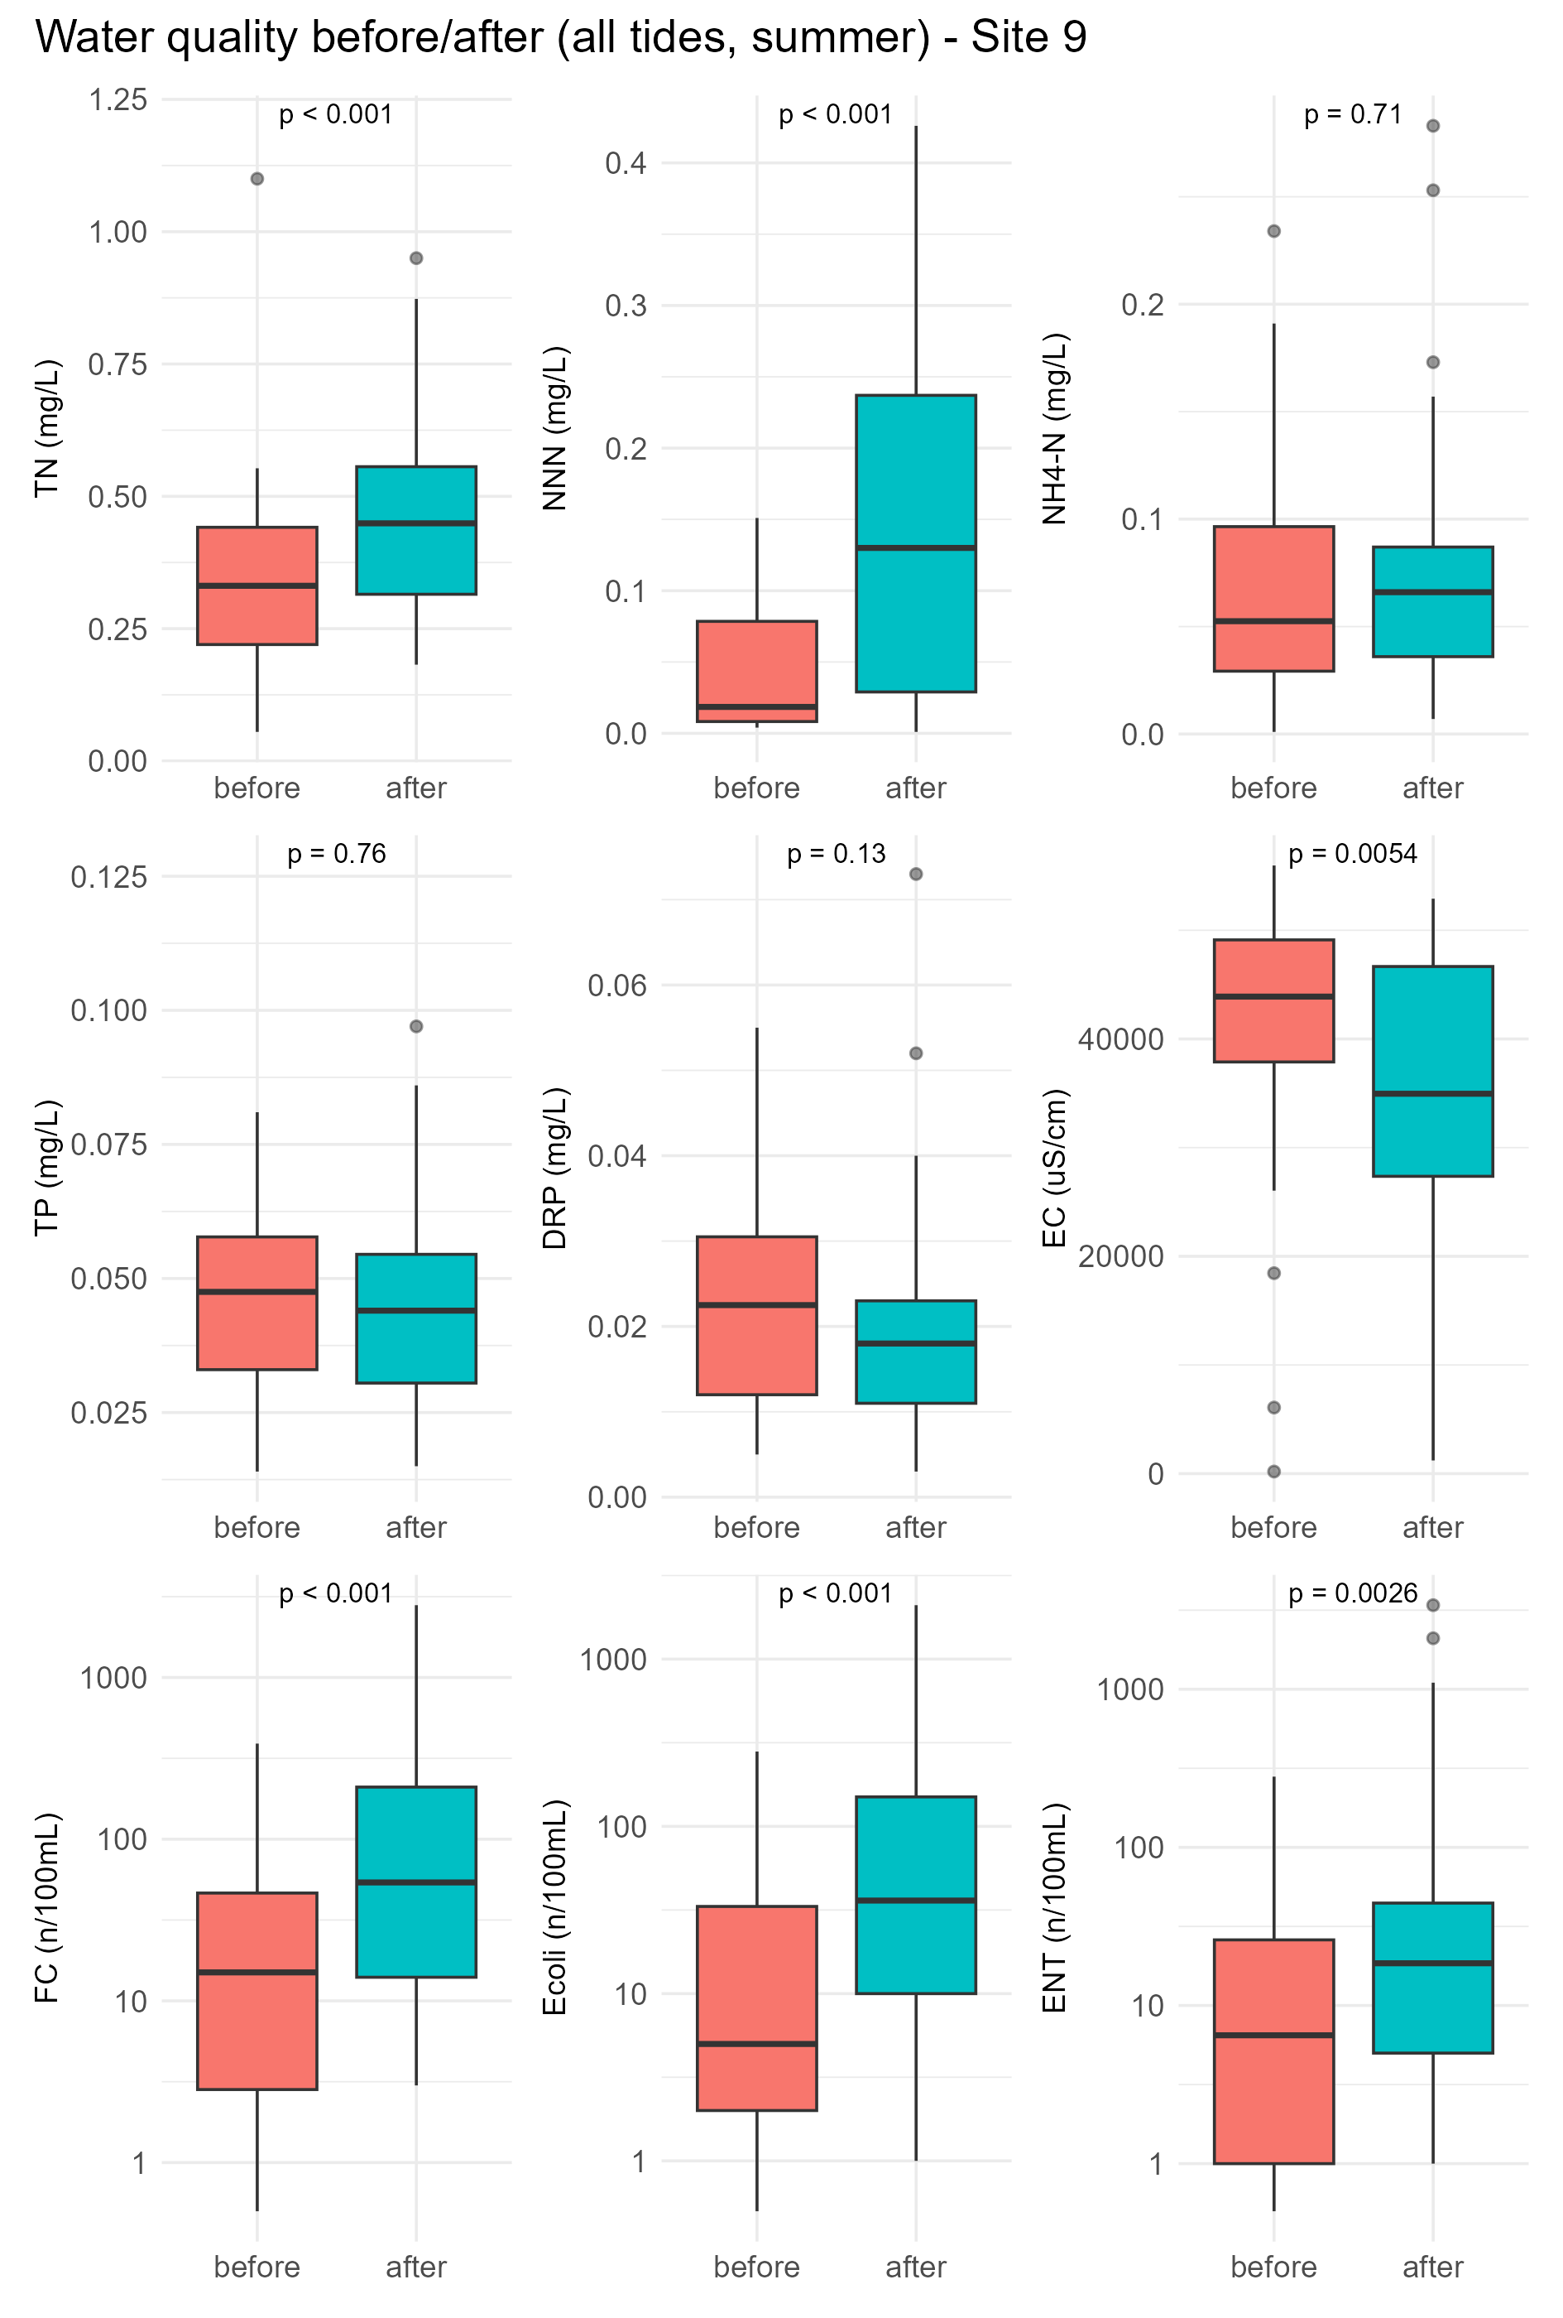
Figure 3.25: Comparison of summer water quality before and after the re-diversion (Feb 2020) at Site 9. All tides, summer. P-values indicate the result of the Wilcoxon rank-sum test.
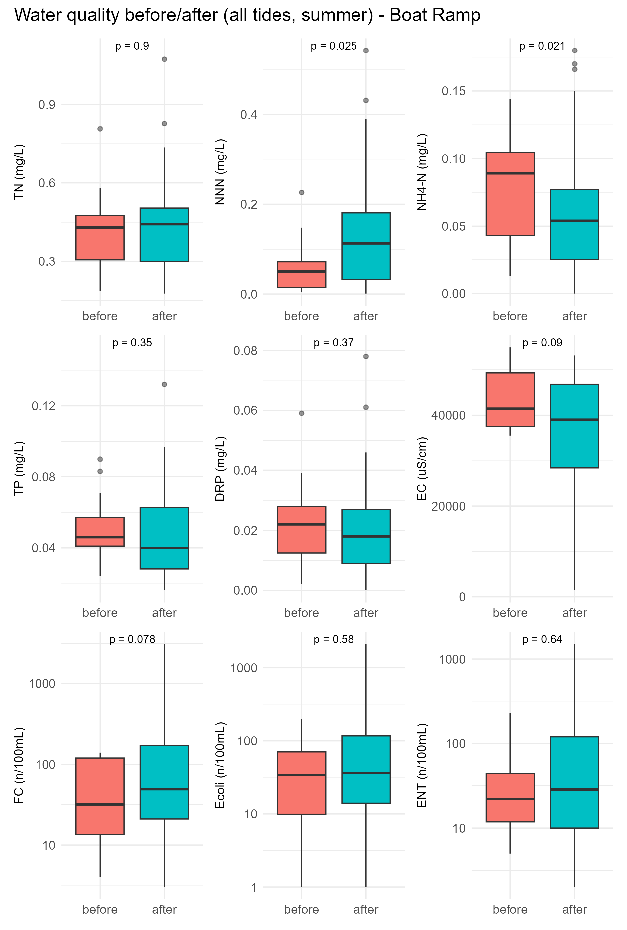
Figure 3.26: Comparison of summer water quality before and after the re-diversion (Feb 2020) at Boat Ramp. All tides, summer. P-values indicate the result of the Wilcoxon rank-sum test.
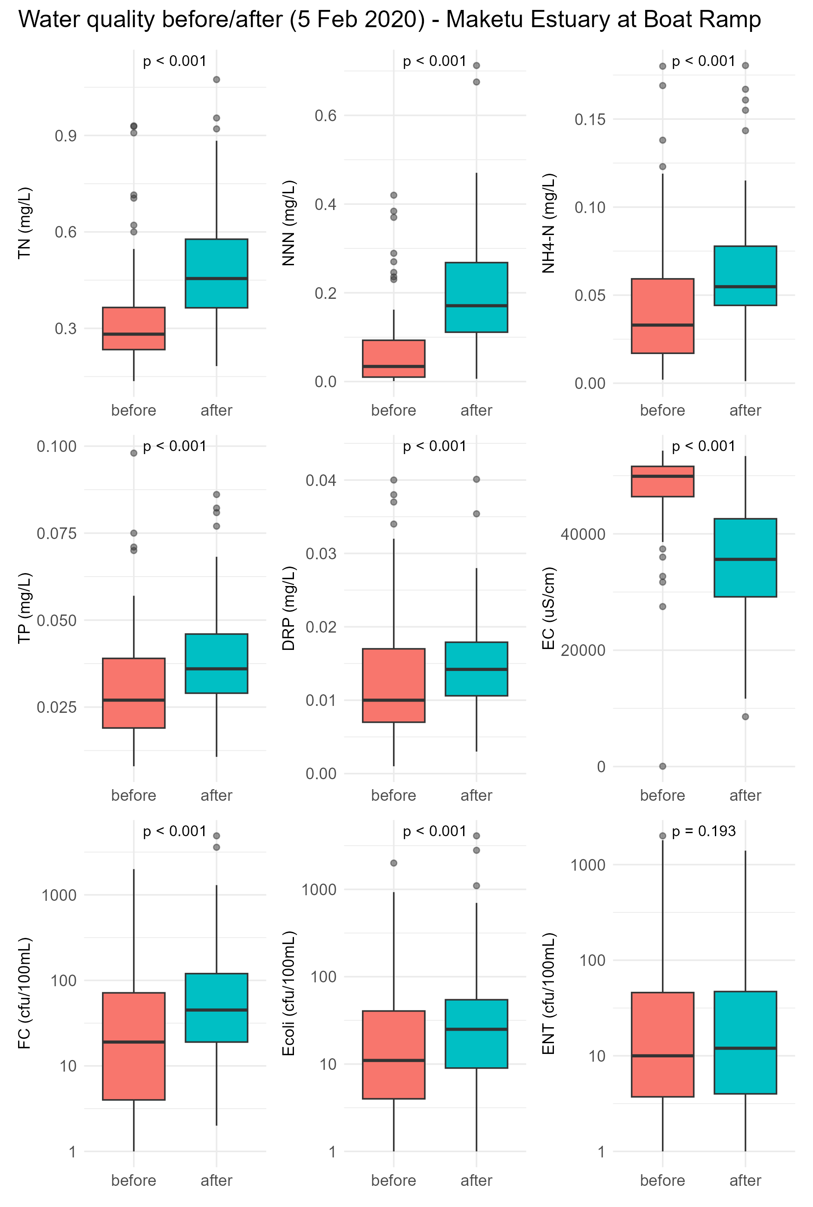
Figure 3.27: Comparison of water quality before and after the re-diversion (Feb 2020) at Boat Ramp collected by monthly sampling at mid-tide from NERMN programme. This dataset has more frequent, monthly sampling, that provides more statistical power than the less frequent consent monitoring. P-values indicate the result of the Wilcoxon rank-sum test.

Shellfish microbial condition
Sampling of shellfish flesh has found that the concentration of E.coli bacteria in tuangi (cockle) and pipi has increased since the re-diversion in 2021 (Figure 3.28, Figure 3.29). A Wilcoxon rank-sum test comparing before and after the re-diversion found the increase to be statistically significant.
The increase in E. coli in the shellfish flesh is consistent with the water quality sampling results. It most likely reflects more loading of microbial bacteria with more inflow from the Kaituna River. It is also likely skewed upward due to the very wet weather conditions during 2022.
Microbial guidelines for approved shellfish growing areas (MPI 2024) require median E.coli of shellfish flesh samples to be less than 230 MPN/100g, and the 90th percentile to be less than 700 MPN /100 g. Prior to the rediversion (2010-2019) the median E.coli for pipi and tuangi respectively was 95 MPN/100g and 355 MPN/100g, and the 90th percentile E.coli for pipi and tuangi respectively was 943 MPN/100g and 1650 MPN/100g. Prior to rediversion pipi met the median guideline but failed the 90th percentile, and cockles failed both guidelines. After the rediversion (2020-2026) the median E.coli for pipi and tuangi respectively was 490 MPN/100g and 1010 MPN/100g, while the 90th percentile E.coli for pipi and tuangi respectively was 943 MPN/100g and 5400 MPN/100g - all failing the guidelines.
Over the last two years (2024-2026), which excludes the extreme wet period of 2022/23, the median E.coli for pipi and tuangi respectively was 330 MPN/100g and 790 MPN/100g, and the 90th percentile E.coli for pipi and tuangi respectively was 1300 MPN/100g and 3880 MPN/100g. These values exceed the guideline values for both cockle and pipi.

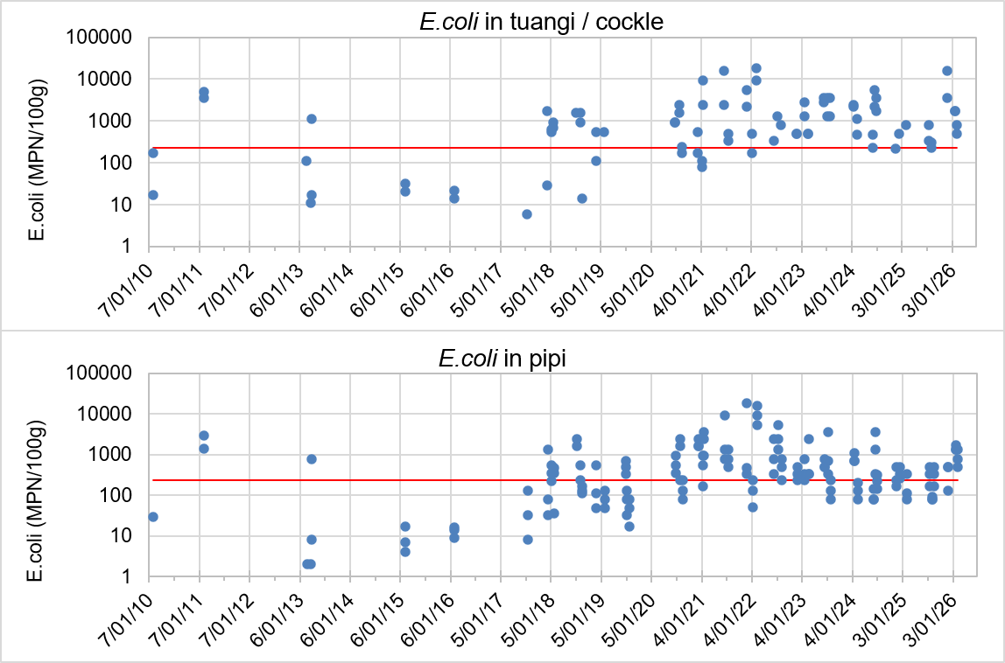
Figure 3.27: E. coli bacteria in tuangi (top graph) and pipi (lower graph) from lower Maketū Estuary (Site 9, Site 9 north of Marae, and Boat Ramp). Kaituna River inflows increased in February 2020 and again in February 2021. The red line is the shellfish guideline median of 230 E.coli/100g.

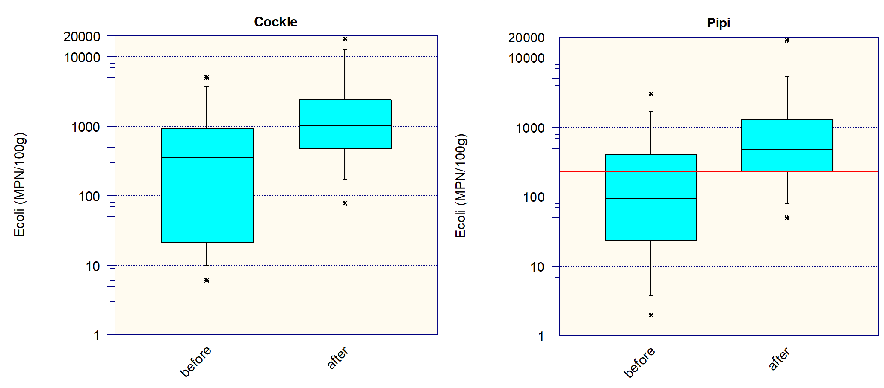
Figure 3.27: E.coli bacteria in tuangi and pipi collected from lower Maketū Estuary before and after the re-diversion in February 2020. Data from February 2010 to February 2025. The red line is the shellfish guideline median of 230 E.coli/100g.

Summary and Conclusions

Summary
Algal cover
- Macroalgal cover has been assessed in Maketū Estuary by both broadscale mapping and direct measurements at quadrates and transects. Surveys of algae cover over time has found high macroalgae cover in the estuary prior to 2017/18, a reduction macroalgae in Papahikahawai lagoon following works to remove bunds in this area during 2017/18 to 2018/19, and a substantial reduction macroalgae throughout the main estuary following commissioning of the gates in February 2020 and 2021.
- Since full commissioning of the gates, the average macroalgae cover has been less than 6% as recorded in broadscale mapping and less than 1% as measured at quadrates and algal transects.
- Current total nitrogen concentrations are within the C band, indicating a high risk of nuisance algal bloom development (Crawshaw & Dare 2026).
- This overall shows that the increase in flushing potential in the upper estuary has been successful at reducing nuisance macroalgae cover. However, nutrient concentrations in the estuary remain at concentrations that could result in further nuisance macroalgae growth in the future.
Sediment
- Since about 2017, sediment plates have recorded sediment accumulation at P1, P3 and P11, and erosion at P2, P4, P6 and P8.
- RPD, a measure of oxygenated sediment, has improved at sites P2, P4, P5, P6, P7, and P8, with more step change improvements occurring after 2021 or 2022. No site had an obvious decline.
- Sites in the upper estuary tend to have high mud content, rated ‘fair’ or ‘poor’. Since 2012, the fraction of mud in sediments has increased at ten sites - mostly in the mid to lower estuary. The fraction of mud has tended to decrease at sites previously in the upper estuary (P8) and Papahikahawai lagoon.
- Sediment TOC and TN are low (good quality) at most sites in the estuary except at sites P10 and P11 - which was used for farmland prior to the restoration works.
- Most sites in the estuary (10) had a decrease (improvement) in TOC and TN. Sites P3 and P7 stood out as having an increase (deterioration) in sediment %mud, TOC, TN, TP and many of the metals. This increase occurred after 2021 and may reflect a redistribution of mud previously located in the upper estuary near P8.
- The diversion has resulted in flushing of mud content from numerous sites across the estuary. Large areas of muddy sediments have been flushed from the upper estuary, improving their state, however some of the mud appears to have redistributed within the estuary.
Macrofauna
- The macrofaunal community composition in Maketū Estuary can be broadly grouped into lower to mid-estuary sites (P1-P5 and S43C) and upper estuary sites (P7, P8 and Causeway 2). The macrofaunal community composition of P6 is spans these groups, with the presence of species characteristic to both.
- Prior to 2018 macrofauna community diversity in the upper-estuary and in Papahikahawai lagoon (P7, P8, Main causeway, Maimai Point and Causeway 2) was extremely low, with no macrofauna at some sites. Macrofauna diversity at these sites substantially improved with removal of the causeways (2017-2018) and increasing flow with commissioning of the rediversions (2020 and 2021).
- A statistically significant improving trend in macrofauna diversity was also apparent at site P2 in the southern estuary.
- Non-metric Multidimensional Scaling (NMDS) was used to visualize patterns of similarity in macrofauna species composition. During 2025/26 the upper estuary sites (P7, P8 and Causeway 2) had distinctly different macrofauna community composition compared to the other sites. P6 had a wide range of species composition spanning between the upper and lower estuary sites. The other mid to lower estuary sites (P1 – P5, S43C) shared many species in common, with neighbouring sites being most similar.
- Macrofauna species composition at sites in the estuary has changed over time. The strongest changes occurred at site P8, followed by P7, P6, P3, P2, and Maimai Point. Main Causeway also had substantial change in species composition – with zero macrofauna detected in years prior to the interventions.
- The diversion has had significant improvements in macrofauna diversity at many sites across the estuary, with some sites strongly linked to sediment and flushing improvements (e.g. site P8, Main Causeway).
Shellfish (intertidal)
- Tuangi / cockle were much more abundant (median 7875 per m²) at site P3 than all other sites. No (or almost no) tuangi were found in the upper estuary (P7, P8, causeway 2), and P2 in the southern estuary had low abundance (c. 226/m²). The abundance of tuangi has significant increasing trends over time at P3 and S43C, and possible increasing trends at P2, P4 and P5. There was a step increase in abundance at P3 after 2021, and at P2 after 2019.
- Wedge shells were found in relatively high density in the lower estuary (i.e. P1, P2, P3 and P4) but are absent from the upper estuary (P6, P7, P8 and Causeway 2). The abundance of wedge shell significantly increased over time at sites P2, P3, P4 and P5, and ‘possibly’ increased at P1. There was a decrease in abundance at site S43C.
- Pipi were most abundant at site P5 (median 452/m²) but had been absent from this site in all previous surveys. Pipi were also present at sites P3, P4 and P8. The sites for macrofauna plots do not target pipi habitat as they are all exposed at low tide, while pipi tend to be most abundant within channels and in the lower estuary.
- The abundance of pipi increased at P3, and showed a ‘possible’ increase at P4, P5 and P8 driven by more abundant pipi during the 2026 survey.
- Overall shellfish showed positive responses to the rediversion, with improvement in density at many sites. There was no indication that changes in sediment mud content in Maketū has had adverse effects on shellfish.
Pipi beds
- Pipi density has increased at transect 1 since the re-diversion. The increase was statistically significant when comparing before and after July 2022. Transect 2 also appeared to have higher pipi density compared to previous years, but the difference was not statistically significant.
- Transect 1 appeared to have more large pipi (>40mm) in 2024 and 2026 compared to previous years. Transect 3 appeared to have a shift towards smaller sized pipi in 2026 compared to previous years. This may reflect changes in the channel at this location or recruitment processes.
- Overall pipi densities appear to show positive improvements following the rediversion, with likely increases in density and size in the lower estuary.
Oxygen and salinity loggers
- The mean DO concentration would place both sites in Band B (Good quality), while the 1-day minimum values would place site WQ 5 in Band C (fair) and the Causeway 2 site in Band D (poor).
- There was lower salinity in the estuary following Stage 1 re-diversion. The salinity measured mid-estuary during February 2026 was the lowest of any year despite moderately low river flows compared to 2023.
- There was smaller diurnal variation in DO and slightly higher (better) mean DO in the main estuary in years following re-diversion compared to before the re-diversion.
- The Papahikahawai channel (site WQ2) has consistently lower DO compared to the mid-estuary site WQ5 which probably reflects more organic mud in this area. Considerably organic mud accumulated in the Papahikahawai lagoon during the decades when it was isolated from the rest of the estuary, and it is likely to many years to adjust to the new regime.
- Overall increased river flow from the rediversion has decreased overall estuary salinity and improved oxygen concentrations within the estuary.
Water Quality
- Water quality in Maketū Estuary has a general spatial pattern of the upper estuary having lower salinity, higher concentrations of nutrients (particularly nitrate), and high concentrations of faecal indicator bacteria.
- Following the re-diversion in 2020, there was:
  - A reduction in salinity at all sites but particularly in the mid-estuary sites.
  - An increase in nitrogen concentrations (TN and NNN) in the mid-estuary and lower estuary.
  - A decrease in TP, DRP and NH4-N at most sites, but especially at Ford’s Cut and Site 5. The reduction in these nutrients is consistent with less sediment anoxia due to less macroalgae cover since the re-diversion.
  - An increase in microbial contaminants (e.g. E.coli bacteria) in the mid to lower estuary (esp. site 9).
  - The latest long term estuary water quality report (Crawshaw & Dare 2026) showed very likely worsening trends for most nutrients, and chlorophyll-a and microbial indicators.
  - Overall, the increased water flows from the rediversion has resulted in higher (worse) concentrations of TN, NNN and microbial contaminants, but lower (better) concentrations of TP, DRP, and NH4-N due to increased sediment/algae conditions in the upper estuary.
Shellfish microbial condition
- The concentration of E.coli bacteria in pipi and cockle samples collected from the lower estuary has increased since the re-diversion. The increase in E. coli in the shellfish flesh is consistent with the water quality sampling results. It most likely reflects more loading of microbial bacteria with more inflow from the Kaituna River. It is also likely skewed upward due to the very wet weather conditions during 2022.
- The increase in microbial indicators in the lower estuary following re-diversion was predicted at the time of the consent. It is one of the very few negative effects of the rediversion and its effects should be addressed by a focus on improving management of landuse and discharges to the estuary and Kaituna River.

Recommendations for future monitoring

Consent condition changes
- Shellfish water quality monitoring locations
Recommended change
Discontinue shellfish water quality monitoring at Site 9 and retain monitoring at Site 9 North of Marae. Retain shellfish water sampling at Site 10.
Rationale
- The two sites are in close proximity and provide largely overlapping information on shellfish water quality.
- Historical datasets have generally aggregated results from the two sites, making it difficult to distinguish site-specific patterns during analysis.
- If shellfish flesh monitoring is focused on pipi (see Recommendation 3), Site 9 North of Marae is the more appropriate monitoring location because it is located adjacent to the primary pipi bed.
Benefit
- Reduces duplication in monitoring effort while maintaining a monitoring location that is directly relevant to the remaining shellfish flesh monitoring programme.
- Improves alignment between shellfish water quality and shellfish flesh monitoring datasets.

- Estuary water quality monitoring
Recommended change
- Remove the requirement for summer low- and high-tide water quality sampling (three sampling rounds at three sites).
- Add a monthly water quality monitoring site at Site 1 Fords Cut to the existing NERMN estuary water quality programme.
Rationale
- The current programme requires intensive sampling across multiple sites and tidal states but provides a relatively small number of observations, limiting statistical power for detecting trends.
- Since the rediversion, water quality at Site 5 has generally been intermediate between Site 1 Fords Cut and the Boat Ramp site, indicating limited additional value from maintaining all current consent-monitoring locations.
- The Boat Ramp site is already monitored monthly through the estuary water quality NERMN programme and has generated a substantially stronger dataset for assessing temporal change than the current summer-only monitoring.
- Incorporating Site 1 Fords Cut into the monthly programme would increase sampling frequency and improve the ability to detect long-term trends.
Benefit
- Provides a more statistically robust dataset for assessing changes in estuary water quality.
- Improves efficiency by redirecting monitoring effort from intensive short-term sampling towards consistent long-term monitoring.
- Three low-tide water quality samples would still be collected annually during pipi shellfish flesh monitoring, providing some continuity with the existing programme.

- Shellfish flesh monitoring
Recommended change
- Cease cockle flesh monitoring and continue shellfish flesh monitoring using pipi only.

Rationale
- Cockles within Maketū Estuary are generally small, and individuals of suitable size for flesh analysis are relatively sparse.
- Sample collection is time-consuming, requires large numbers of individuals, and results in significant processing effort.
- The distribution of cockle beds varies over time, making interpretation of temporal trends more difficult.
Benefit
- Reduces field and laboratory effort while retaining monitoring of the shellfish species most readily available within the estuary.
- Maintains the ability to assess potential contaminant exposure through shellfish consumption using a practical and repeatable sampling approach.

Opportunities to improve environmental monitoring
- Review monitoring frequency at non-NERMN ecological sites. Continue annual monitoring of algae cover, sediment, sediment plates and macrofauna at NERMN sites. For ecological monitoring sites outside the NERMN network, consider reducing monitoring frequency to every three to five years, as ecological recovery in areas such as Papahikahawai Lagoon is expected to occur over decadal timescales. Periodic monitoring will continue to track long term changes while reducing effort.
- Macroalgae monitoring methods. Consider discontinuing dedicated algal transects while continuing to record macroalgae species and percentage cover at macrofauna and sediment plate sites. Continue with the broad scale assessment of algal cover using aerial images.
- Continue pipi population surveys. Given the cultural, recreational and customary importance of pipi to the local community, and the improvements in pipi abundance and distribution observed through the monitoring programme, it is recommended that pipi population surveys continue at two-year intervals. Ongoing monitoring would help track the long-term response of the population and provide evidence of whether gains are being maintained over time.
- Improve sediment redox monitoring. Consider including measurement of RPD using redox potential electrodes. Currently sediment oxygen is measured visually as apparent RPD (aRPD). This approach should generally be used alongside meter approaches, i.e. redox potential electrodes coupled to a millivolt meter to measure redox potential (Eh).

Conclusions
Overall, the changes observed in the estuary since re-diversion are in line with what was predicted to occur with the restoration activities and increased river flow back into the estuary. Macroalgal cover has substantially reduced, and there are generally stable or improving trends in macrofauna diversity and abundance of shellfish. Parts of the upper estuary have shown significant ecological improvements in terms of biodiversity and productivity which contributes significantly to the overall ecological health and integrity of the estuary. Water quality data also shows results consistent with predicted changes, including increased concentrations of bacteria due to increased river influence.
While increased freshwater inputs are supporting estuarine restoration, they are also highlighting the influence of poor catchment water quality. As river flows increase, greater loads of contaminants, including faecal bacteria, sediments and nutrients, are delivered to the estuary from the wider catchment. Consequently, achieving the full ecological benefits of the restoration will depend not only on the hydrological reconnection of the river and estuary, but also on continued efforts to improve water quality across the catchment.
Many of the potential ecological benefits of higher river flows into the estuary such as saltmarsh health, sediment, and net nutrient transports out of the estuary will occur more gradually over time. Ongoing catchment management and water quality improvement initiatives will help maximise these benefits and support continued ecological recovery of the estuary.

References
Crawshaw J., Dare J. 2026. NERMN Estuary Water Quality Report 2025. Bay of Plenty Regional Council Environmental Publication 2026/06. Bay of Plenty Regional Council, Whakatane.
DHI 2009: Kaituna River to Ōngātoro/Maketū Estuary Re-diversion: Model Calibration and Initial Hydrodynamic Impact Assessment. A report prepared for the Bay of Plenty Regional Council. DHI Water and Environment Ltd, Auckland, New Zealand.
DHI 2014: Kaituna River Re-diversion and wetland Creation Project: Numerical modelling. A report prepared for the Bay of Plenty Regional Council. DHI Water and Environment Ltd, Auckland, New Zealand.
DHI 2021. Memo regarding validation of ebb tide volumes for consent compliance.
Hamill K.D. 2026. Ongatoro/Maketū Estuary Consent 67958 Compliance Water Quality and Ecology 2025. Memo from River Lake Ltd to Courtney Bell and Kirsty McGregor, Bay of Plenty Regional Council, 24 July 202.
Hamill K.D. 2014. Kaituna River Re-diversion Project: Ongatoro/Maketū estuary condition and potential ecological effects. Prepared for Bay of Plenty Regional Council by River Lake Ltd.
Ho M, Mitterwallner P, Clark D, Floerl L. 2026. Ecological health across Bay of Plenty estuaries: state and trends, 1990−2025. Nelson: Cawthron Institute. Cawthron Report 4254. Prepared for Bay of Plenty Regional Council.
Jowett, I. 2018.TimeTrends. v.6.30 2017. Trends and Equivalent Analysis. Funded by FRST Envirolink and sponsorship from Northland Regional Council, Hawke's Bay Regional Council, Southland Regional Council and Auckland Council.
McBride, G.B., Cole, R., Westbrooke, I., and Jowett, I.G. 2014. Assessing environmentally significant effects: A better strength-of-evidence than a single P value? Environmental Monitoring and Assessment, 186: 2729–2740.
Ministry of Primary Industry (MPI) 2024. Animal Products Notice: Regulated Control Scheme - Bivalve Molluscan Shellfish for Human Consumption. 15 November 2024
Park, S.G. 2014: Extent of wetland vegetation in Maketū Estuary – 1939 to 2011. Environmental Report 2014/05. Bay of Plenty Regional Council, P.O. Box 364, Whakatāne, New Zealand.
Park, S.G. 2017: Consent 67958 Environmental monitoring requirements. Internal BOPRC memo. Objective reference A2619840. Bay of Plenty Regional Council, P.O. Box 364, Whakatāne, New Zealand.
Park, S.G. 2018: State (health) of benthic ecology in Waihi and Maketū Estuaries. Internal BOPRC memo. Objective reference A2892930. Bay of Plenty Regional Council, P.O. Box 364, Whakatāne, New Zealand.
Park, S.G. 2020: Maketū Estuary benthic ecology monitoring 2020. Internal BOPRC memo. Objective reference A3558494. Bay of Plenty Regional Council, P.O. Box 364, Whakatāne, New Zealand.
Park, S.G. 2021: Maketū Estuary Consent 67958 Compliance Water quality and Ecology. Internal BOPRC memo. Objective reference A3804018. Bay of Plenty Regional Council, P.O. Box 364, Whakatāne, New Zealand.
Park, S.G. 2022: Maketū Estuary Consent 67958 Compliance Water quality and Ecology. Internal BOPRC memo. Objective reference A4386971. Bay of Plenty Regional Council, P.O. Box 364, Whakatāne, New Zealand.
Park, S.G. 2023: Maketū Estuary Consent 67958 Compliance Water quality and Ecology. Internal BOPRC memo. Bay of Plenty Regional Council, P.O. Box 364, Whakatāne, New Zealand.
Park, S.G. 2024: Maketū Estuary Consent 67958 Compliance Water quality and Ecology. Internal BOPRC memo. Bay of Plenty Regional Council, P.O. Box 364, Whakatāne, New Zealand.
Putt, C. 2021: Lower Kaituna River Tidal Flow Survey – 02 December 2021. Internal BOPRC memo. Objective reference A3995865. Bay of Plenty Regional Council, P.O. Box 364, Whakatāne, New Zealand.
R Core Team. 2024. R: a language and environment for statistical computing; Version 4.4.3. Vienna: R Foundation for Statistical Computing.
Robertson, B.M, Stevens, L., Robertson, B., Zeldis, J., Green, M., Madarasz-Smith, A., Plew, D., Storey, R., Hume, T., Oliver, M. 2016. NZ Estuary Trophic Index Screening Tool 1. Determining eutrophication susceptibility using physical and nutrient load data. Prepared for Envirolink Tools Project: Estuarine Trophic Index, MBIE/NIWA Contract No: C01X1420. 47p.
Robertson, B.M, Stevens, L., Robertson, B., Zeldis, J., Green, M., Madarasz-Smith, A., Plew, D., Storey, R., Oliver, M. 2016. NZ EstuaryTrophic Index Screening Tool 2. Determining Monitoring Indicators and Assessing Estuary Trophic State. Prepared for Envirolink Tools Project: Estuarine Trophic Index, MBIE/NIWA Contract No: C01X1420. 68p.
(PDF) NZ ETI Tool 2: Assessing estuary trophic state using measured trophic indicators.
Stevens L and Robertson B 2015. Hutt Estuary Intertidal macroalgal monitoring 2014/15. Prepared for Greater Wellington Regional Council by Wriggle Coastal Management.
Stevens L, Roberts KL, Forrest B, Morrisey D, Zeldis J, Dudley B, Mangan S, Lam-Gordillo O, Lundquist C, Lohrer D, et al. 2024. Advice on indicators, thresholds and bands for estuaries in Aotearoa New Zealand. Nelson: Salt Ecology. Salt Ecology Report 141. Prepared for Ministry for the Environment.
Waugh R, Dean H, Conroy E 2022. Peer review of annual reporting for the Kaituna River Re-Diversion and Te Awa o Ngātoroirangi/Maketū Estuary Enhancement Project. Prepared by Independent Peer Review Panel for Bay of Plenty Regional Council.

Appendix 1: Relevant Monitoring Conditions of Consent 67958
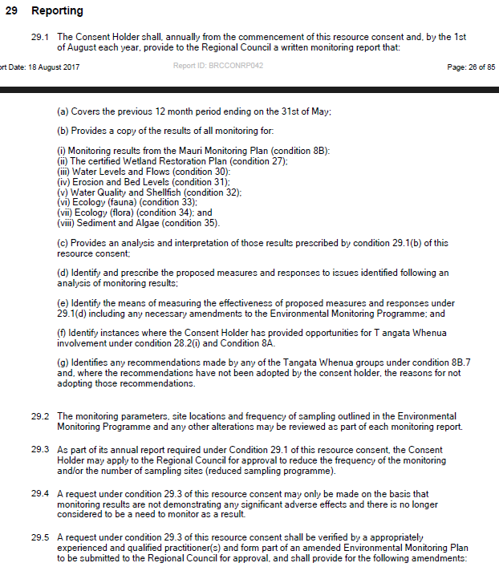
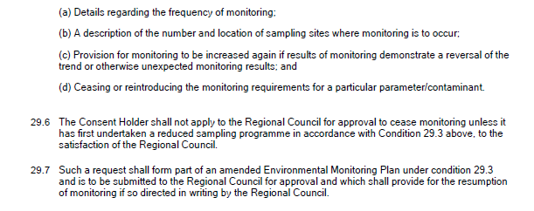
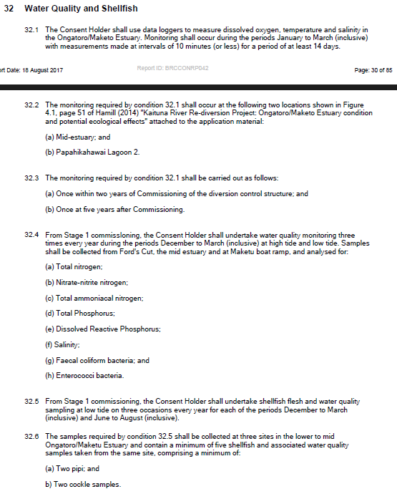
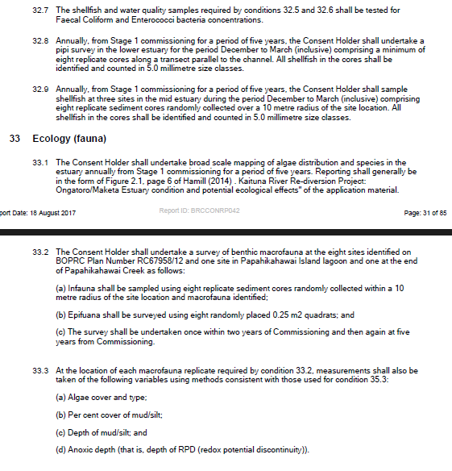
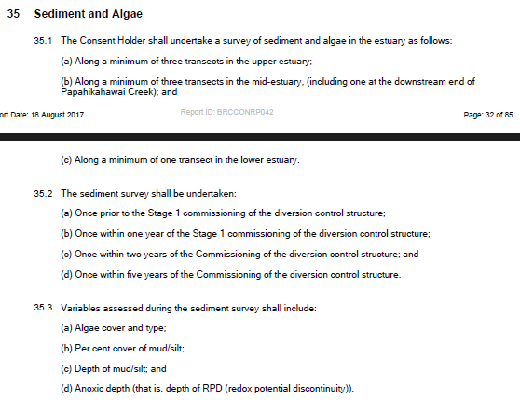

Appendix 2: Maketū Estuary Sampling Protocols (BOPRC)
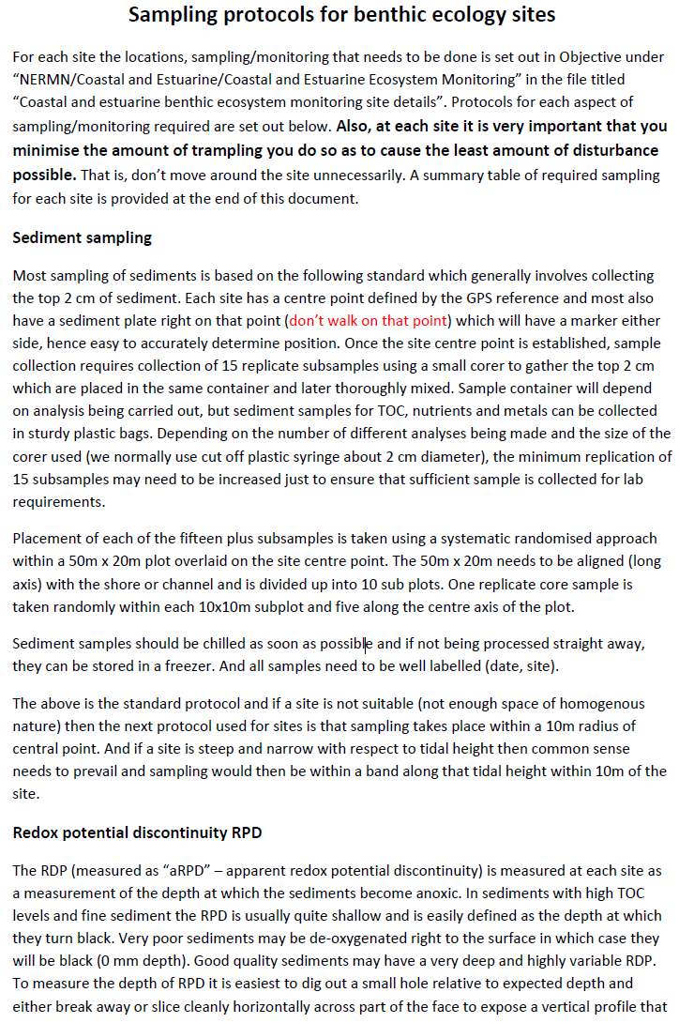
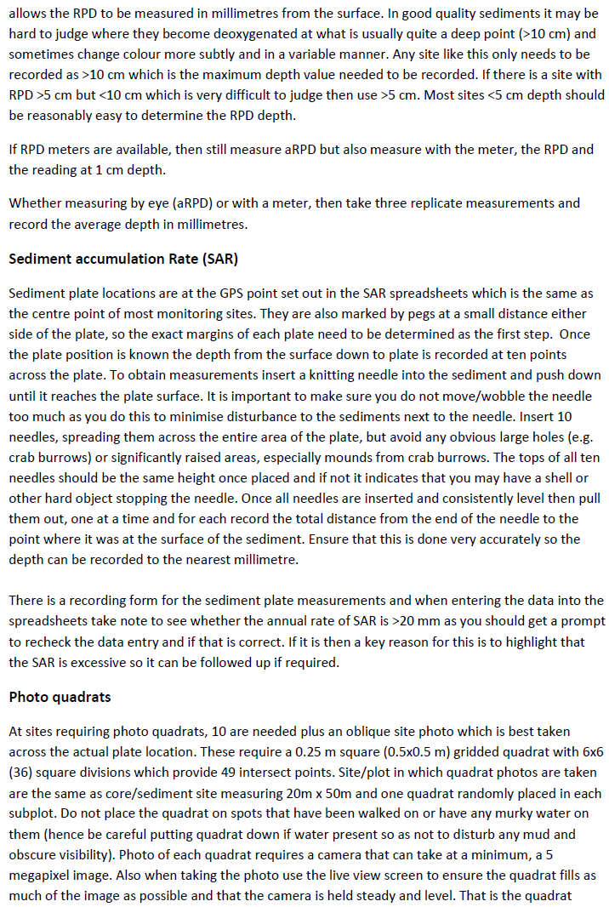
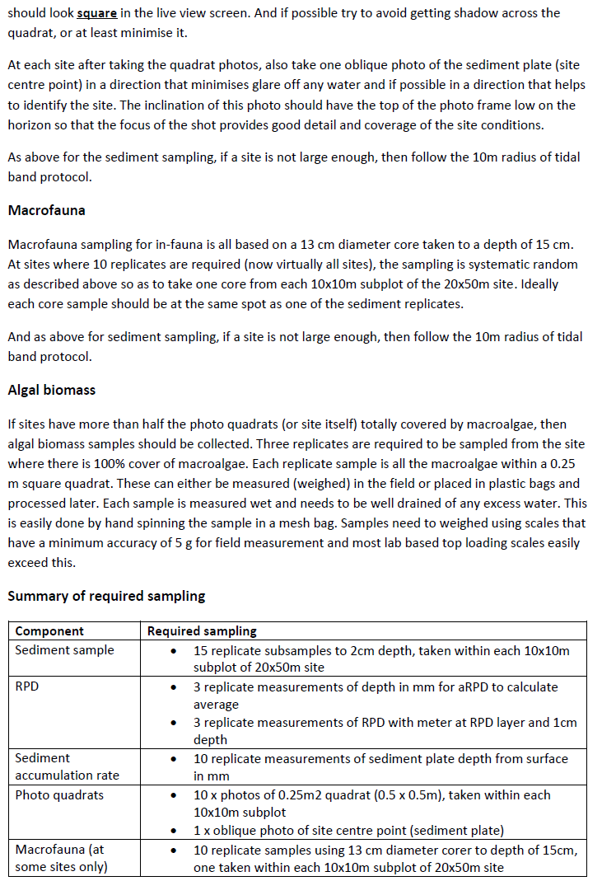
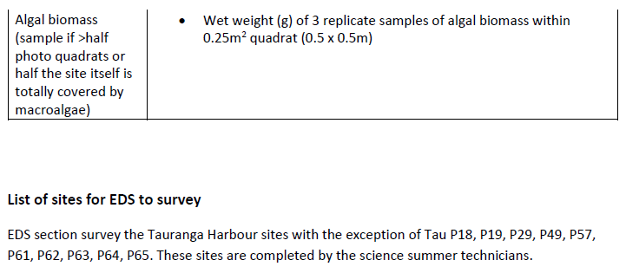

Appendix 3: Total macroalgae by site
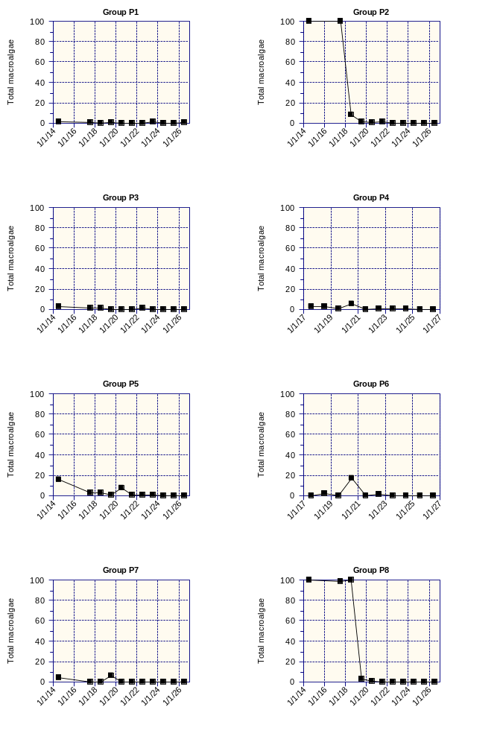
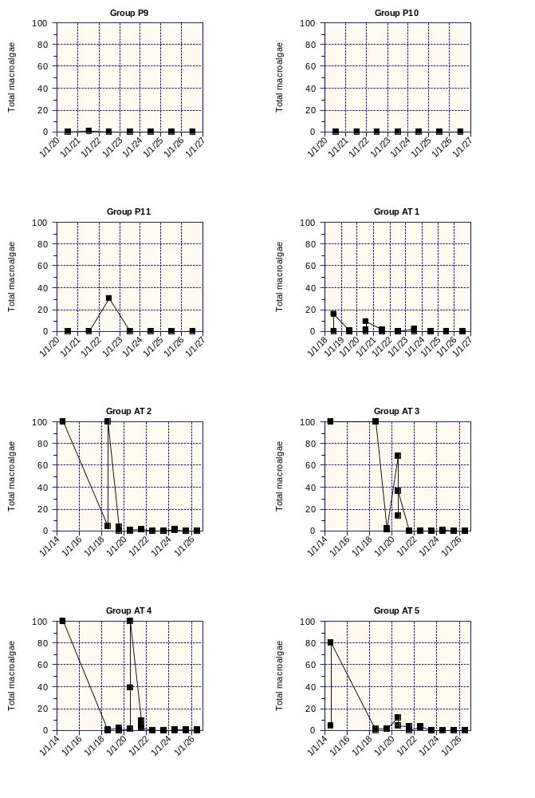
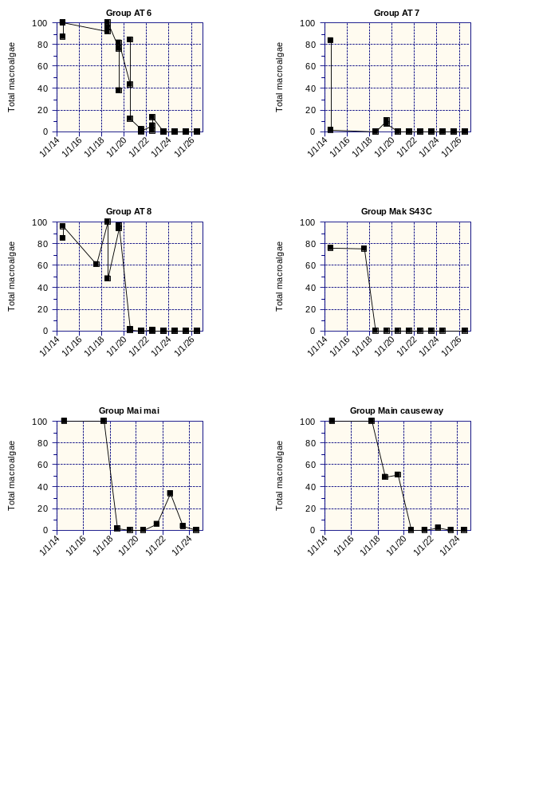

Appendix 4: Dissolved oxygen and electrical conductivity logger results
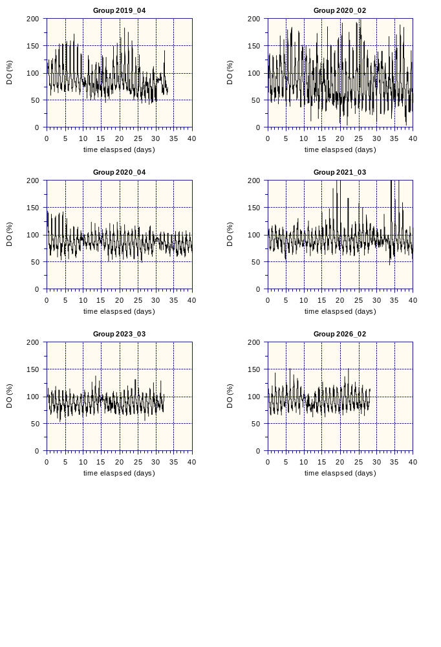
Figure A4.1: Site WQ5 mid-estuary dissolved oxygen logger results for years since 2019. The 2017_03 logging period occurred before causeways were removed and Stage 1 opening of the gates occurred on 12 February 2020 – halfway through the 2020_02 logging period.
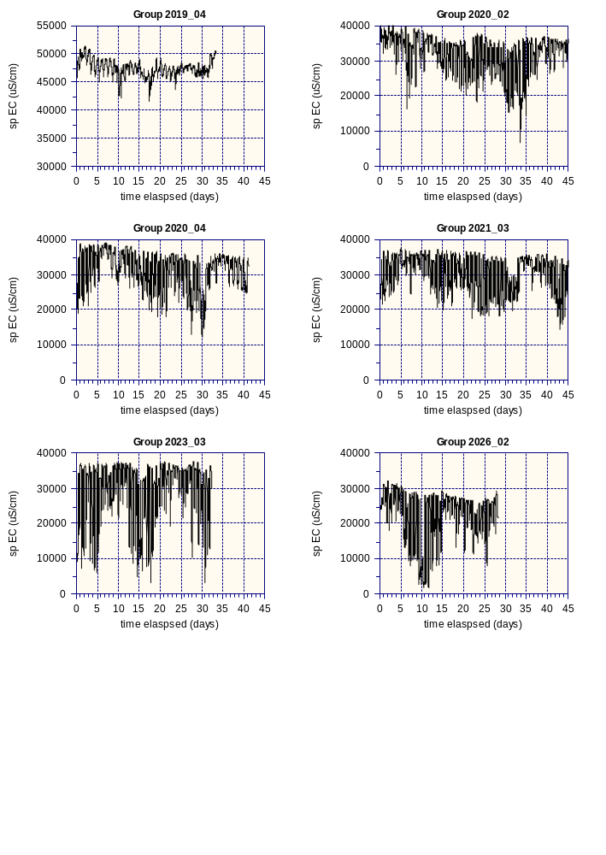
Figure A4.2: Site WQ5 mid-estuary electrical conductivity logger results for years since 2019. The 2017_03 logging period occurred before causeways were removed and Stage 1 opening of the gates occurred on 12 February 2020 – halfway through the 2020_02 logging period.
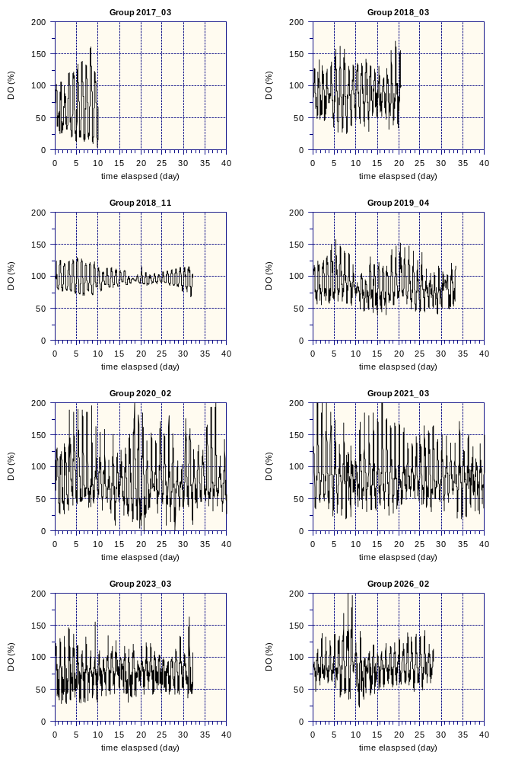
Figure A4.3: Site WQ2 Causeway 2 dissolved oxygen logger results for years since 2019.
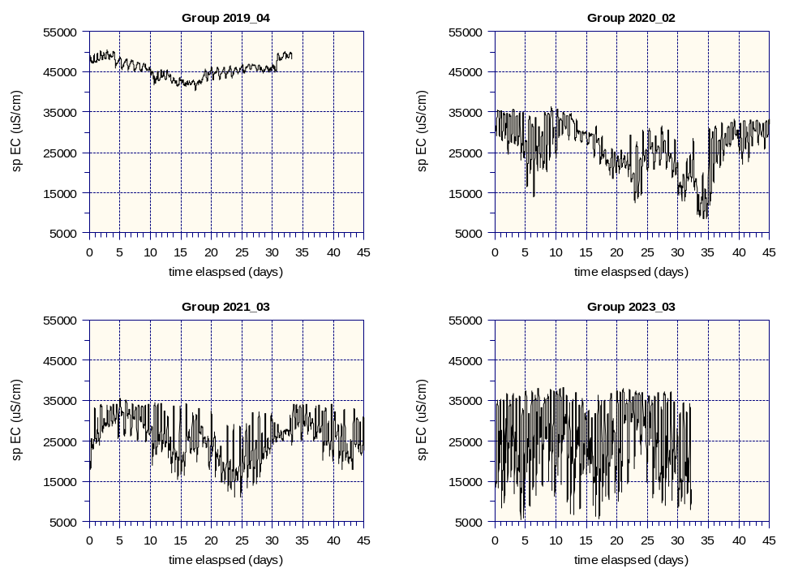
Figure A4.4: Site WQ2 Causeway 2 electrical conductivity logger results for years since 2019. The 2017_03 logging period occurred before causeways were removed and Stage 1 opening of the gates occurred on 12 February 2020 – halfway through the 2020_02 logging period.

Appendix 5: Macrofauna and Shellfish graphs

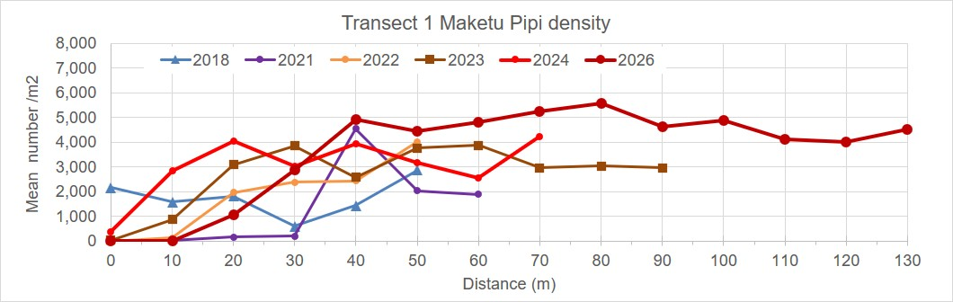
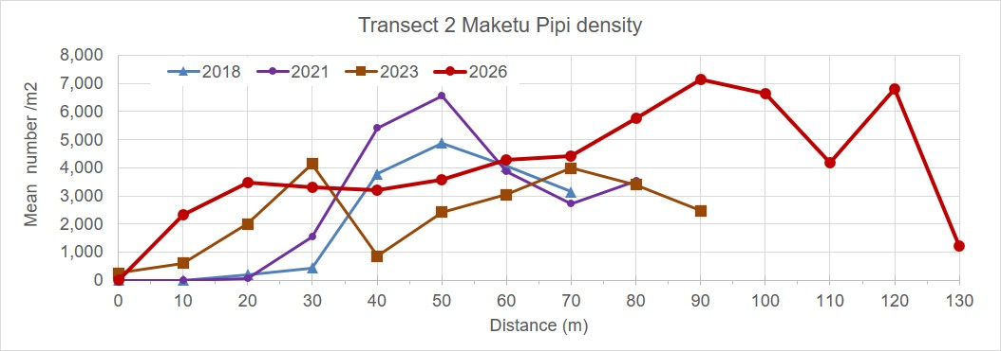
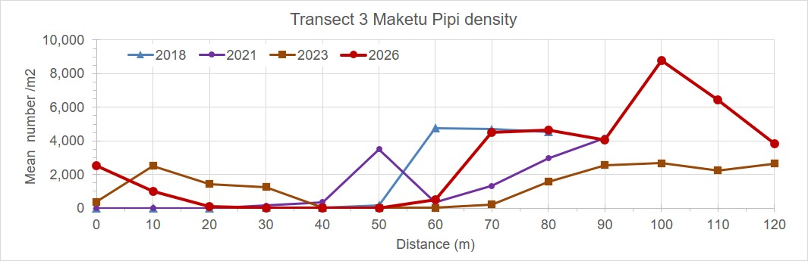
Figure A5.1: Pipi density along transects T1, T2 and T3 during years where surveys have been undertaken since 2018. The density of pipi along transects changes with channel location between years.

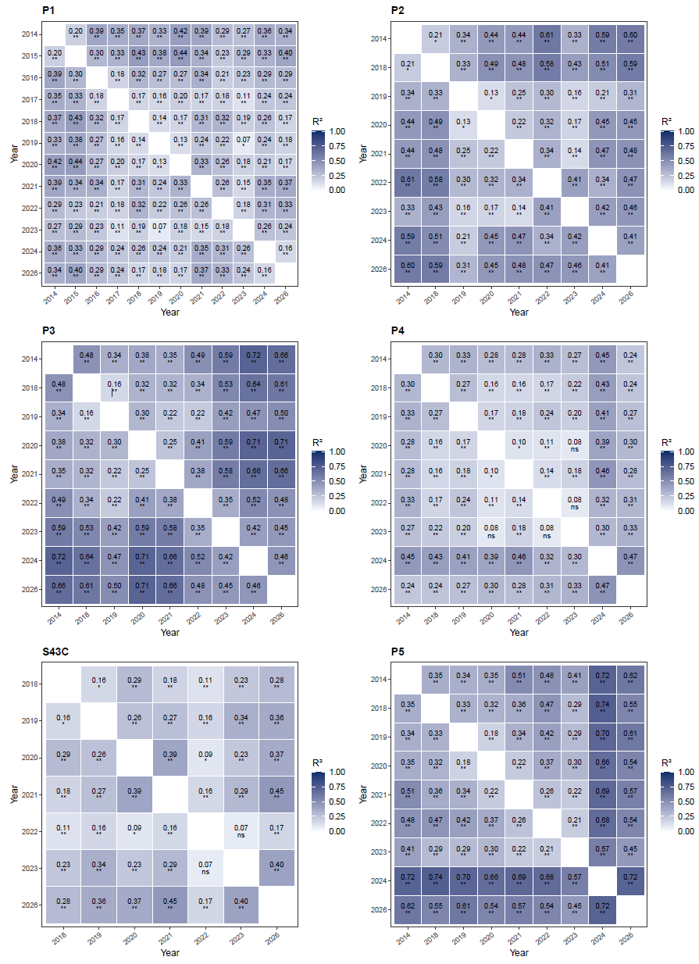
Figure A5.2: Heat map plot of a pairwise (post-hoc) PERMANOVA per site from the macrofauna NMDS.
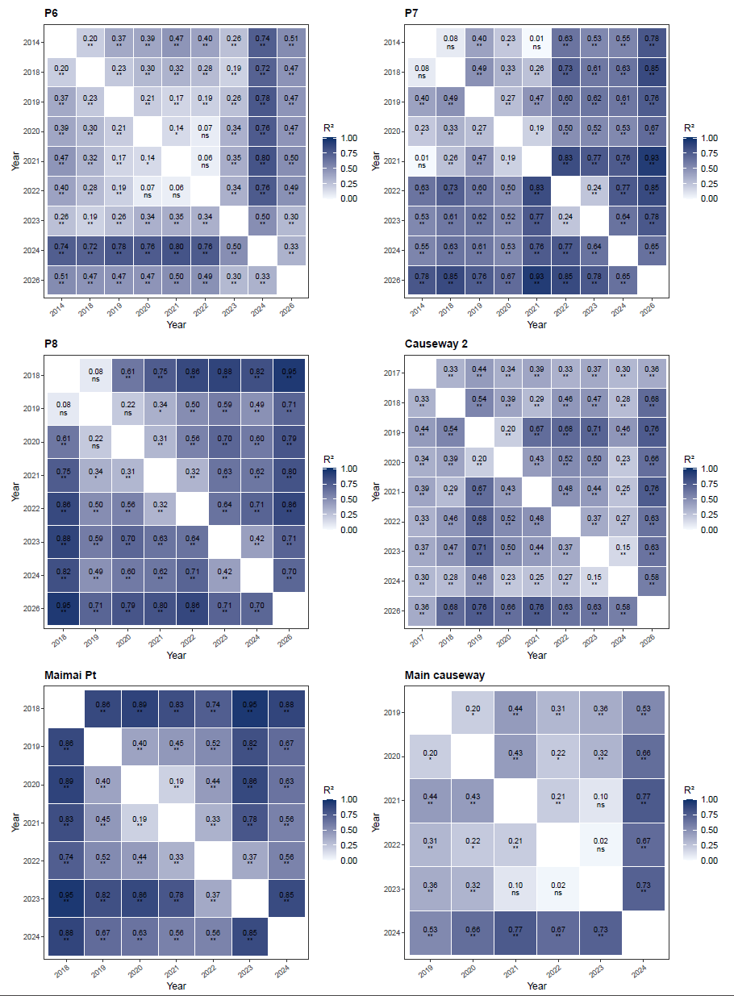
Figure A5.2: Heat map plot of a pairwise (post-hoc) PERMANOVA per site from the macrofauna NMDS.

Appendix 6: Water quality results
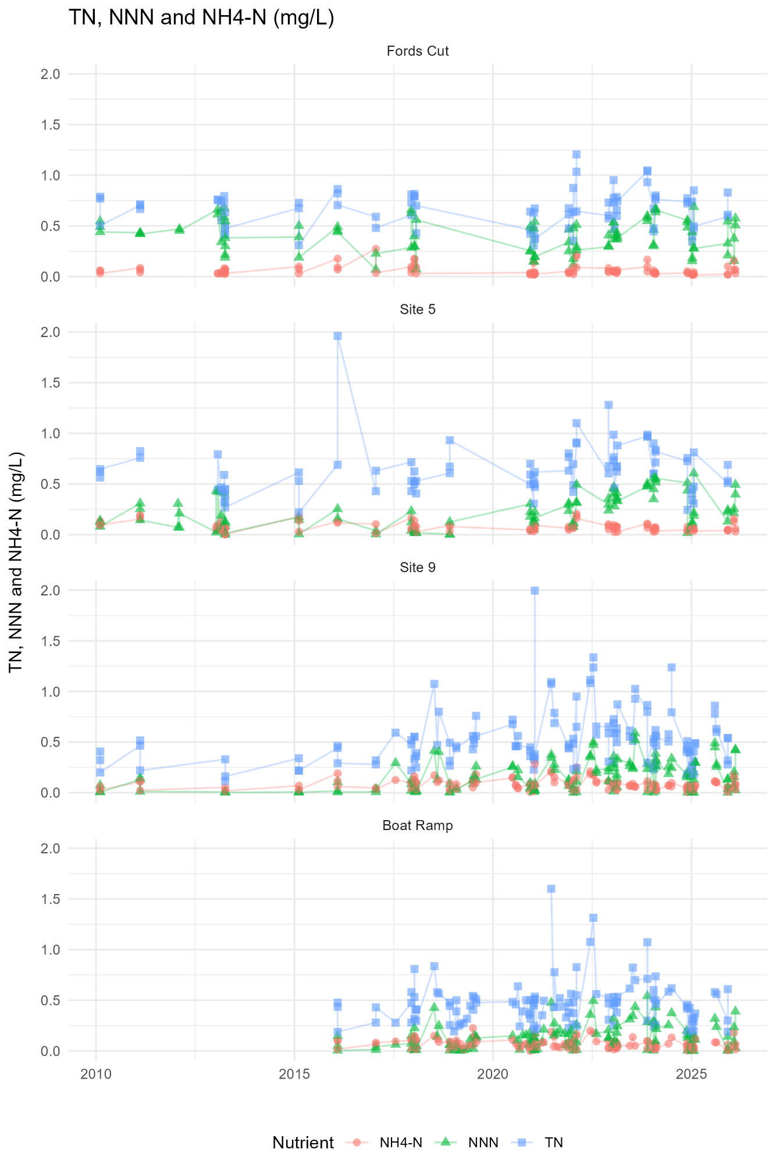
Figure A6.1: Nutrient levels (TN, NNN, NH4-N) recorded for the Fords Cut, Site 5, Site 9 and Boat ramp in Maketū Estuary – all tides.
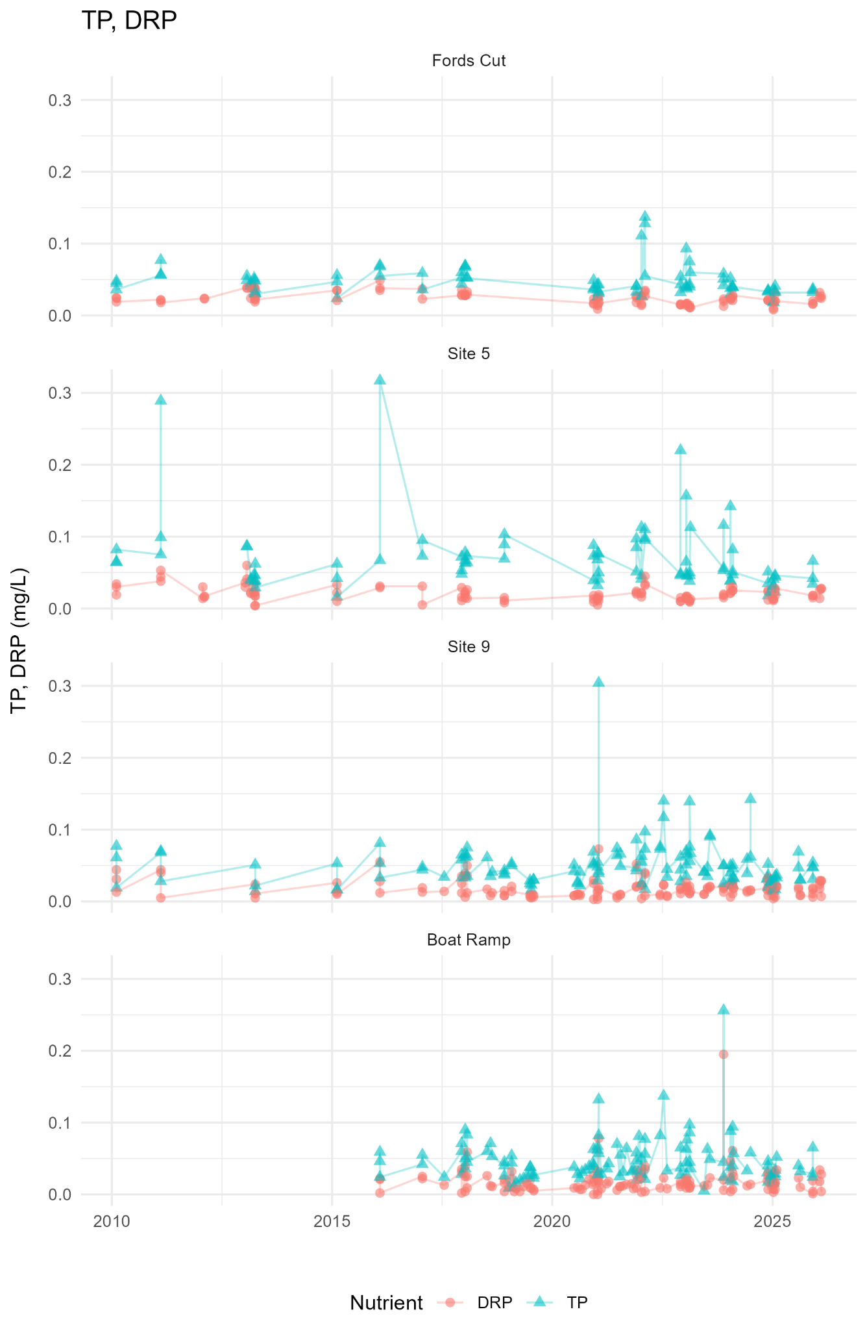
Figure A6.2: Nutrient levels (TP, DRP) recorded for the Fords Cut, Site 5, Site 9 and Boat ramp in Maketū Estuary – all tides.
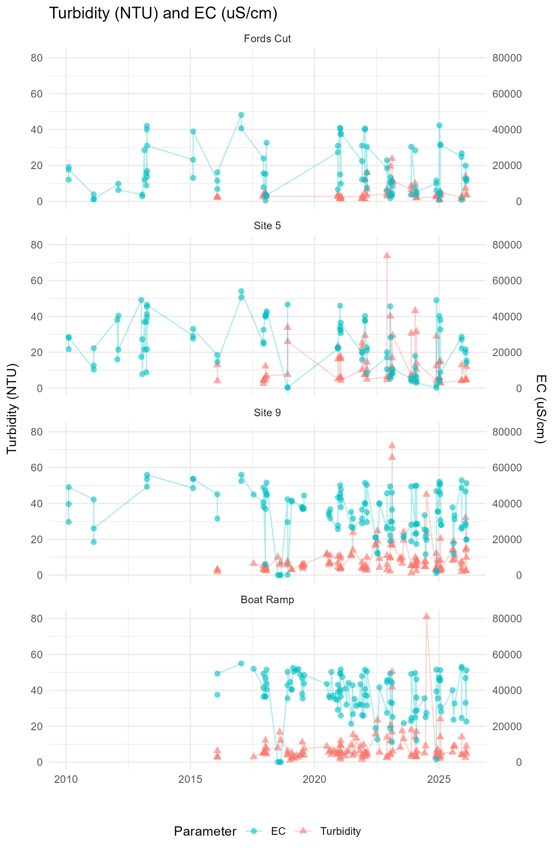
Figure A6.3: Nutrient levels (Turbidity and EC) recorded for the Fords Cut, Site 5, Site 9 and Boat ramp in Maketū Estuary – all tides.
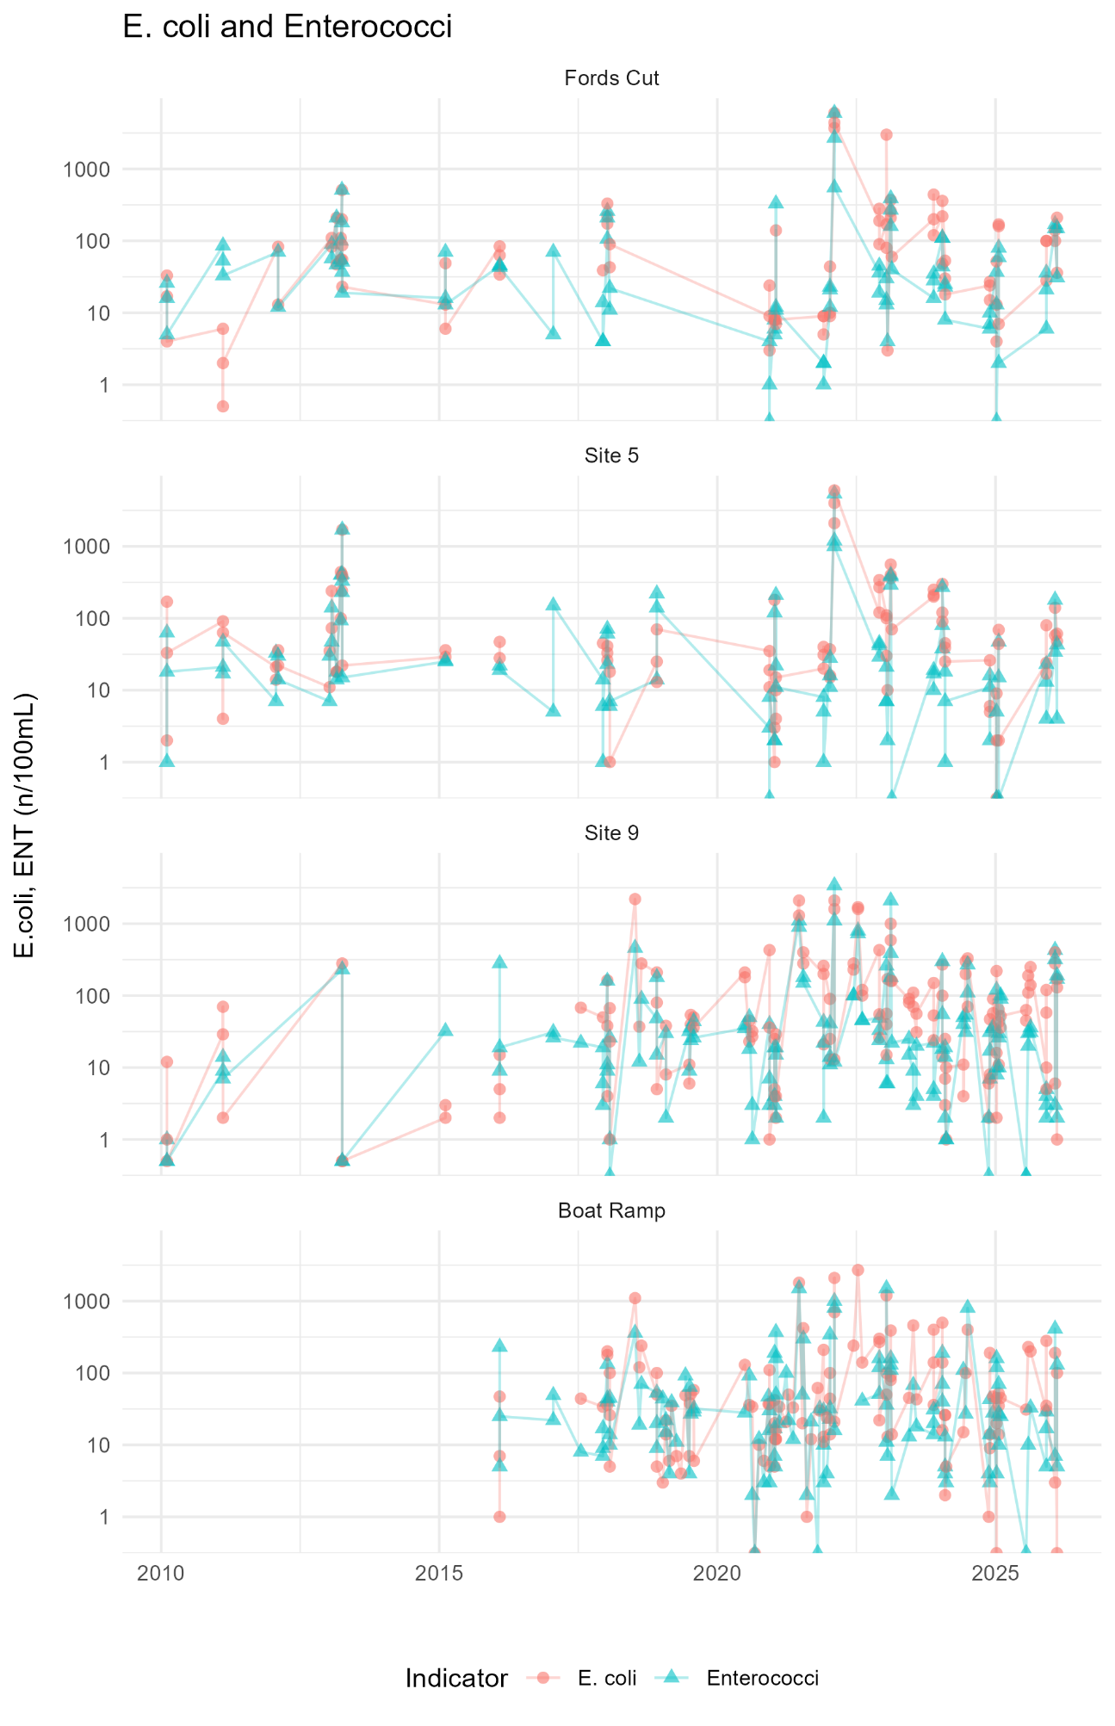
Figure A6.4: Nutrient levels (E.coli and Enterococci) recorded for the Fords Cut, Site 5, Site 9 and Boat ramp in Maketū Estuary – all tides.
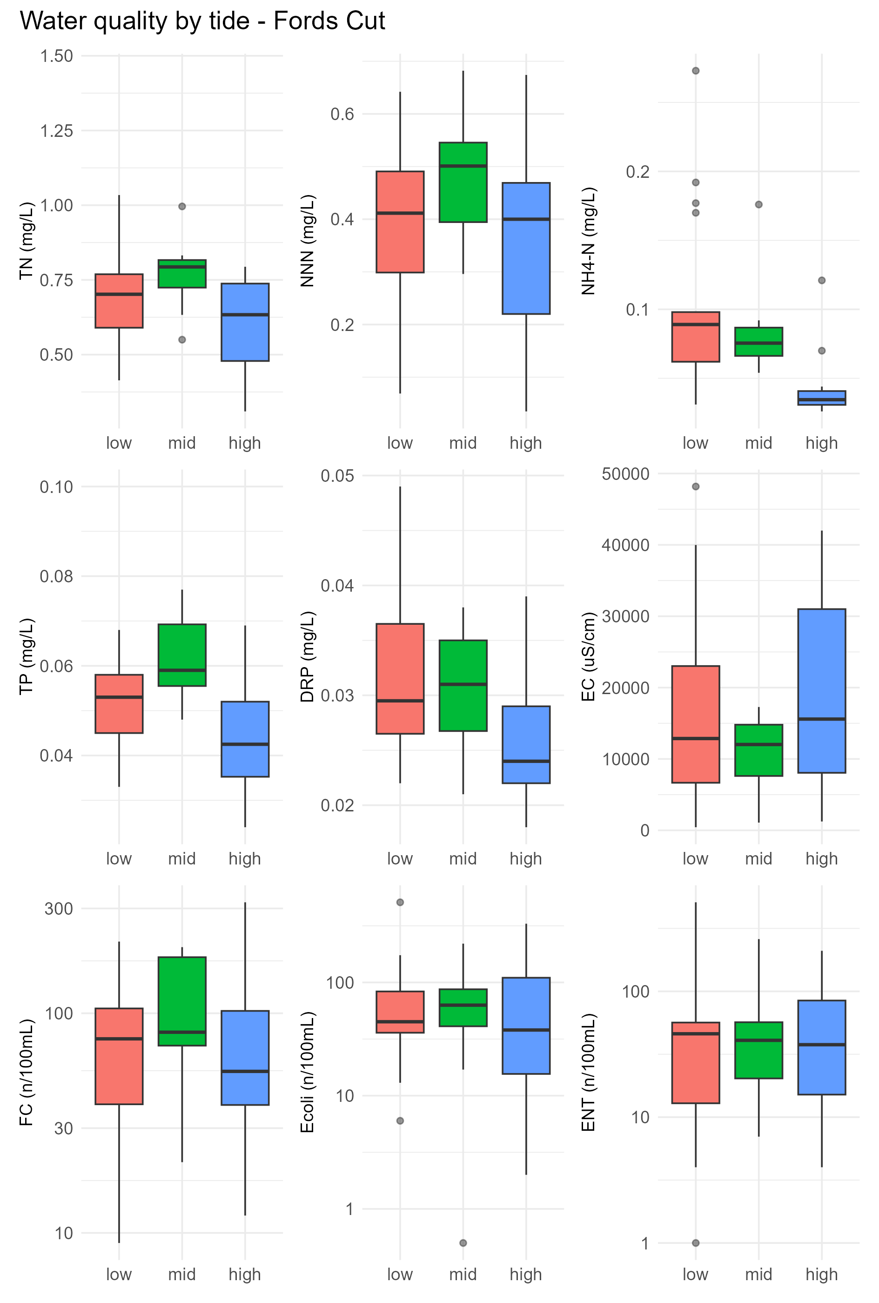
Figure A6.5: Effect of tides on water quality at Maketū Fords Cut, before rediversion. Summer data, 2006 to June 2020.
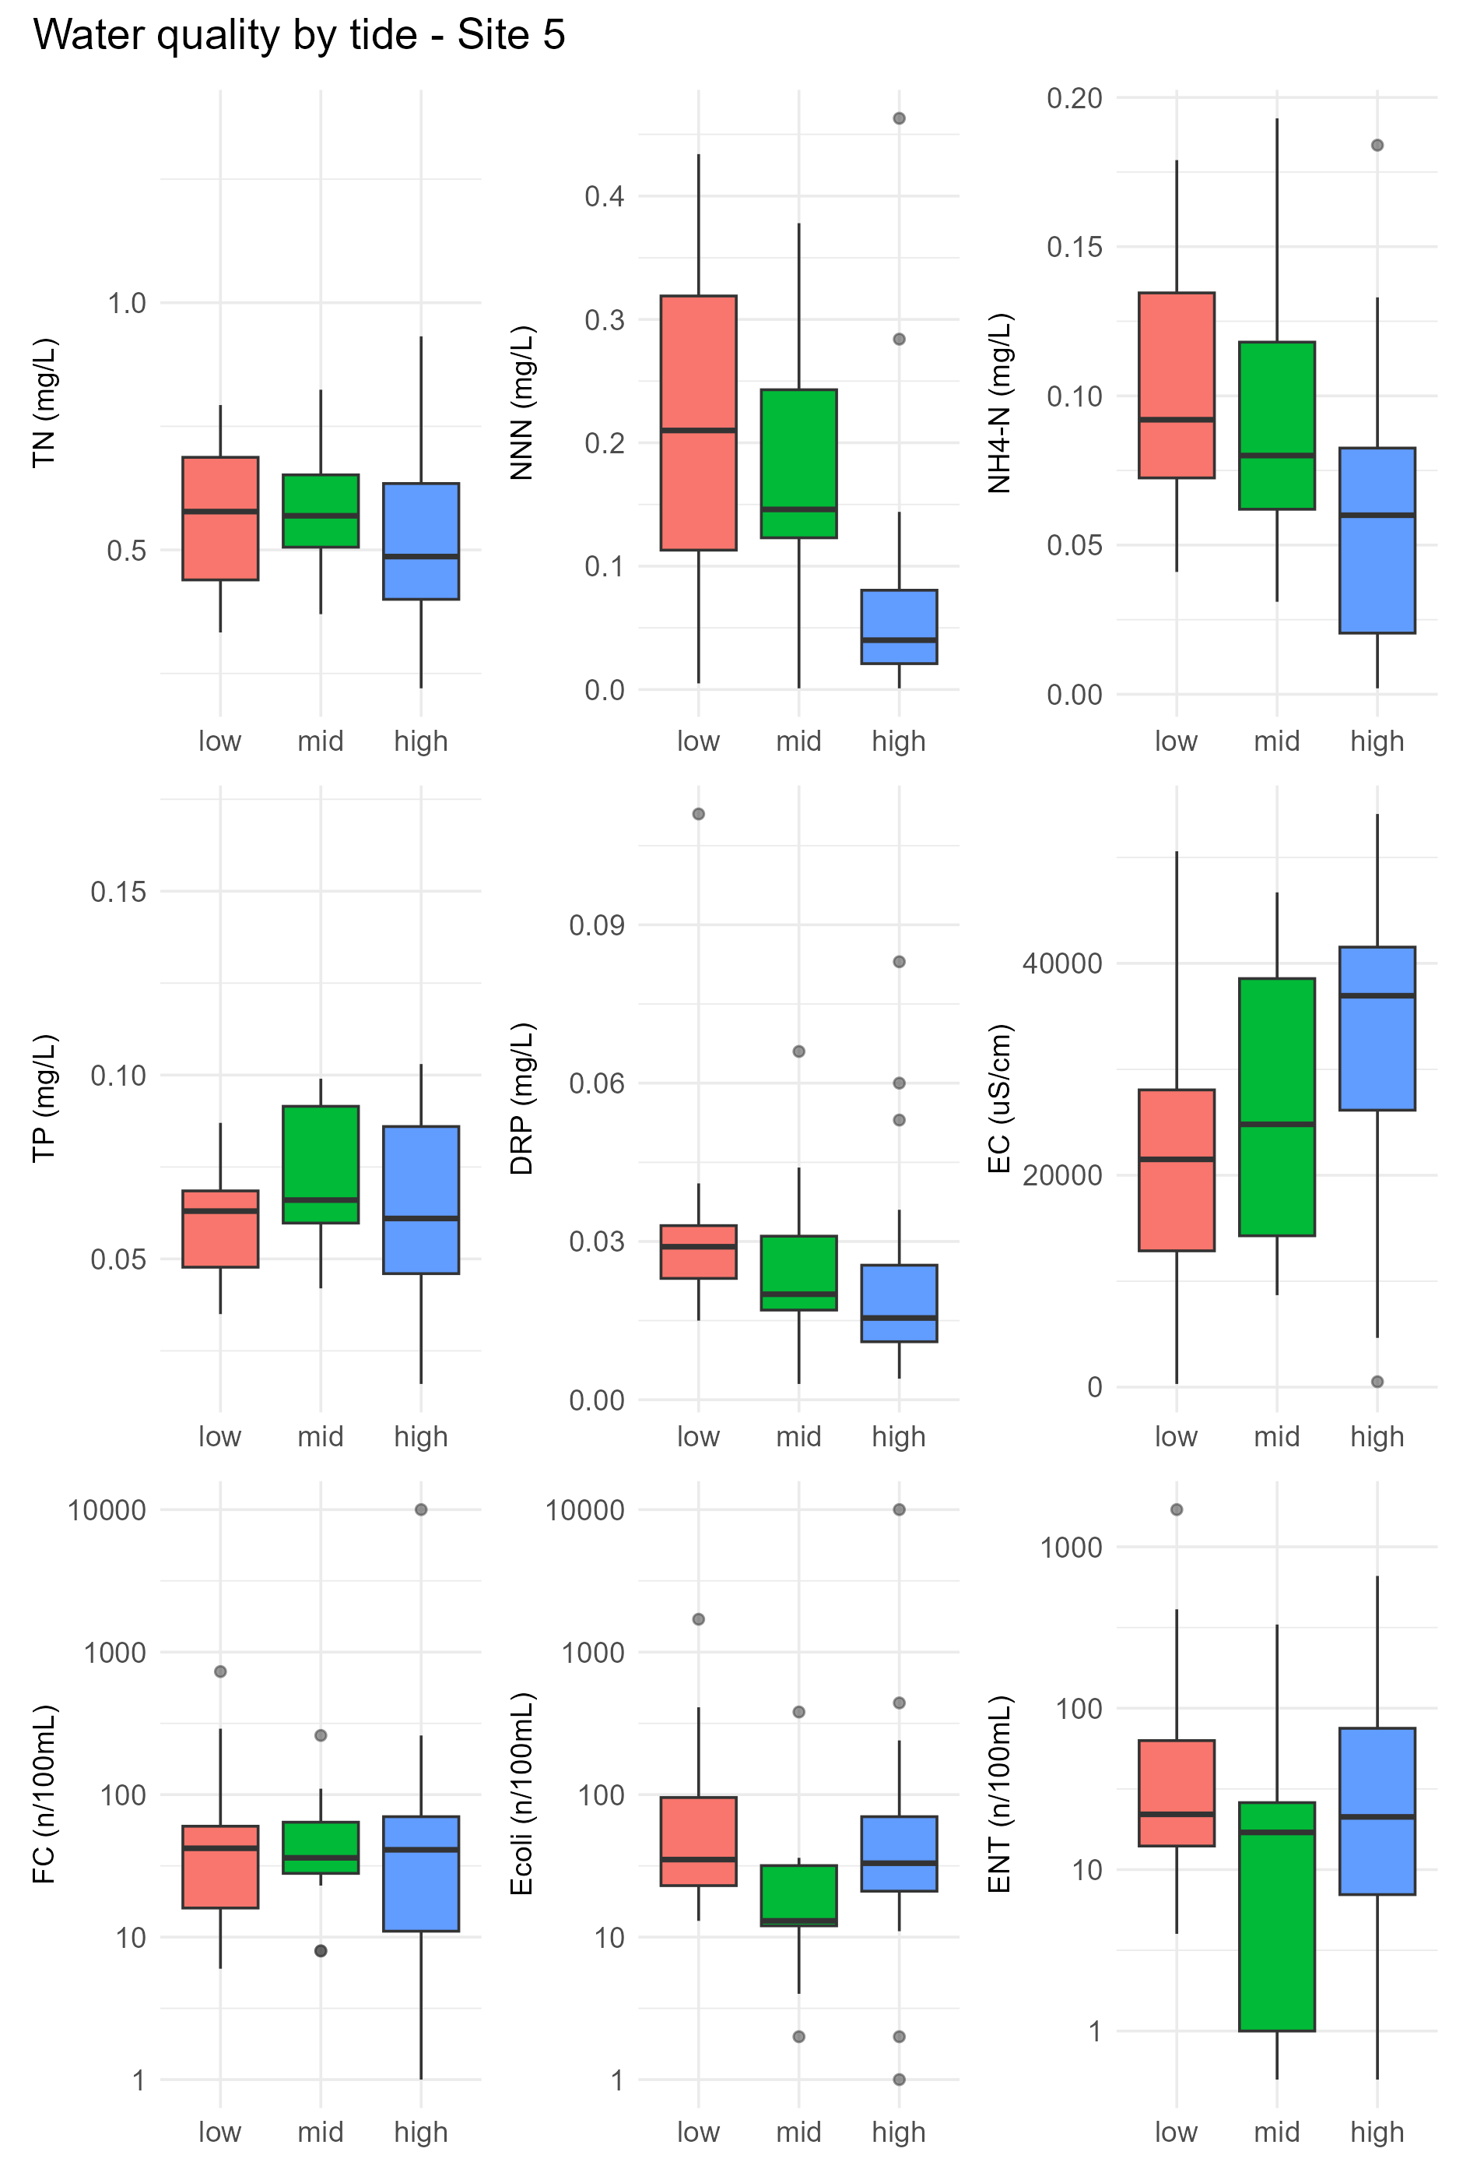
Figure A6.6: Effect of tides on water quality at Maketū Site 5 before rediversion. Summer data, 2006 to June 2020.
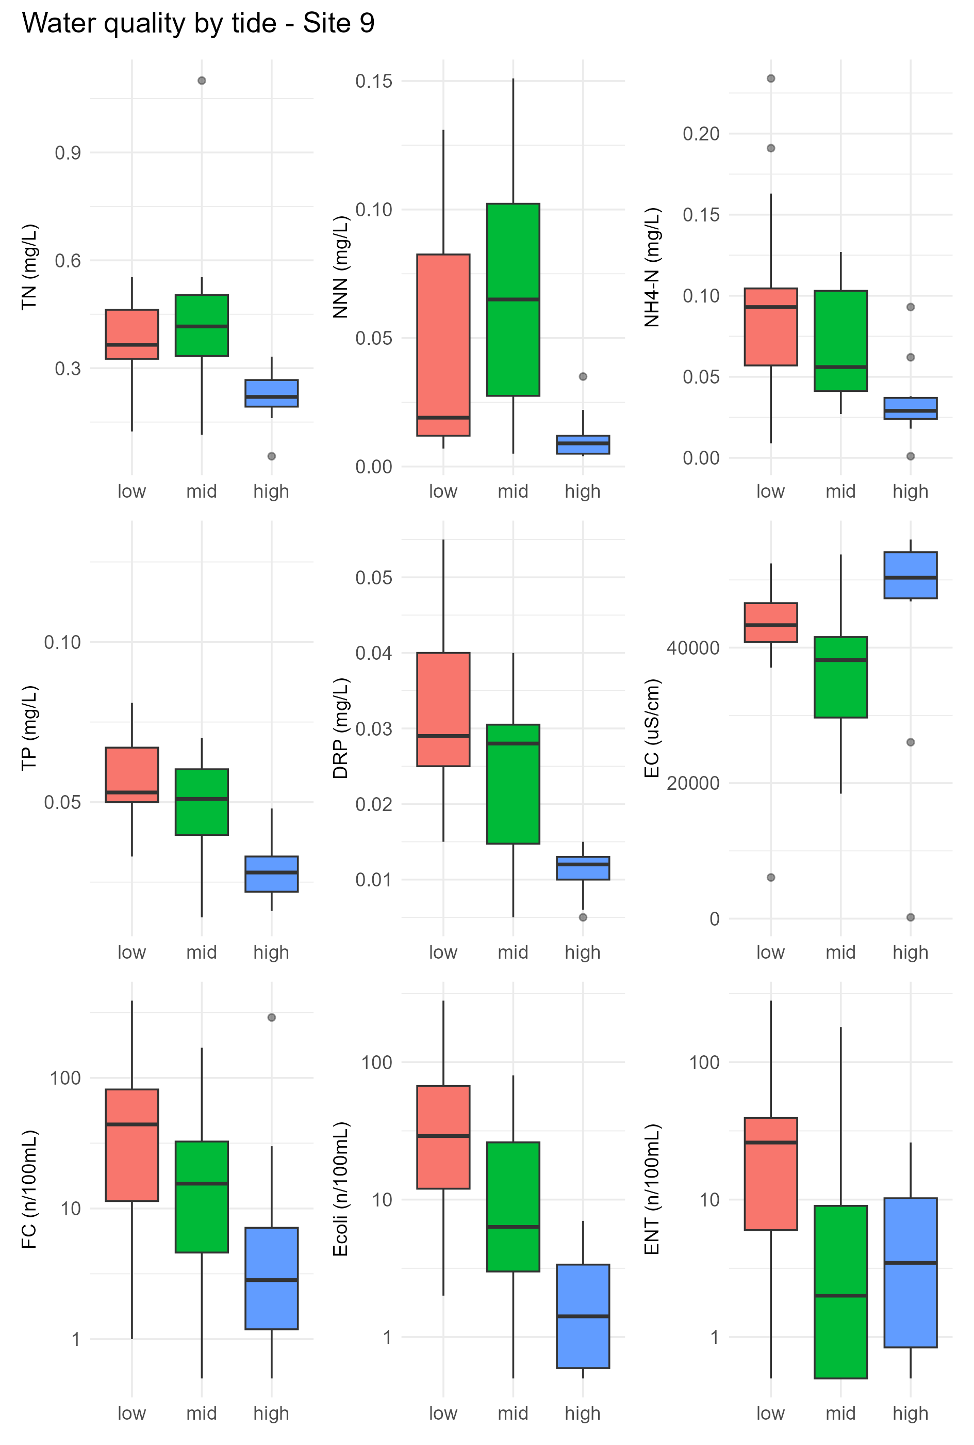
Figure A6.7: Effect of tides on water quality at Maketū Site 9 before rediversion. Summer data, 2006 to June 2020.
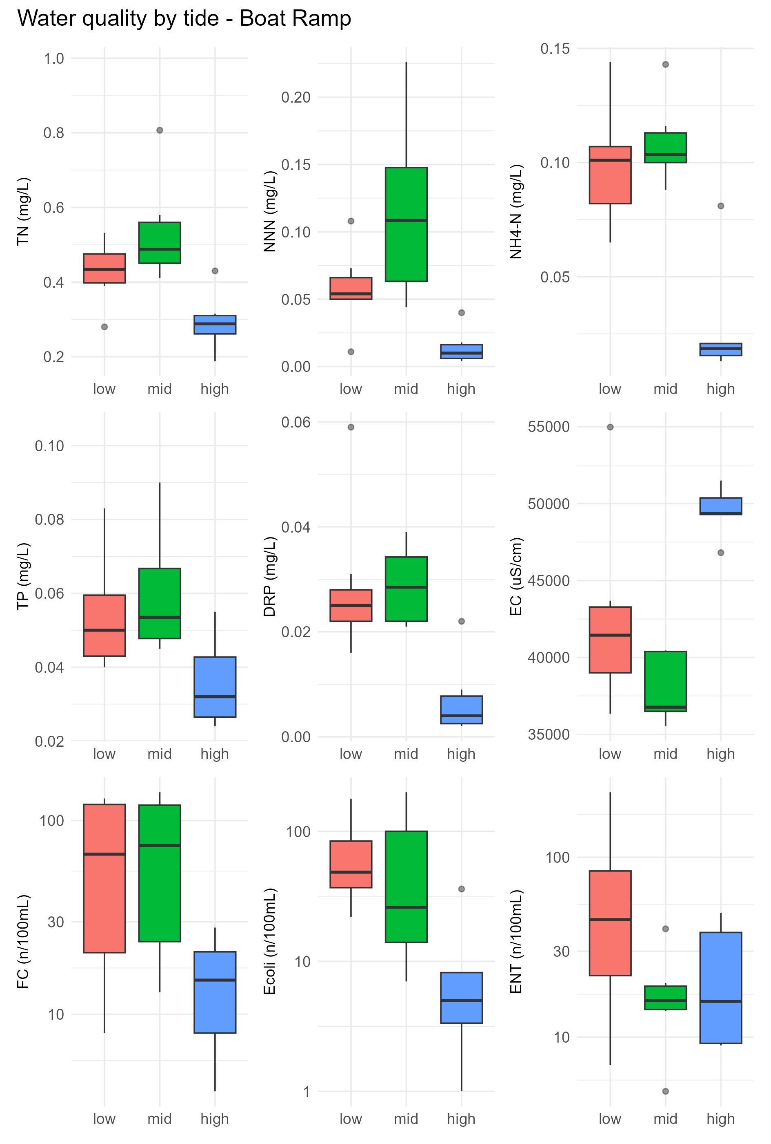
Figure A6.8: Effect of tides on water quality at Maketū Boat Ramp before rediversion. Summer data, 2006 to June 2020.

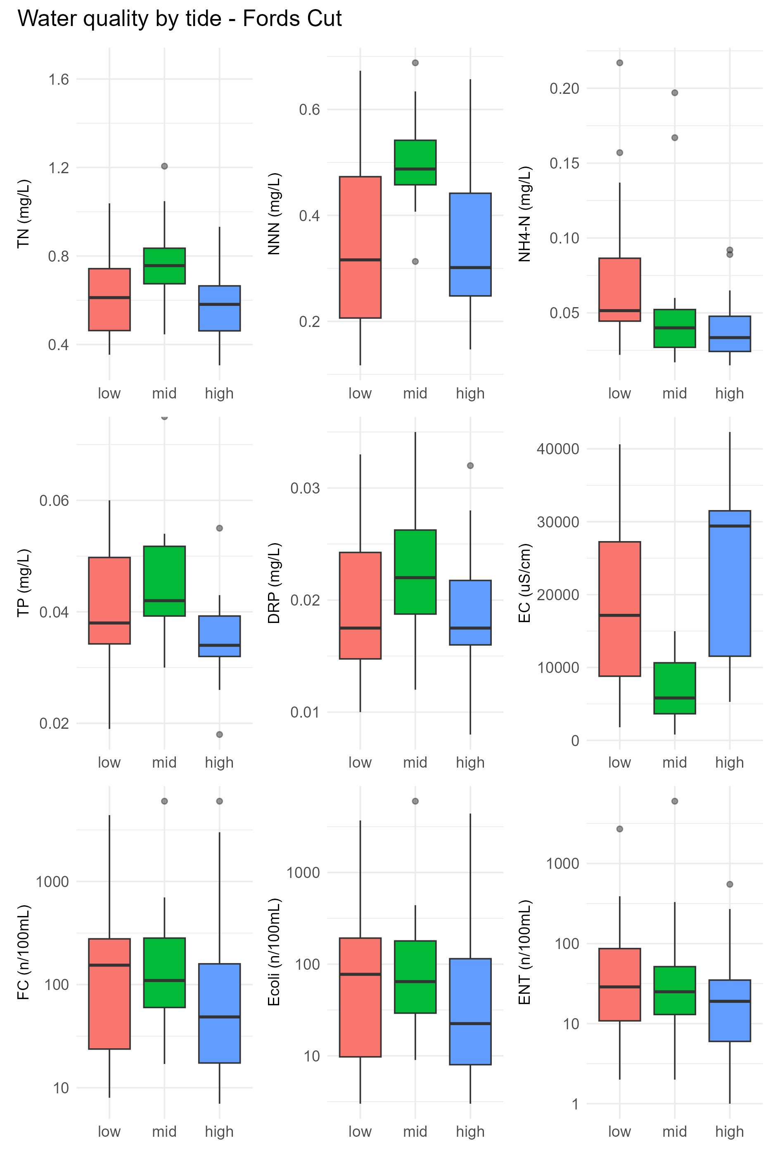
Figure A6.9: Effect of tides on water quality at Maketū Fords Cut. Summer data, June 2020 to 2026.
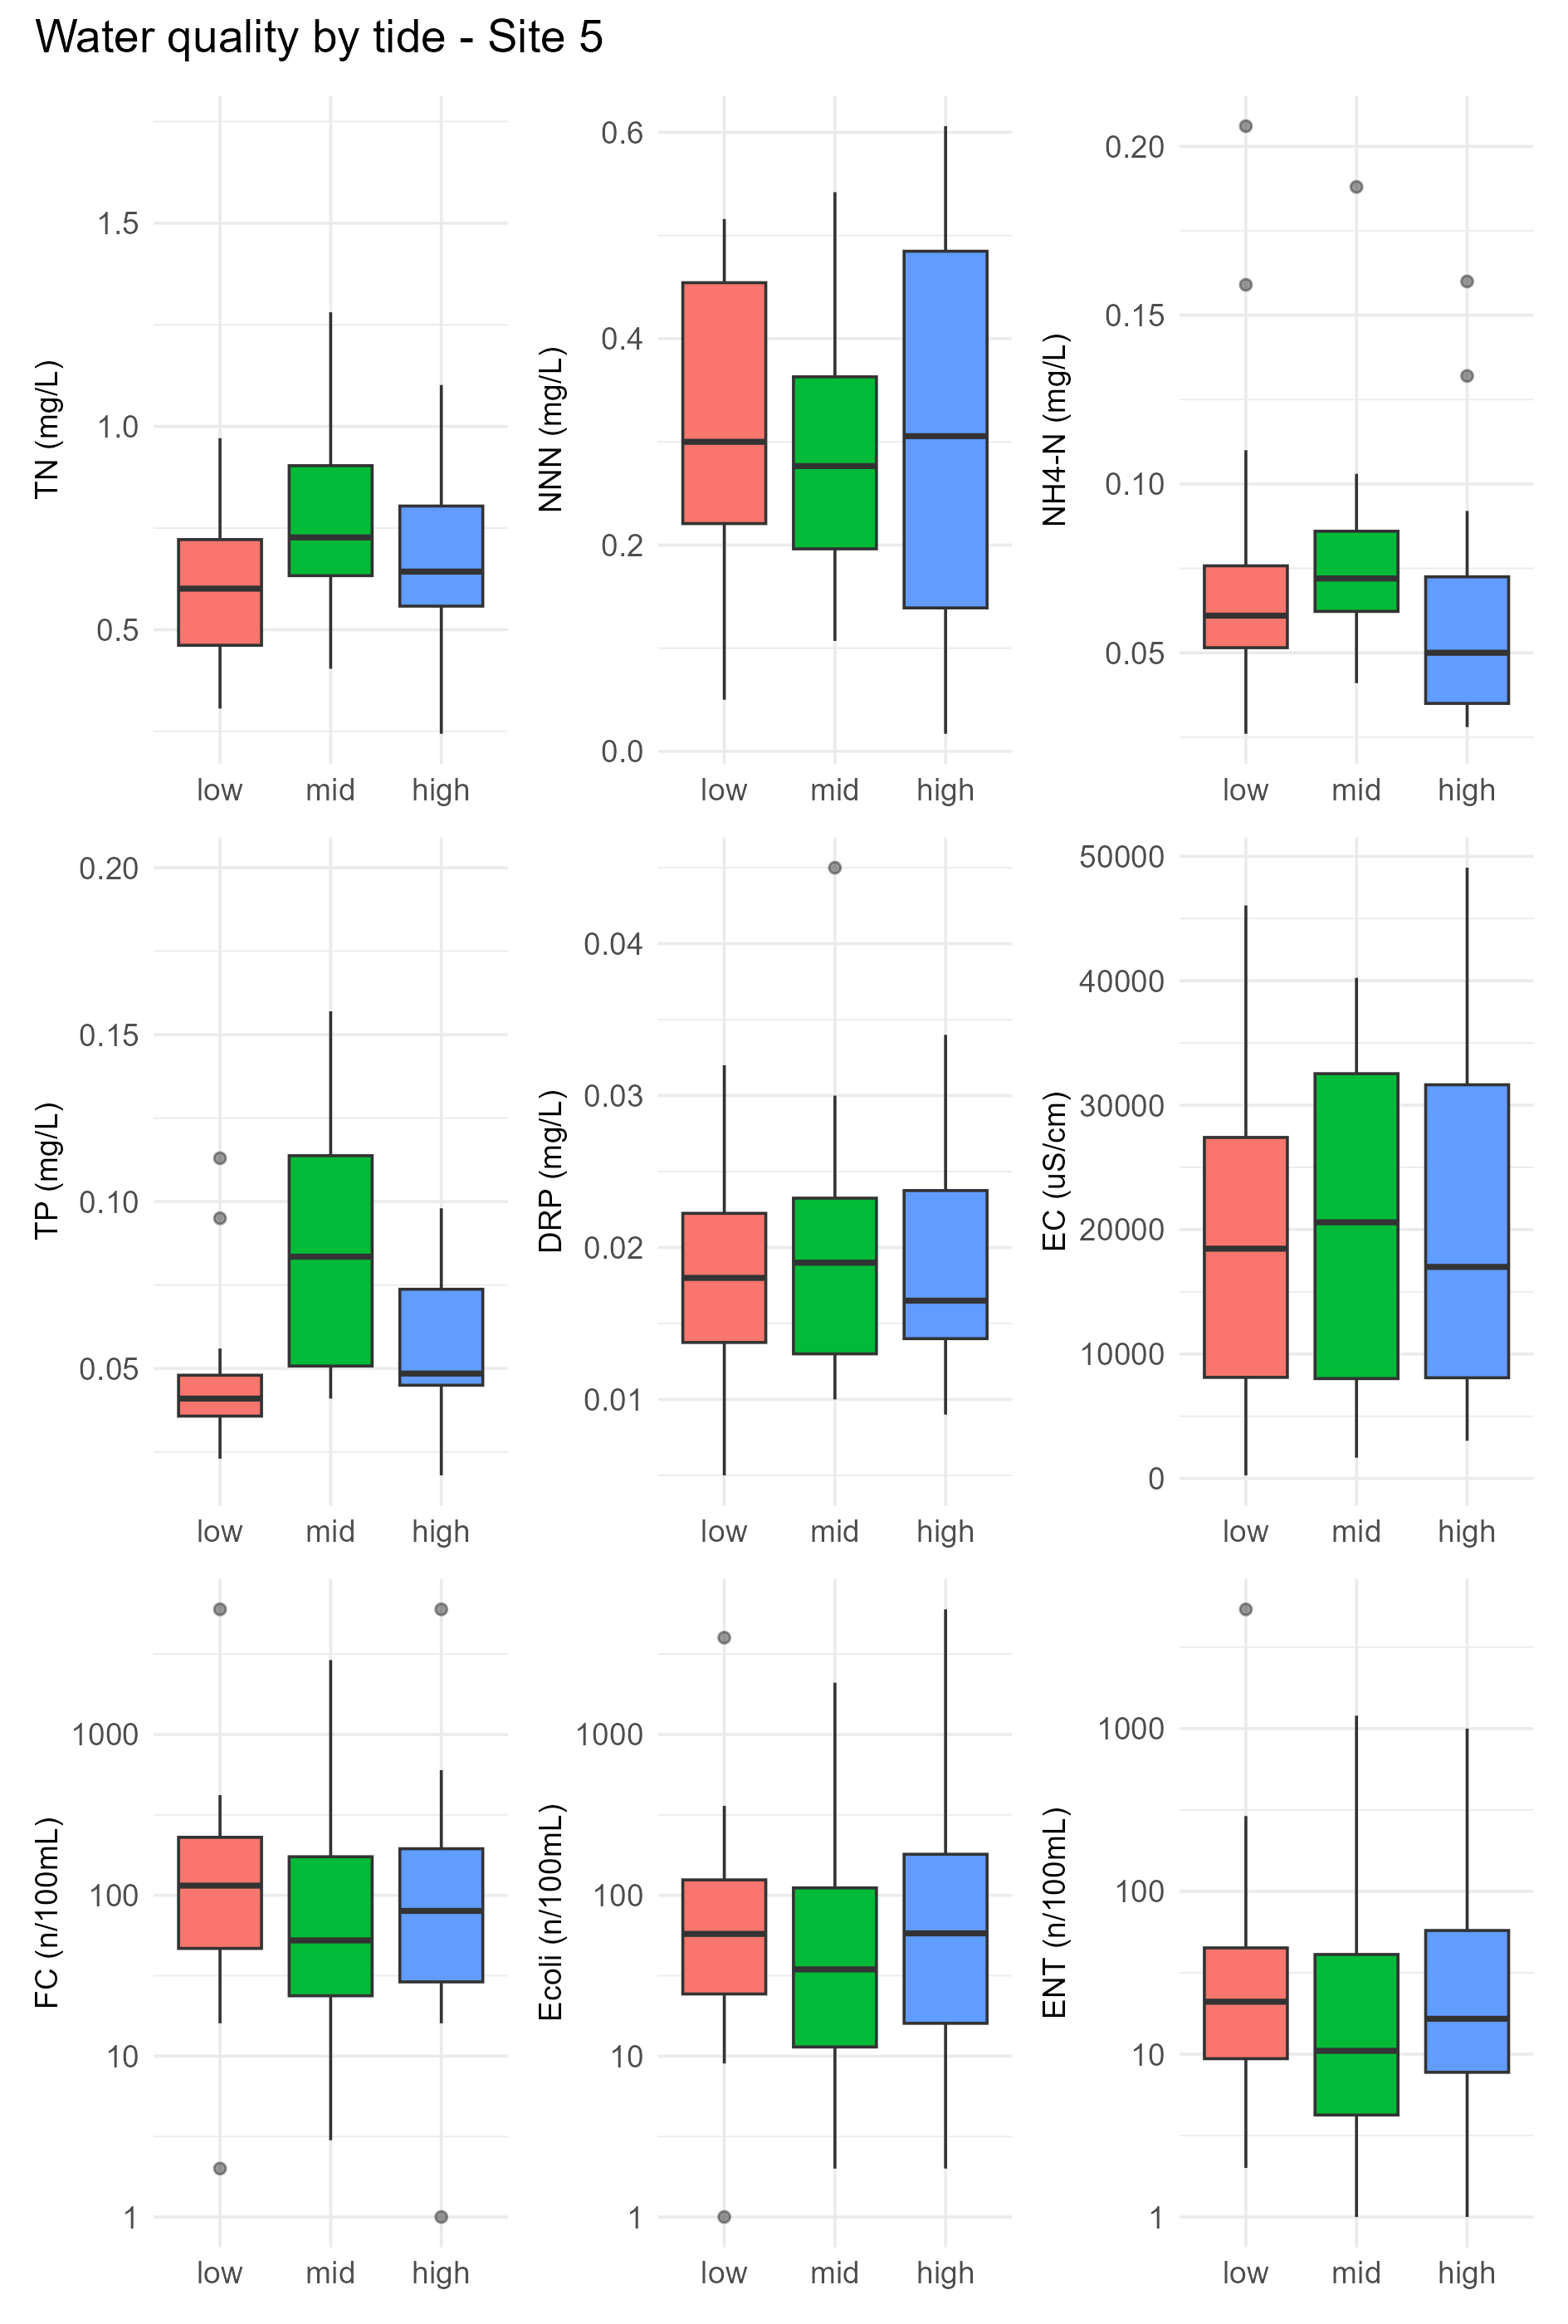
Figure A6.10: Effect of tides on water quality at Maketū Site 5. Summer data, June 2020 to 2026.
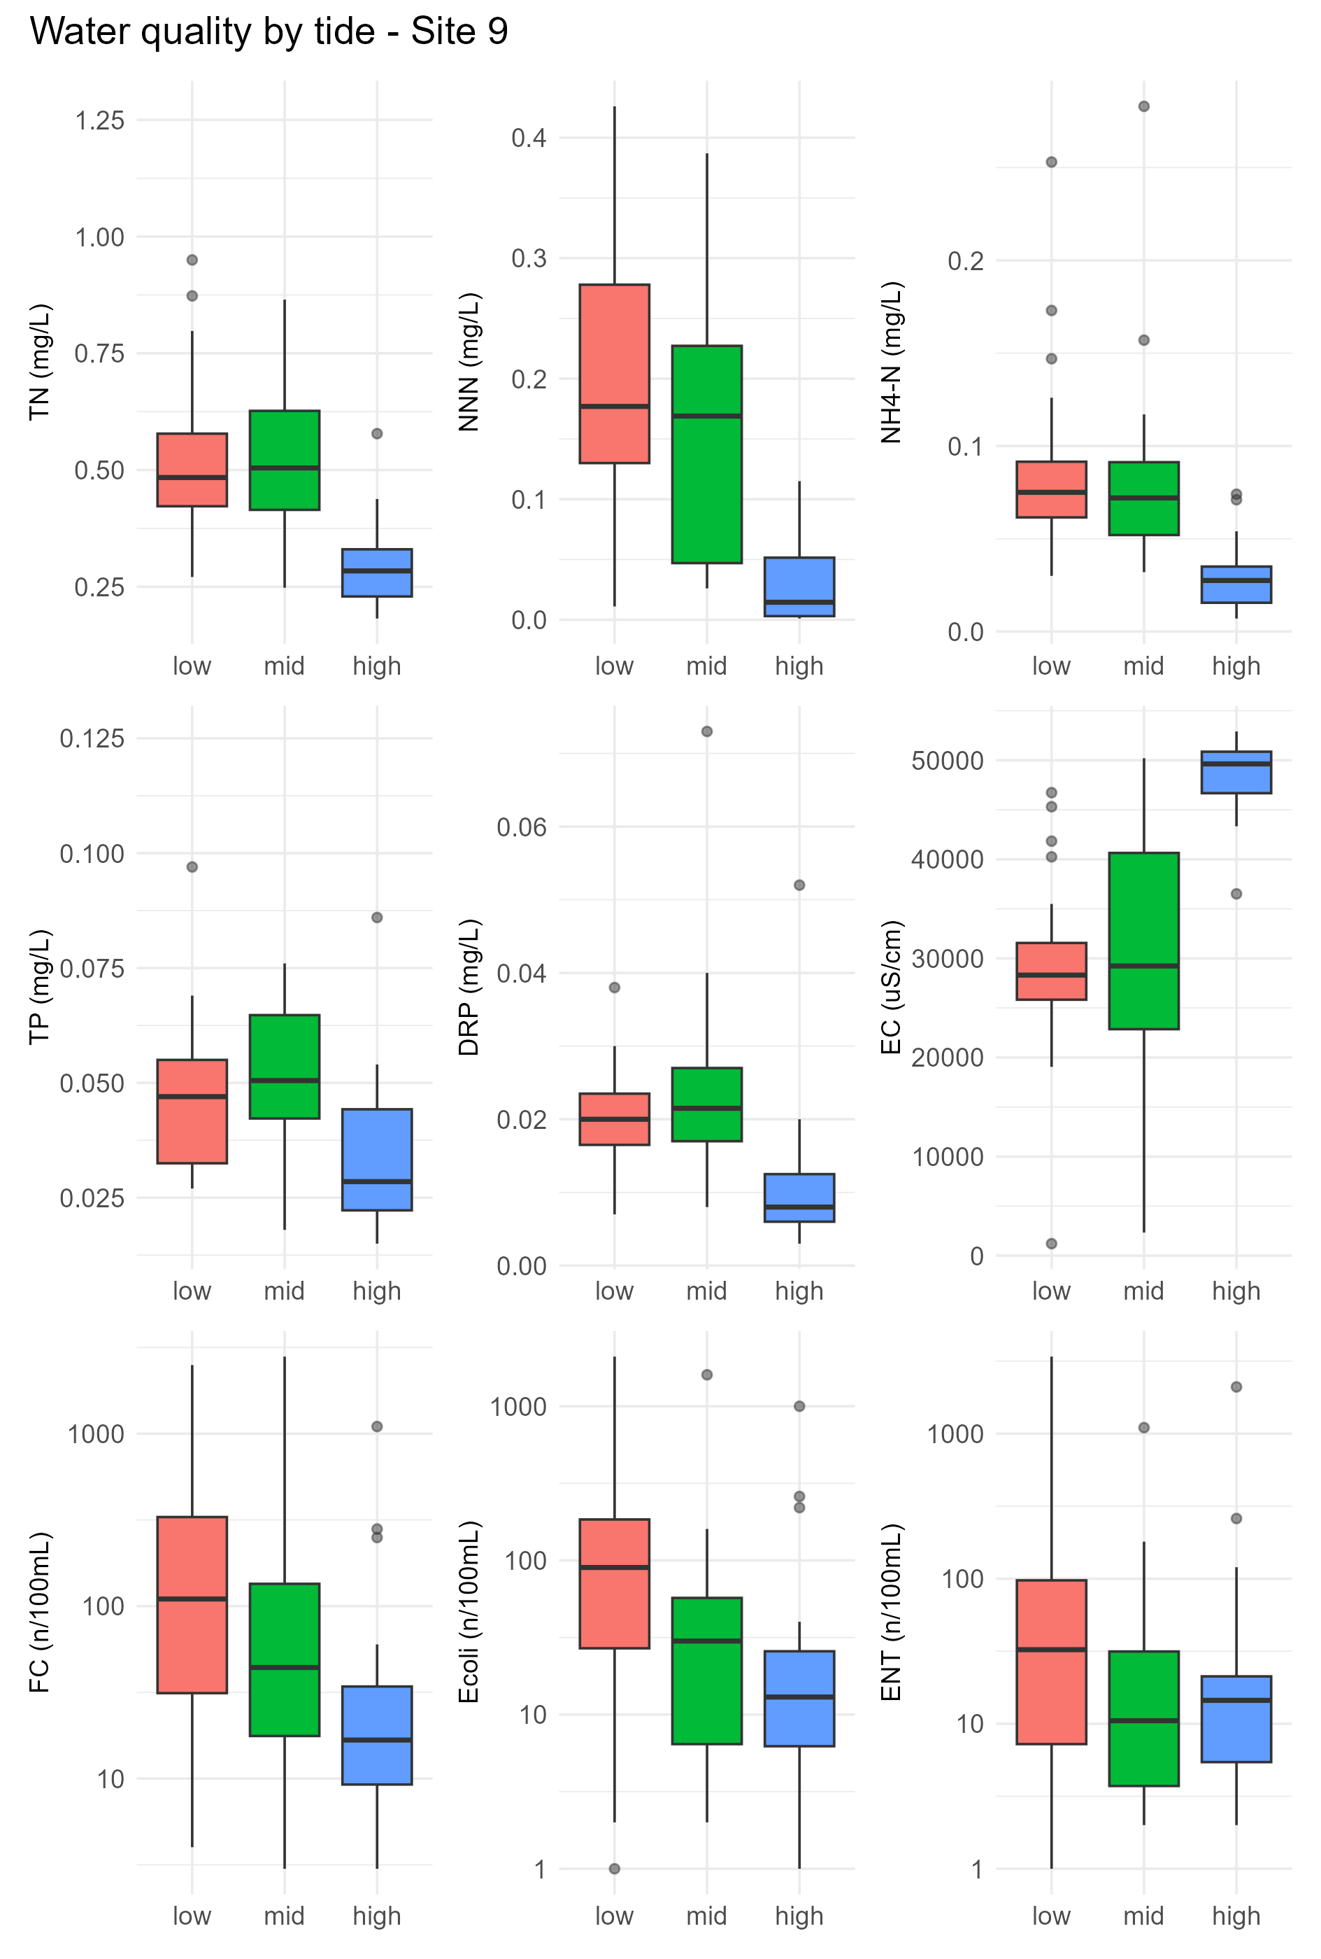
Figure A6.11: Effect of tides on water quality at Maketū Site 9. Summer data, June 2020 to 2026.
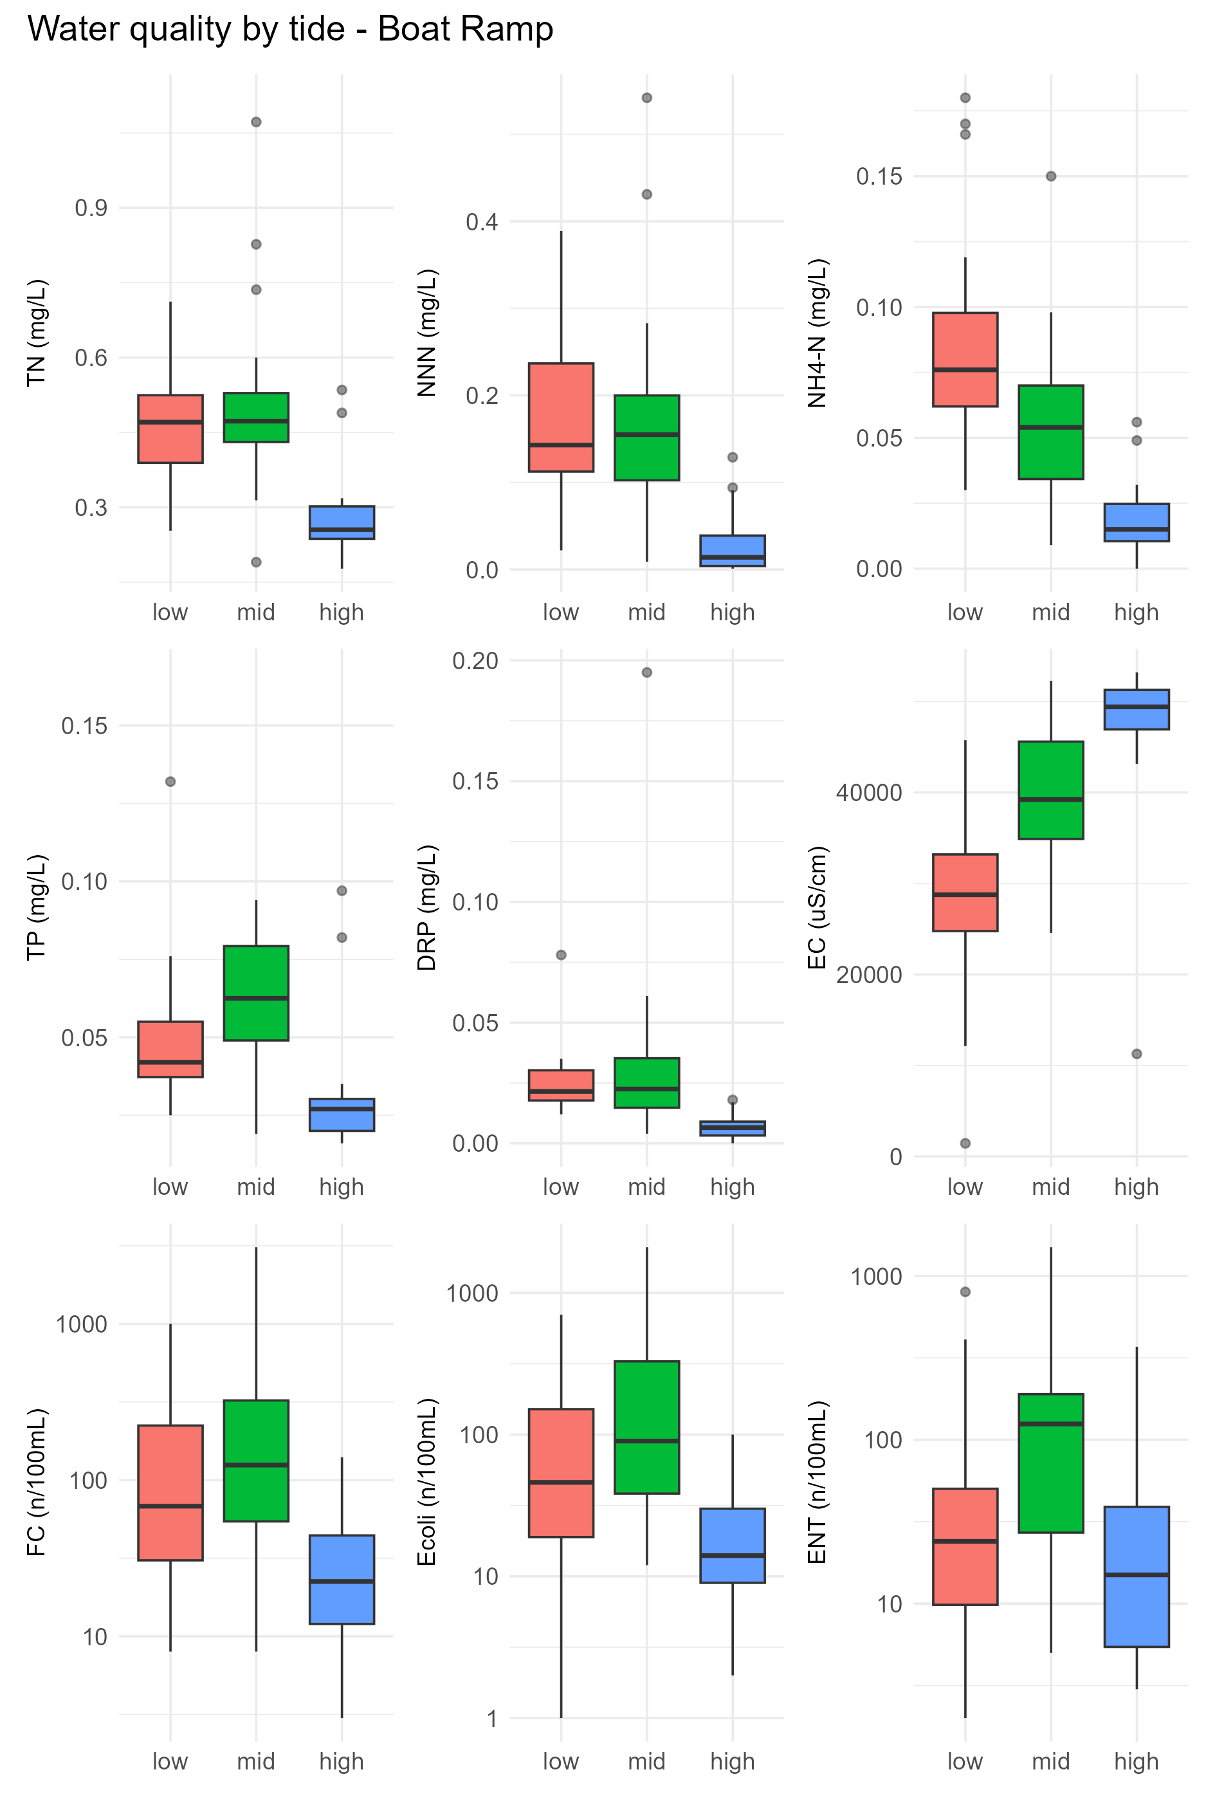
Figure A6.12: Effect of tides on water quality at Maketū Boat Ramp. Summer data, June 2020 to 2026.

Consent conditions specify measurements of salinity. Salinity can be derived for specific electrical conductivity by multiplying by 0.0062.
The winter water quality sampling is in addition to what is required in the consent. In the past, a mid-tide water quality sample has also been collected in addition to the low tide and high tide samples.
Equivalence Test including a student t-test.
Based on the mean annual slope of the linear trend line.
This statistical test did not find significant trends in the other upper estuary sites due to the step change nature of improvement and small number of baseline samples.
Previously named Tellina liliana
Tested using a Kruskal-Wallis with a Dunn post-hoc test in R software.
The size class dataset grouped all replicates within a plot. Size class data for individual replicates was not available for past years, and this reduced the power of the Kruskal-Wallis test (non-parametric, one-way).

